Christoph F. Eick, Raunak Sarbajna and Md/ Mahin

COSC 4368: Fundamentals of Artificial Intelligence Spring 2024

Problem Set 3 (Individual Tasks)

First Draft

Deadlines: Task 6: April 20; Task 7: April 30

Last updated: April 8, 11a

6. Ethical and Societal Problems of AI (33 points) Raunak
Write a short essay of 470-570 words, choosing one of the following three topics:

a. exploring the ethical dilemma of managing Artists' Rights vs. AI Advancement in Art Generation Models; focus on any three of the following points:
- Examine the contentious issue surrounding the unauthorized usage of artists' works by AI companies, notably exemplified by instances like MidJourney and Sora AI.
- Analyze the ethical implications of utilizing art without permission for the development of AI-driven creative platforms, considering both the creative rights of artists and the technological advancements made possible through such practices, using the example of a real-life artist who was impacted.
- Critically examine the balance between innovation and artistic integrity, delve into questions of intellectual property, fair compensation, and the broader societal impact of AI in the creative domain.
- Propose potential solutions or frameworks to reconcile the conflicting interests of artists and AI companies in this ongoing debate.

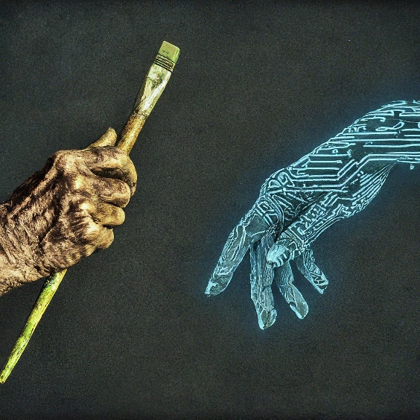
Fig. 1: Brushes vs. Algorithms: The Great Debate on Artistic Ownership in the Age of AI

b. How to ensure that AI systems follow our principles when making decisions? Explore and discuss some strategies and policies for ensuring ethical decision-making in AI systems.
c. Outline a future of our society in which language models like ChatGPT play a positive role. Describe the role language models would play in some detail and what is positive about it.

Be aware of the fact that plagiarism will not be tolerated in this course; however, this does not mean that you are not allowed to use material on the internet or taken from the scientific literature when writing your essay; you just need to cite the material you used and you will need to use quotations, if you use (parts of) sentences “unchanged” from other publications in your essay! Moreover, read the evaluation rubric before writing your answer.

7. Using a Belief Network Tool (20 points) Mahin

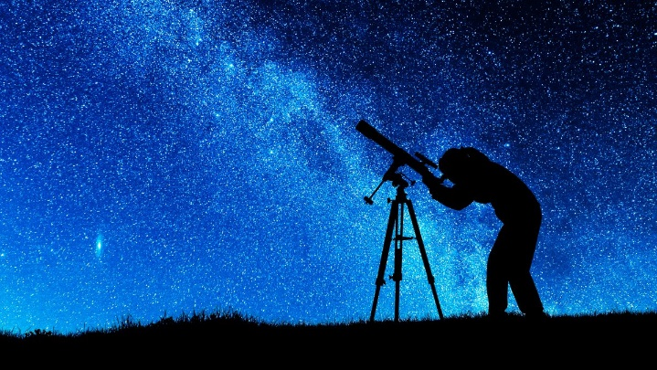
Fig. 2: Astronomer looking at the sky
Assume we have 3 astronomers in different parts of the world who make measurements M1, M2 and M3 of the number of stars N in some region of the sky. Normally, there is a probability of 0.05 that the astronomer counts a single star twice (overcounts by one star; you can assume that the four astronomers never undercount; moreover, if there is no star visible (N=0) the astronomer never overcounts). Moreover, there is a 10% probability (P(F_{i}=1)=0.1 for i=1,2,3) that a telescope is out of focus (represented using random variables F1, F2, and F3), in which the astronomer undercounts by 2 or more stars (e.g. if N is 3 and the astronomer’s telescope is out of focus, the astronomer will count 1 or 0 stars; if N, on the other hand, is 2 an astronomer with an out of focus telescope will count 0 stars). You can assume if information is missing that each case has the same probability. Design a belief network, and compute the probability of the other variables assuming the following pieces of evidence are given (feel free to use Netica (http://www.norsys.com/download.html ) or any another belief network tool to compute your answer!):

- M1=4 M2=3 M3=1
- M1=3 M2=3 M3=0
- N=3 M2=1 M3=0
- N=4 M1=6
- N=4 F1=0 F2=0 F3=1
- N=6
- No evidence
Submit the complete Belief Network you created—including all its probability tables—, and the findings you obtained for the seven cases listed above!

E.g. they do not discriminate and follow other principles, such as saving lives is more important than avoiding property damage.
You can assume that N is limited to 7—but the astronomer do not know that: M1, M2 and M3 are therefore limited to values 0 through 8.
Assuming the astronomer’s telescope is not out of focus
Including the answer ‘inconsistent’ in the case that the evidence is inconsistent, e.g, the evidence N=1 M1=3 is inconsistent—as it is ‘impossible’, because astronomer1 never overcounts by more than 1 star!

