Eiben Smith EA Walkthrough

Evolutionary Algorithm is the European name of Evolutionary Computing; another US name is Genetic Algorithm; in general, the terminology in this field is confusing.

“the environmental pressure causes natural selection”
What does environmental pressure mean here?
Environmental pressure leads to ‘less fit’ individual die earlier and/or reproduce at a lower rate, causing fitter solutions to recombine their genetic material with a higher probability: fitter individual participate in the breeding of offspring with a higher probability.

EC/EA simulate this Darwinian Evolution

2 Model of Population Management
- Produce new generation from the scratch (lecture last week)
- Replace an individual in the population with an offspring (this paper)

What is the role of variation operators:
Create new solutions, enhance diversity in the population
By: a. combining different features present in the mother’s/father’s genes

Variation operators are stochastic and should have the capability to produce any solution in the search space!

Selection operators on the other hand reduce diversity…

Fig. 2.1
Remark: mutation is only applied causing a small degree or sometime no change

Page 18:

Genotype: how solutions look like we apply genetic operators to (e.g. sequence 1-2-3-4-5 for TSP)
Phenotype: how the solution looks like to the ‘outside’ (circular route including the path 5-1)

Page 20

Diversity can be computed using a similarity/distance function for solutions.

Page 21

Mutation has the capability to introduce new genotypes (e.g. black hair, in the case that the population only has brown and blond hair)

Page 22:

How solutions are combined/mutated is stochastically chosen
What does this mean??

Page 25:
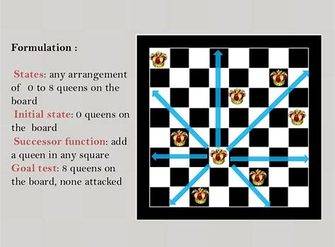
Q(x) Number of checking queens or pairs of queens “potentially’’ hitting each other)

xQxx
Qxxx
xxxQ
xxQx

has two pair violation and all 4 queens violate the constraint

Solution space genotype (1,4,3,2)---permutations of number 1…n
Phenotype {(1,1), (2,4),(3,3), (4,2)}

Why is this genotype brilliant? 1

Page 26
Crossover

234|5671
257|1346
Offsprings
2345716
2573461
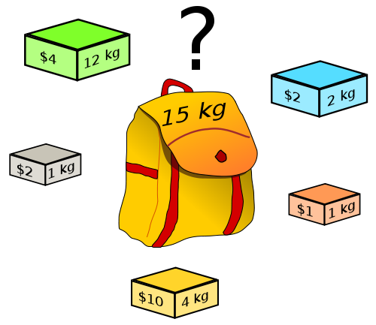

Problem: Pack the knapsack maximizing the reward not violating the

Simpler Problem: Just pack the knapsack
https://en.wikipedia.org/wiki/Knapsack_problem
Chrom0somal represention:

Use binary string genotypes; e.g. 01111
0001|11
1010|10
2 offspring could be:
000111
101010
2 possible phenotypes:

- Just the item in the knack sack
- Pack in sequential order until knapsack is full; e.g. genotype 11111 actually represents the solutions 11100 assuming that adding item 4 and 5 to {1,2,3} violates the weight constraint.

