Group Homework Credit

COSC 4368 Spring 2024

Groups B and C Tasks
Remark: both Groups will present on Mo., Feb. 12!

Group B Task

Design and implement a simulated annealing approach which minimizes the following function:

f_{Frog}(x,y)= x∗cos(sqrt(|x+y+1|))∗sin(sqrt(|y−x+1|)) +
(1+y)∗sin(sqrt(|x+y+1|))∗cos(sqrt(|y−x+1|))

with x,y∈[−512,512]

Assumptions
- You run the simulated annealing algorithm for 8000 steps (step=1,…,8000)
- Assume the neighborhood size is z=5; that is, new solutions will be constructed by the SA implementation by adding random numbers in [-5,+5] to the current solution current=(x,y)
Steps to be Conducted:
- Come up with cooling function, named cool, which computes the probability prop of accepting a downward move, based on step and ΔE: prop= cool,(step, ΔE)
- Implement a SA algorithm using cool,.
- Run the SA algorithm using starting position (444,444), outputting (current,f_{Frog}(current)) every 80 steps (101 outputs)
- Potentially enhance the cool function and repeat step 3! (optional task)
- Assess the performance of your SA algorithm.
- Summarize the challenges in using SA for minimizing f_{Frog}.

Summarize your task findings and present them in appox. 12 minutes during the Feb. 12, 2024 class!

Group C Task

Applying Various Search Strategies to a State Space
Assume that you have the following search graph, where S is the start node and G1 and G2 are goal nodes. Arcs are labeled with the cost of traversing them and the estimated cost to a goal is reported inside nodes. Apply the search strategies listed below to the search graph:, (a) indicate which goal state is reached if any, (b) list, in order, the states expanded, and (c) show the final contents of the OPEN and CLOSED lists. (Recall that a state is expanded when it is removed from the OPEN list.) When there is a tie with respect to which node has to be expanded next, nodes should be expanded in alphabetical order. The used search strategies include;
- depth-first
- best-first (using f = h)
- A* (using f = g + h)

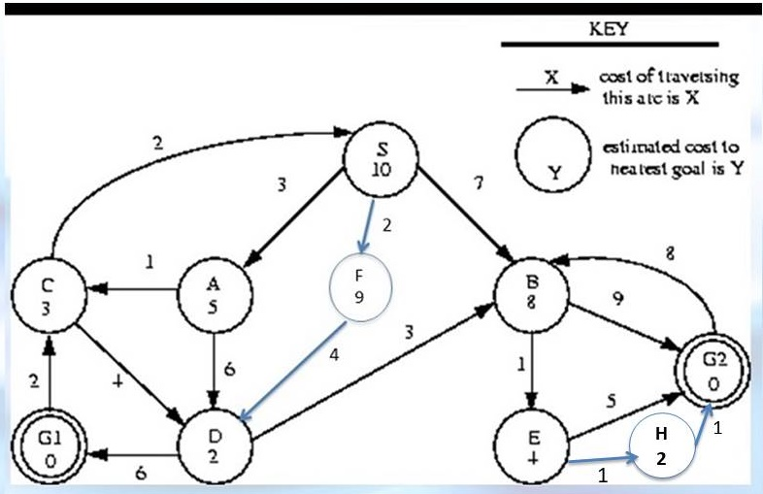
3

General Pseudocode for Depth/Breath/Best First Search
OPEN = { startNode } // Nodes under consideration.
CLOSED = { } // Nodes we're done with.

while OPEN is not empty
{
remove an item from OPEN based on search strategy used
- call it X

if goalState?(X) return the solution found

otherwise // Expand node X.
{
1) add X to CLOSED
2) generate the immediate neighbors (ie, children of X)
3) eliminate those children already in OPEN or CLOSED
4) add REMAINING children to OPEN
}
}
return FAILURE // Failed if OPEN exhausted without a goal being found.

General Pseudocode for SMA*/A*Search
OPEN = { startNode } // Nodes under consideration.
CLOSED = { } // Nodes we're done with.

while OPEN is not empty
{
remove an item from OPEN based on search strategy used
- call it X

if goalState?(X) return the solution found

otherwise // Expand node X.
{
1) add X to CLOSED
2) generate the immediate neighbors (ie, children of X)
3) add all children to OPEN
}
}
return FAILURE // Failed if OPEN exhausted without a goal being found.Submission Guidelines:

The solution needs to be summarized as follows:

GOAL Reached first
Expanded states sequence
OPEN List at the end
CLOSE List at the end

