Simulating the Performance of Parallel Applications on Desktop Grids

A Thesis
Presented to
the Faculty of the Department of Computer Science
University of Houston

In Partial Fulfillment
of the Requirements for the Degree
Master of Science

By
Girish Nandagudi
August 2009
Simulating the Performance of Parallel Applications on Desktop Grids

Girish Nandagudi

APPROVED:

Dr. Jaspal Subhlok
Department of Computer Science

Dr. Rong Zheng
Department of Computer Science

Dr. Yuhua Chen
Department of Electrical & Computer Engineering

Dean, College of Natural Sciences and Mathematics
Acknowledgements
I am very much grateful to Dr. Jaspal Subhlok for his guidance, encouragement, and support during this work. He kept me motivated by his insightful suggestions for solving many problems, which would otherwise seem impossible to solve. I would not be able to complete my work in time without his guidance and encouragement.
I would like to express my deepest gratitude towards Dr. Edgar Gabriel, who gave me innumerable suggestions regarding MPI and helped me many times to solve difficult problems in this research.
I would like to thank Dr. Rong Zheng for her valuable suggestions and guidance during the course of this work. I would like to thank Judit Gimenez and her team in Barcelona Super Computing for helping me to solve numerous problems related to Dimemas and for their valuable inputs. I express my sincere gratitude towards Dr. Yuhua Chen for agreeing to be a part of my thesis committee.
I thank the National Science Foundation (NSF) for partially supporting this work under NSF’s Computer Systems Research program under awards CNS-0834750 and CNS-0410797.
I would like to thank my roommates Anup, Hrishikesh, Tusheet, and Vikram for their support and encouragement during this work. They truly did make this journey seem like it is fun!
Finally, I would like to thank my parents, my brother, my friends, and relatives for encouraging me in this work and for being there for me when I needed them the most. I dedicate this research to all of them!
Simulating the Performance of Parallel Applications on Desktop Grids

An Abstract of a Thesis
Presented to
the Faculty of the Department of Computer Science
University of Houston

In Partial Fulfillment
of the Requirements for the Degree
Master of Science

By
Girish Nandagudi
August 2009
Abstract
In this work, we simulate the performance of parallel applications on desktop grids. We provide a framework to effectively estimate the effects of varying bandwidth, latency and node failure on the performance of parallel applications. The framework is used to estimate the usage potential of desktop grids to run parallel applications and is instrumental in knowing what kind of applications perform reasonably well in such computing environments.
The experiments have been conducted using NAS parallel benchmarks, by collecting the trace of their execution on Shark cluster, which is a collection of 29 nodes connected through a 96 port 4xInfiniBand switch, and simulating their performance using Dimemas, which is a performance simulation tool. The types of network simulated include actual bandwidth and latency measurements taken in different labs at University of Houston.
The simulation results for actual bandwidth and latency measurements show us that on average, the applications perform 2x, 4x and 6x slower in the minimum, average and maximum case when deployed on desktop grids consisting of machines in a single lab compared to Shark cluster, which is a dedicated parallel machine. Parallel benchmarks perform faster by 2x, 3x and 5x in the minimum, average and maximum case on machines in a single lab environment compared to being deployed on machines in distributed labs connected through WAN/intranet. The results show that desktop grids are a suitable platform to deploy and run parallel applications by incurring minimal performance degradation.
Table of Contents

Chapter 1. Introduction 1
1.1 Introduction 1
1.2 Related Work 3
1.2 Thesis Outline 5
Chapter 2. Desktop Grids 6
2.1 What are Desktop Grids? 6
2.2 Characteristics and Properties of Desktop Grids 6
2.2.1 Architecture 6
2.3 Desktop Grids and Parallel Machines – A Comparison 8
2.4 Why Desktop Grids? 9
2.4.1 Suitable Applications and their Performance Estimation 10
2.5 Limitations of Desktop Grids 11
2.5.1 Vulnerability to Failure 12
2.5.2 Soft and Hard Failures 13
2.5.3 Implications of Failure on the Parallel Application 13
2.5.4 What is the Solution? 14
Chapter 3. Fault Tolerance in Desktop Grids 15
3.1 What is Fault Tolerance? 15
3.2 Fault Tolerance Techniques 15
3.2.1 Checkpoint/Restart 15
3.2.1.1 Global Checkpointing 16
3.2.1.2 Message Log 17
3.2.1.3 Parameters Affecting the Performance of Checkpointing Systems 18
3.2.2 Replication 18
3.3 Pros and Cons of Fault Tolerance 19
3.4 Measuring the Fault Tolerance Overhead 21
Chapter 4. Simulation Procedure 22
4.1 Simulation objective 22
4.2 Tools 22
4.2.1 MPIDTRACE 22
4.2.2 MPI2TRF 23
4.2.3 Dimemas 23
4.3 Network Configurations 23
4.4 Experimental setup and simulation 24
4.4.1 Simulation Steps 25
4.4.2 Simulation Summary 32
Chapter 5. Simulation and Results 34
5.1 Validation of Simulation Results 34
5.2 Characteristics of NAS benchmarks 35
5.3 Desktops over Internet (DOI) Configuration 38
5.3.1 CG Benchmark 38
5.3.2 FT Benchmark 40
5.3.3 IS Benchmark 41
5.3.4 SP Benchmark 42
5.3.5 Comparison of all the Benchmarks 43
5.4 Collection of Networked Computers (CNC) Configuration 44
5.4.1 CG Benchmark 44
5.4.2 FT Benchmark 46
5.4.3 IS Benchmark 47
5.4.4 SP Benchmark 48
5.4.5 Comparison of all the Benchmarks 49
5.4.6 α and β Setup 51
5.5 Comparison of DOI and CNC Configurations 53
5.5.1 CNC versus HPSL and Shark Cluster 53
5.5.2 DOI versus CNC using Synthetic Bandwidth and Latency Values 56
5.5.2.1 CG Benchmark 56
5.5.2.2 FT Benchmark 57
5.5.2.3 IS Benchmark 58
5.5.2.4 SP Benchmark 59
5.6 Summary 59
Chapter 6. Modeling the Performance with Failure 61
6.1 Terms 61
6.2 The failure model 62
6.3 Failure Statistics 63
6.3.1 Effects of MTBF on T/T_{s} 63
6.3.2 Effects of T_{d} on T/T_{s} 65
6.3.3 Effects of Checkpoint Interval (X) on T/Ts 66
6.3.4 Effects of Bandwidth on T/T_{s} 68
Chapter 7. Conclusion 70
References 72
Appendix 74

List of Figures
Figure 1. Desktop Grid 6
Figure 2. Replication 19
Figure 3. Desktops over Internet (DOI) Config 24
Figure 4. Collection of Networked Computers (CNC) Config 24
Figure 5. Simulation Steps 25
Figure 6. Initial Machine Configuration in Dimemas 27
Figure 7. Target System Configuration in Dimemas 28
Figure 8. WAN Configuration in Dimemas 28
Figure 9. Environment Configuration in Dimemas 29
Figure 10. Node Information in Dimemas 30
Figure 11. Dimemas Simulator 31
Figure 12. Simulation Procedure 32
Figure 13. Communication Pattern for NAS CG (16 processors) 37

List of Graphs
Graph 1. Validation of Dimemas’ Results 35
Graph 2. Percentage computation/communication time for NAS class B benchmarks for a bandwidth of 128 MBps and a latency of 0.05 milliseconds 36
Graph 3. Total execution time for NAS CG Class B benchmark 38
Graph 4. Percentage increase in total execution time for NAS CG Class B benchmark in comparison to execution time on a bandwidth of 128 MBps and a latency of 0.05 milliseconds 39
Graph 5. Total execution time for NAS FT Class B benchmark 40
Graph 6. Percentage increase in total execution time for NAS FT Class B benchmark in comparison to execution time on a bandwidth of 128 MBps and a latency of 0.05 milliseconds 40
Graph 7. Total execution time for NAS IS Class B benchmark 41
Graph 8. Percentage increase in total execution time for NAS IS Class B benchmark in comparison to execution time on a bandwidth of 128 MBps and a latency of 0.05 milliseconds 41
Graph 9. Total execution time for NAS SP Class B benchmark 42
Graph 10. Percentage increase in total execution time for NAS SP Class B benchmark in comparison to execution time on a bandwidth of 128 MBps and a latency of 0.05 milliseconds 42
Graph 11. Percentage increase in total execution time for NAS Class B benchmarks. Assumed values: latency=0.05 milliseconds; bandwidth={12.5, 1.25} MBps. Comparison with bandwidth=128 MBps 43
Graph 12. Percentage increase in total execution time for NAS Class B benchmarks. Assumed values: bandwidth=1.25 MBps; latency={1, 10} milliseconds. Comparison with latency=0.1 milliseconds 43
Graph 13. Total execution time for NAS CG Class B benchmark 44
Graph 14. Percentage increase in total execution time for NAS CG Class B benchmark in comparison to execution time on a bandwidth of 128 MBps and a latency of 0.05 milliseconds 45
Graph 15. Total execution time for NAS FT Class B benchmark 46
Graph 16. Percentage increase in total execution time for NAS FT Class B benchmark in comparison to execution time on a bandwidth of 128 MBps and a latency of 0.05 milliseconds 46
Graph 17. Total execution time for NAS IS Class B benchmark 47
Graph 18. Percentage increase in total execution time for NAS IS Class B benchmark in comparison to execution time on a bandwidth of 128 MBps and a latency of 0.05 milliseconds 47
Graph 19. Total execution time for NAS SP Class B benchmark 48
Graph 20. Percentage increase in total execution time for NAS SP Class B benchmark in comparison to execution time on a bandwidth of 128 MBps and a latency of 0.05 milliseconds 48
Graph 21. Percentage increase in total execution time for NAS Class B benchmarks. Assumed values: latency=0.05 milliseconds; bandwidth={12.5, 1.25} MBps. Comparison with bandwidth=128 MBps 49
Graph 22. Percentage increase in total execution time for NAS Class B benchmarks. Assumed values: bandwidth=1.25 MBps; latency={1, 10} milliseconds. Comparison with latency=0.1 milliseconds 50
Graph 23. Execution times for NAS Class B benchmarks on α and β setup. α setup: LAN: 12.5 MBps and 0.1 milliseconds; WAN: 1.25 MBps and 1 millisecond. β setup: WAN and LAN: 1.25 MBps and 1 millisecond 52
Graph 24. Percentage increase in execution times (WAN and Lan:β over WAN: β, LAN: α) for NAS Class B benchmarks on α and β setup. α setup: LAN: 12.5 MBps and 0.1 milliseconds; WAN: 1.25 MBps and 1 millisecond. β setup: WAN and LAN: 1.25 MBps and 1 millisecond 52
Graph 25. Execution time for NAS Class B benchmarks on CNC config, DOI config and Shark Cluster 54
Graph 26. Percentage increase in total execution time for NAS Class B benchmarks – CNC config and HPSL versus Shark cluster 55
Graph 27. Percentage increase in total execution time for NAS CG benchmark – CNC config compared to DOI config 56
Graph 28. Percentage increase in total execution time for NAS FT benchmark – CNC config compared to DOI config 57
Graph 29. Percentage increase in total execution time for NAS IS benchmark – CNC config compared to DOI config 58
Graph 30. Percentage increase in total execution time for NAS SP benchmark – CNC config compared to DOI config 59
Graph 31. Effects of MTBF and bandwidth on T/T_{s}. Assumed values: process image size=100 MB; bandwidth={128, 12.5, 1.25} MBps; latency=0.1 milliseconds; t_{d}=15 seconds; t_{initiate_restart}=25 seconds; X=optimal 63
Graph 32. Effects of MTBF and t_{d} on T/T_{s}. Assumed values: process image size=100 MB; bandwidth=1.25 MBps; latency=0.1 milliseconds; t_{d}={600, 300, 60, 10} seconds; t_{initiate_restart}=25 seconds; X=optimal 64
Graph 33. Effects of T_{d} on T/T_{s}. Assumed values: MTBF=24 hours; process image sizes={1024, 512, 100} MB; bandwidth=1.25 MBps; latency=0.1 milliseconds; t_{initiate_restart}=25 seconds; X=optimal 65
Graph 34. Effects of X on T/T_{s}. Assumed values: MTBF=24 hours; process image size=100 MB; bandwidth=1.25 MBps; latency=0.1 milliseconds; t_{d}=15 seconds; t_{initiate_restart}=25 seconds; number of processors=16 66
Graph 35. Effects of X on T/T_{s}. Assumed values: MTBF=24 hours; process image size=100 MB; bandwidth=1.25 MBps; latency=0.1 milliseconds; t_{d}=15 seconds; t_{initiate_restart}=25 seconds; number of processors=32 67
Graph 36. Effects of bandwidth on T/T_{s}. Assumed values: MTBF=24 hours; process image sizes={1024, 512, 100} MB; bandwidth=128 to 0.125 MBps; latency=0.1 milliseconds; t_{d}=15 seconds; t_{initiate_restart}=25 seconds; X=optimal 68

Graph A. 1. Computation and communication percentage for NAS CG Class B benchmark – DOI config 74
Graph A. 2. Computation and communication percentage for NAS FT Class B benchmark – DOI config 74
Graph A. 3. Computation and communication percentage for NAS IS Class B benchmark – DOI config 75
Graph A. 4. Computation and communication percentage for NAS SP Class B benchmark – DOI config 75
Graph A. 5. Computation and communication percentage for NAS CG Class B benchmark – CNC config 76
Graph A. 6. Computation and communication percentage for NAS FT Class B benchmark – CNC config 76
Graph A. 7. Computation and communication percentage for NAS IS Class B benchmark – CNC config 77
Graph A. 8. Computation and communication percentage for NAS SP Class B benchmark – CNC config 77
Graph A. 9. Computation and communication percentage for NAS CG Class B benchmark – α and β setup 78
Graph A. 10. Computation and communication percentage for NAS FT Class B benchmark – α and β setup 78
Graph A. 11. Computation and communication percentage for NAS IS Class B benchmark – α and β setup 79
Graph A. 12. Computation and communication percentage for NAS SP Class B benchmark – α and β setup 79
Graph A. 13. Computation and communication percentage for NAS CG Class B benchmark – CNC versus DOI config 80
Graph A. 14. Computation and communication percentage for NAS FT Class B benchmark – CNC versus DOI config 80
Graph A. 15. Computation and communication percentage for NAS IS Class B benchmark – CNC versus DOI config 81
Graph A. 16. Computation and communication percentage for NAS SP Class B benchmark – CNC versus DOI config 81

List of Tables

Table 1. Comparison between Dedicated Parallel Machines and Desktop Grids 9

Chapter 1. Introduction

1.1 Introduction
Desktop grids offer a suitable environment to deploy and run parallel applications. Since the computing resources are already available, the organization need not invest in clusters, super computers or other high performance computing equipment to solve complex scientific problems and other problems that demand huge computing resources. Desktop grids are readily available, are cheap to maintain, and perform reasonably well when applications that demand high computing powers are deployed on them.
The challenges of deploying and running parallel applications on desktop grids are numerous. The nodes in a desktop grid are inherently volatile, can be heterogeneous, are slower than dedicated parallel machines, and the communication system that connects these computers (or nodes in this context) doesn’t guarantee constant performance and efficiency. The fact that nodes may fail at any time during the program execution throws various design and deployment challenges at the programmer.
To counter the problem of volatility, system designers have come up with various methods such as Checkpoint/Restart, Replication, etc. Checkpoint/Restart [10] is an interesting fault tolerance method wherein the snapshot of the program execution is taken at regular intervals and saved in a stable storage. When a node failure happens, the stored snapshot (or process image) is used to restore the failed process either on the same node or elsewhere. Replication is another interesting fault tolerance mechanism which relies on multiple replicas of the same process running on multiple nodes. The idea of fault tolerance is simple: if one of the nodes fails, the replica node(s) will continue the execution and thus make the system robust up to some level.
With the advantages of fault tolerance, comes a disadvantage in the form of overhead. The fault tolerance overhead is the amount of time an application spends in enforcing fault tolerance policies. Every time a checkpoint-enabled application takes a snapshot of its process image, it incurs an overhead that is unavoidable. So, when implementing fault tolerance, the inevitability of incurring the overhead has to be kept in mind. With each mechanism having its own pros and cons, it is very difficult for a system administrator to judge which one to choose for his/her application unless there is a way to judge which mechanism is best for the application running on a target architecture with different network and computation properties.
Since desktop grids offer an effective platform to deploy and run parallel applications, system designers and application programmers have an alternative platform, other than dedicated parallel machines, to deploy and run parallel applications. However, it has to be taken into account that the nodes on desktop grids are vulnerable to failure, their performance is relatively inferior to the performance offered by dedicated parallel machines and the network interconnect is in most cases slower than the network interconnect in parallel machines. All these factors determine the performance of the parallel applications that are deployed and executed on desktop grids.
In this work, we simulate the performance of parallel applications on desktop grids. We provide a framework to effectively estimate the effects of varying bandwidth, latency and node failure on the performance of parallel applications. The framework is used to estimate the usage potential of desktop grids to run parallel applications and is instrumental in knowing what kind of applications perform reasonably well on such computing environments.
The experiments have been conducted using NAS parallel benchmark, by collecting the trace of their execution on Shark cluster [12] and simulating their performance using Dimemas [2], a performance simulation tool. The types of network simulated are based on actual bandwidth and latency measurements taken in different labs at University of Houston.

1.2 Related Work
Dimemas [2] is a performance analysis tool for parallel applications. It allows the user to predict the performance of a parallel application on simulated target architecture. It reconstructs the time behavior of parallel applications on the target architecture that is configured by the user. The advantage of Dimemas is that the parallel application can be run on any machine, even on a single processor machine to obtain its trace file. The trace file is then used by Dimemas to predict the performance of the parallel application when executed on the configured target system.
Dimemas provides a GUI to attach a trace file to a simulation session and to configure the target system parameters like number of machines, number of processors on each machine, the WAN bandwidth, the latency and other important system parameters that determine the performance of parallel applications.
Once all the inputs are provided, the simulator must be started with appropriate settings to obtain the results. The result format is simple and self-describing. The results include: (a) Overall execution time, (b) Computation time, (c) Communication time, and (d) Speedup.
Dimemas assumes that the target architecture consists of systems that do not fail. In short, Dimemas does not support performance simulation of the parallel application that run on systems that are volatile and vulnerable to failures.
SimBOINC [16] is a simulator for heterogeneous and volatile desktop grids and volunteer computing systems, a simulator designed to test new scheduling strategies in BOINC, and other desktop and volunteer systems. SimBOINC is based on the SimGrid [17] simulation toolkit for simulating distributed and parallel systems, and uses SimGrid to simulate BOINC by implementing a number of required functionalities.
SimBOINC simulates a client-server platform where multiple clients request work from a central server. The characteristics of client (for example, speed, project resource shares, and availability), characteristics of the workload (for example, the projects, the size of each task, and checkpoint frequency), and characteristics of the network connecting the client and server (for example, bandwidth and latency) can all be specified as simulation inputs. Using those inputs, the simulator will execute and produce an output file that gives the values for a number of scheduler performance metrics, such as effective resource shares, and task deadline misses.
EmBOINC [18] (Emulator of BOINC Projects) is a trace-driven emulator that models heterogeneous hosts and their interaction with a real BOINC server. By plugging into a BOINC server, EmBOINC initiates the server's daemons to generate and distribute jobs to the EmBOINC hosts. EmBOINC uses statistical information obtained from real BOINC traces to characterize volatile, heterogeneous, and error-prone hosts. A discrete event simulator is used in EmBOINC to accurately model the hosts' behavior. EmBOINC also interacts with the BOINC daemons and triggers the collection and validation of completed job instances.
Both the simulators (SimBOINC and EmBOINC) discussed so far do not provide a way to simulate the performance of parallel applications on desktop grids. Both the simulators are based on BOINC, which is a middleware system for volunteer and desktop grid system. In this work, we’ll be using Dimemas to simulate the performance of parallel applications on desktop grids since Dimemas supports the kind of architectures similar to desktop grids.

1.2 Thesis Outline
The thesis is organized as follows: Chapter 2 explains in detail the properties of desktop grids. The architectural details have been elaborated to make it clear why a fault tolerance mechanism is needed. Chapter 3 explains all the details of fault tolerance mechanisms used in desktop grids. The two major fault tolerance mechanisms have been compared to show the pros and cons of both. The experimental setup, objective of simulation and the procedure to simulate and estimate the performance of the application is presented in Chapter 4. Chapter 5 presents the simulation results for various settings and for various NAS benchmarks. We investigate the effects of occurrence of failure on the performance of a parallel application in Chapter 6. The work is finally concluded in Chapter 7.

Chapter 2. Desktop Grids

2.1 What are Desktop Grids?
Desktop grids are a type of distributed system in which collection of network of workstations (or computers; machines; nodes) are employed to run applications. Desktop grids are grid computers without administrative restrictions of grid computers. Desktop grids connect all the computers into a flat hierarchy. In this work, the example desktop grid we have chosen is collection of lab machines connected to each other via campus network/internet.

2.2 Characteristics and Properties of Desktop Grids

2.2.1 Architecture
The high level architecture of a desktop grid looks similar to the one shown in Figure 1.
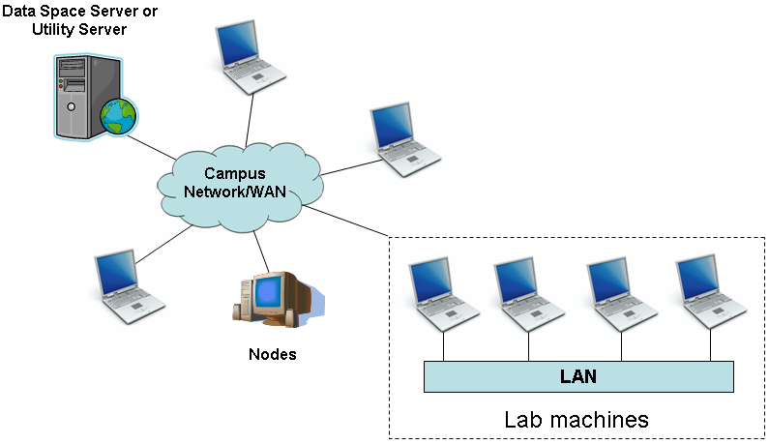
Figure 1. Desktop Grid
The nodes are connected to other nodes/servers in the system through campus network/WAN. The nodes can either communicate with each other directly or through other nodes/servers depending on the middleware used in the system. The design of software/applications that is designed to run on desktop grid must take into account various factors like firewalls, donor user’s security policies etc.
In desktop grid environment, the nodes communicate between each other and other servers through the local area network and/or internet. The communication properties are an important factor to be considered in designing and developing applications to be run on desktop grids. In many cases, the communication in desktop grids is based on the internet, which doesn’t guarantee failure-free service all the time. This has an implicit impact on the application that runs on desktop grids. Some of the applications (for example NAS NPB CG and IS benchmark [7]) are communication intensive and are very sensitive to changes in communication parameters such as bandwidth and latency. Running such programs/applications on desktop grids can therefore yield unexpected results due to the inherent fluctuations in internet Quality of Service (QoS) parameters.
Another important aspect to be considered while designing applications is that most of the nodes in a desktop grid are behind firewalls and are subject to administrative restrictions of the owner. This might make it impossible for other systems and servers to initiate the communication.

2.3 Desktop Grids and Parallel Machines – A Comparison
Desktop grids are different compared to a dedicated parallel machine in many aspects. By Dedicated Parallel Machines, we mean a parallel computer system falling into one of these categories:
- Multicore computing
- Symmetric multiprocessing
- Cluster computing
- Massive parallel processing
- Specialized parallel computers
- Vector processors
The table below summarizes few of the important characteristics unique to each paradigm:
Property | Parallel Machine | Desktop Grids
Processor speed | Normally more than that of home PCs and desktop grids | Comparable to that of home PCs
Memory Model | One of the following:  - Shared memory  - Distributed memory | Distributed memory
Processor-Processor and Processor-Memory Communication | Via  - Shared memory  - Crossbar switch  - Shared bus  - Interconnect network | Processor-Processor  - Via LAN/Internet  Memory-Memory  - NA
Network Interconnect | LAN/High Speed Communication Lines | LAN/Internet
Heterogeneity | Is seldom heterogeneous | Can be heterogeneous
Scalability | Does not scale beyond a certain point | Very much scalable
Accuracy and Efficiency | Fairly accurate and very efficient | Less efficient and can produce inaccurate results
Maintenance | Requires special and dedicated maintenance | Individual owners maintain their own computers
Failure statistics | Fail very rarely | Failure is frequent

Table 1. Comparison between Dedicated Parallel Machines and Desktop Grids

2.4 Why Desktop Grids?
Desktop grids offer a wide range of computing possibilities to users. Since the resources are already available as part of the organization’s computing facility, the cost of procuring and maintaining a dedicated parallel machine can be saved. Also since the nodes are not in the administrative control of the organization that wishes to use the nodes for a project, the organization can do away with the headaches of maintaining such huge number of nodes.
Such computing environment also provides huge computing power to big projects. Since the number of nodes that are available can be huge, applications with high demand for resources can be executed on a desktop grid. One such example of running large applications on a desktop grid is the Condor system [19]. Condor is a specialized workload management system for compute-intensive jobs. The goal of the Condor project is to develop, implement, deploy, and evaluate mechanisms and policies that support High Throughput Computing (HTC) [20] on large collections of computing resources that are distributed in nature.
Another example that uses desktop grids to achieve high computing performance is the BOINC project [4], designed and developed at University of California, Berkeley. BOINC is an open source middleware system and a useful platform for distributed applications in the field of mathematics, medicine, molecular biology, climatology and astrophysics [21]. BOINC uses the idle CPU cycles of the nodes in volunteer computers and desktop grids to solve some of the scientific problems in different fields discussed above.

2.4.1 Suitable Applications and their Performance Estimation
Desktop grids are well suited for different kinds of parallel applications. They are well suited for parallel applications that are embarrassingly parallel in nature, like the NAS EP benchmark and for parallel applications that have significant amount of communication between processes, like NAS CG, SP, etc. Since the number of nodes available in desktop grid environment is generally high, many scientific applications and parallel applications of other nature can be deployed on desktop grids.
Although desktop grids are well suited for many different kinds of parallel applications, deploying and running parallel applications might not always be as efficient as running parallel applications on parallel machines or clusters. Hence, it is very much necessary to estimate the performance of parallel applications before deploying them on desktop grids. There are two basic methods of estimating the performance. The first method is straight forward; deploy and run the application on a set of networked computers forming the desktop grid and estimate the performance by recording the results like total execution time, communication time, etc. The application can then be fine-tuned to suit the environment to achieve maximum efficiency. Although this method is simple, it is not a feasible option. The reason for this is that it is very costly and difficult to test the performance of parallel applications on actual setup and for various scenarios. The second method involves the usage of simulation tools to simulate the performance of parallel applications on desktop grids. In this method, the parallel application performance can be simulated on various virtual models of desktop grids. The advantage of this method is that it is easy to manipulate the dynamic properties of the underlying system architecture, which in turn lets us simulate the performance of parallel applications under various scenarios and for various dynamic states of the system.
In this work, we have chosen simulation method to estimate the performance of parallel applications on desktop grids due to the advantages discussed above.

2.5 Limitations of Desktop Grids
Even after having so many advantages in terms of scalability and ease of availability of computing resources, desktop grid systems have many limitations. But one of the most important and challenging problem to overcome in a desktop grid is their failure rate. In most of the frameworks that utilize desktop grids, the processes belonging to the owner of the node are given higher priority compared to guest processes that run on them. When the user returns to the computer, say by clicking the mouse or hitting a key on the keyboard, the rule is to suspend all guest processes running on the node to leave enough room for host processes to execute. Decreasing the priority of the guest processes is also an option. This design decision leads to a critical problem of losing all the computations done by the guest process till then. Hence, to save the computation results, the guest process will have to be migrated to another node which is available for computation.

2.5.1 Vulnerability to Failure
As discussed above, desktop grids are vulnerable to failures. As mentioned in [8], the average Mean Time Between Failure (MTBF) for nodes in desktop grids is around 5 hours. When we have such a small MTBF per node, situation becomes even worse for the application. The reason for that is when MTBF for one node is M hours, the MTBF for the application becomes M/P hours, where P is the total number of application processes running on P nodes.
The reasons for failure are numerous. The important factors that affect the failure rate of individual nodes in a desktop grid are:
- The host node user’s usage pattern
- Volatility of the underlying network interconnect (LAN/Internet)
- Hardware/Software errors

2.5.2 Soft and Hard Failures
The failures in nodes are classified into two major types (a) soft failure and (b) hard failure. Soft failures are failures from which a node can recover and start/resume the execution of application code. Examples for soft failures include:
- System reboot by the user
- System reclaim by the user, either by clicking the mouse button or by hitting a keyboard key, which causes the system to go from idle state to active state thus forcing the guest process to terminate/suspend operation
- Other system failures that renders the system unusable for a few minutes before resuming operations again
On the other hand, hard failures are failures from which there is no recovery. Examples for hard failures include:
- The user shutting down the system
- The system being disconnected from other nodes in the network due to some network problem
- Other hardware/software failures that renders the system unusable for more than the expected execution time of the application

2.5.3 Implications of Failure on the Parallel Application
As discussed in § 2.5.2, a failure renders the node unusable for some time. No matter what the type of failure is, the parallel application incurs loss of valuable execution/computation time upon failure of any of the several nodes that it is running on.
The loss of computation time has significant impact on application performance. Applications that run on desktop grids can never be expected to finish close to the time required for execution on dedicated parallel machines. Due to very small MTBF, chances are high that a failure can happen every few minutes [8] at the application level, and at that failure rate, the parallel application execution may never reach completion.

2.5.4 What is the Solution?
Since the volatile nature of the nodes cannot be fixed at a reasonable cost, system designers have come up with fault tolerance techniques to significantly reduce the computation time lost due to failures.
Fault tolerance is applied to any system that falls into desktop grid or volunteer computing [3] category. There are numerous ways of achieving fault tolerance. The two important fault tolerance techniques are:
- Checkpoint/Restart
- Replication
In Checkpoint/Restart, the state of the application is saved at regular intervals. When a failure happens, the application execution is resumed using the saved state of the application. In Replication, the idea is to have multiple replicas running the same application process. If one of the replicas fails, the application process will still be executed by other replicas. This way, the parallel application is guaranteed to complete the execution.

Chapter 3. Fault Tolerance in Desktop Grids

3.1 What is Fault Tolerance?
As discussed in the previous chapter, fault tolerance is a technique applied to computing nodes on desktop grids to significantly reduce the effects of frequent failures on the parallel application. Fault tolerance is an important technique that lets the system designers tackle one of the prominent problems in a computing environment where the nodes are inherently volatile.
Fault tolerance mechanism increases the performance of parallel applications running on desktop grids significantly compared to such applications running on desktop grids without fault tolerance mechanisms. This increase in performance incurs some overheads, as we will see in the subsequent sections of this chapter.

3.2 Fault Tolerance Techniques
There are numerous Fault tolerance techniques. The prominent techniques are discussed below in this section.

3.2.1 Checkpoint/Restart
Checkpoint/Restart is a fault tolerance mechanism in which state of the parallel application is saved at regular intervals and used to restore the application back to the last saved state when failure occurs. There are two major ways of checkpointing an application:
- Global checkpointing
- Message Log

3.2.1.1 Global Checkpointing
There are three classes of global checkpointing: uncoordinated, communication induced, and coordinated checkpointing [9].
In uncoordinated checkpointing, message logging is not used. Each process checkpoints its state independently and no further information (like message logs, etc.) is stored on a reliable media. This might lead to a well known situation called the domino effect. The domino effect starts when a process fails and needs to restart. To maintain consistency, other processes that are related to this process might have to be rolled back to a previous state. Since those processes might be dependent on other processes, they might have to be rolled back to a previous state too. This effect will eventually force all the processes to rollback to the original state [10]. Since it is difficult to estimate the cost of a fault and since there is a greater chance of losing the entire execution upon failure, uncoordinated checkpointing is seldom used in practice.
In coordinated checkpointing protocols, all processes checkpoint their state in a coordinated way to make sure that the global system state composed of the set of all process checkpoints is coherent. In case there is a failure and a process had to restart from its previous checkpoint state, there is no need to rollback other related processes to their last checkpoint since the global state is consistent. This method, however, has a major drawback: the cost of coordination between the processes is high and significant overhead is incurred while executing a coordinated checkpoint.
Communication Induced Checkpointing (CIC) tries to combine the uncoordinated and coordinated checkpointing approaches. Based on the uncoordinated approach, it determines the dependency of a process with another process and forces the other process to checkpoint. This way, there is consistency between the states of related processes. While this approach seems to eliminate the need for global checkpointing, it turns out to be inefficient. There are two main drawbacks with this approach: (1) this protocol does not scale well, and (2) the storage requirements and usage frequency are unpredictable and may have same number of checkpoints as that of the coordinated approach [9].

3.2.1.2 Message Log
Message Log protocols, as the name suggests, logs messages as they are sent and received between processes. By doing this, the processes on which a restarting process depends are not required to rollback to the previous checkpoint. Message Log protocols are divided into three classes: optimistic, pessimistic, and casual [9].
Pessimistic protocols ensure that all messages received are logged by the receiving process. For example, MPICH-V [11] is based on this protocol. Reliable processes called channel memories are used to pass messages. Every process sends the message to the channel memory of the receiving process and every receiving process requests its channel memory for message delivery when it needs one. In this way, all the messages are logged and can be retrieved when the process recovers from crash.
Optimistic protocols log receptions eventually, but they do not wait for the messages before sending a message. This makes the optimistic protocol faster compared to the pessimistic protocol. One drawback of this protocol is that there might be some occasional rollback of other processes when a process recovers from crash.
Casual log protocols, as explained in [9], try to conceal the optimistic and the pessimistic approaches. When a process sends a message, it logs it locally and appends information about its past receptions. Thus when a process crashes, it can either retrieve information about its initial execution’s receptions, or no process depends on its precedent computation.

3.2.1.3 Parameters Affecting the Performance of Checkpointing Systems
Now that we know the different methods of checkpointing, we shall discuss the various parameters that affect the performance of a checkpointing system. The parameters are:
- MTBF: has an implicit effect on the performance of checkpointing systems.
- Checkpoint interval: determines the efficiency of the checkpointing system. The checkpoint interval has to be optimal to achieve high performance.
- Time to checkpoint: determines the bulk of the overhead incurred in checkpointing. We get better performance as the checkpointing overhead reduces.
- Time to restart: determines the overhead incurred in restarting an application process on another node when failure happens. This too is responsible for degradation of performance as its value increases.

3.2.2 Replication
Replication, as its name suggests, achieves fault tolerance by replicating the executing process on several nodes. The idea here is if a node fails or crashes during the execution of the process, then one of its replicas will continue the execution without interruption.
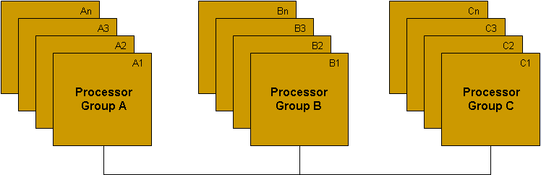
Figure 2. Replication
In Figure 2, the three processor groups collectively execute a parallel application. When one node/processor fails in any of the processor groups, one of the replica nodes will continue the execution without interruption. The desired behavior of the system is to be as transparent to the user as possible.
Several design options arise when dealing with replication. For example, when a node fails and when other nodes get notification of the failure, which replica among the many replicas of the failed node will continue to send/receive messages? This can be easily solved by having the next fastest node to exchange data with other nodes. This means that, even when there is no node failure, there has to be a mechanism to determine the communicating nodes. Similar to this, replication has several design challenges to be overcome in order to make the fault tolerance process as transparent as possible.

3.3 Pros and Cons of Fault Tolerance
Fault tolerance techniques help us in making an application relatively robust when executed on volatile nodes. Without fault tolerance, the application will, in most certainty, fail to complete its execution. The situation becomes worse when the application being deployed is a parallel application since the original MTBF M for one node becomes M/P for P nodes. Hence, fault tolerance is compulsory for applications that are to be deployed on volatile environments such as desktop grids and community grids.
The advantages of fault tolerance techniques have their own price tag. The price we pay here is the additional time consumed in the form of fault tolerance overhead. Since we have to implement fault tolerance algorithms in the application/architecture and since fault tolerance is not implicitly taken care of by the underlying system architecture, we spend some additional time executing those algorithms.
For example, in checkpointing we have to carefully choose the checkpoint interval. Choosing an optimal checkpoint interval has a huge impact on the performance of the application. If the checkpoint interval is too small, the system will spend much time in checkpointing and hence incurs a much greater overhead. On the contrary, if the checkpoint interval is too large, the system spends time executing same sections of code over and over again when it recovers from a crash.
The overheads of fault tolerance also depend on the fault tolerance architecture. For example, there are two main ways of storing the checkpoint image: in the local node and in a checkpoint server. When the checkpoint is stored locally in the node itself, the application is saving the time it needs to transfer the checkpoint image elsewhere. But the disadvantage in this approach is that if that node fails, the application has to be restarted from starting point. Hence, this method has to be avoided. On the other hand, when the checkpoint image is transferred to a checkpoint server, the process can be restarted from the latest checkpoint if a node fails. In this method, the application spends some time in transferring the checkpoint image across the network, which has major contributions in the overhead incurred by the system. However, efficient fault tolerance designs overlap the execution and transfer of the checkpoint image, thereby reducing the checkpoint overhead by a certain percentage.
However, there are still some overheads involved in capturing the checkpoint image, sensing the failure of a node, time taken to restart the process on another node etc., which cannot be avoided completely.

3.4 Measuring the Fault Tolerance Overhead
As discussed in § 3.3, fault tolerance is achieved at a cost of additional execution time for an application. The focus of this work is also to measure the overhead of fault tolerance incurred by parallel applications. We intend to measure the slowdown an application experiences due to fault tolerance mechanism. We use the equations provided in [15] to estimate the slowdown for a parallel application running on desktop grid platform.
The fault tolerance system architecture affects the overhead incurred by the application. In this work, we assume remote storage of checkpoint image. The nodes take snapshots of their process image at regular intervals and transfer this image to a remote checkpoint server. By default, it is assumed that the checkpoint interval is an optimal value returned by the expression for optimal checkpoint interval X in [15]. The default failure detection time is fixed at 15 seconds. We will discuss more about estimating the fault tolerance overhead incurred by parallel applications in chapter 6.

Chapter 4. Simulation Procedure
In this chapter, we shall have a look at the procedure for estimating the performance of parallel applications on different types of architectures in desktop grids. We start by naming the tools we use for simulation, then we will have a look at the two main network configuration types that we are using in our experiments and finally, we will discuss about the steps involved in simulation procedure itself.

4.1 Simulation objective
The objective of simulation procedure discussed in this chapter is to simulate the performance of parallel applications (NAS parallel benchmarks in this case) on desktop grids by creating a virtual model of the real world network, which has all of the characteristics of a real world network plugged in, and to obtain the simulation results for different parallel applications for different combination of network parameters on different varieties of network configurations.

4.2 Tools
Simulation is carried out with the help of the following tools:
- MIPDTRACE – to collect the trace of an application.
- MPI2TRF – to merge the collected trace files into a single trace file.
- Dimemas – a performance simulation tool.

4.2.1 MPIDTRACE
MPIDTRACE is a tracing library provided by Barcelona Super Computing as a part of the Dimemas package [2]. MPIDTRACE program traces the application execution and generates a trace file (one per process) containing the run time details of the application like communication calls, computation blocks, etc. The details like time taken, the source and destination process for communication calls, etc. will be saved in the trace file in a predefined format.

4.2.2 MPI2TRF
The MPI2TRF program is used to merge the trace files generated by the MPIDTRACE program. The MPIDTRACE program generates one trace file per process of the parallel application. The MPI2TRF program merges these trace files into a single file that can be read by Dimemas. The trace file generated by MPI2TRF will be in ASCII format and can be opened and read in any text editor.

4.2.3 Dimemas
Dimemas [2] is a simulator used to simulate the performance of parallel applications on user-defined virtual target architectures. The target architectures defined in Dimemas mock the behavior of real-world architectures they represent. Once the target architecture has been defined, the simulator can be called to simulate the performance of the application whose run time data is captured in the trace file. We shall discuss more about setting up Dimemas for simulation in § 4.3.

4.3 Network Configurations
The simulation is performed on two types of network configurations:
- Desktops over Internet (DOI) config
- Collection of Networked Computers (CNC) config
DOI config is a collection of desktop computers like personal PCs, lab computers, laptops etc. It is assumed that the computers (or nodes in this context) are connected to each other (or can communicate with each other) via a campus network (in case of campus machines) or WAN/internet in case of machines donated by home users to be a part of community grid.
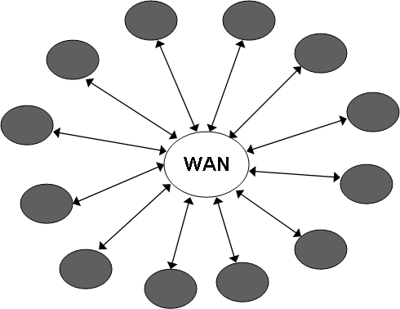
Figure 3. Desktops over Internet (DOI) Config
CNC config is a collection of network of computers, typically many computer labs (with several nodes) connected to each other via WAN/internet. The CNC config is shown in the figure below:
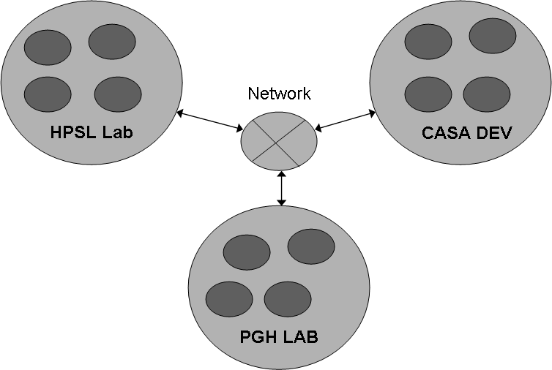
Figure 4. Collection of Networked Computers (CNC) Config

4.4 Experimental setup and simulation
All the simulations were carried out on Shark cluster [12] at Dept. of Computer Science, University of Houston. Shark cluster is a collection of 24 Sun X2100 nodes and 5 Sun X2200 nodes. The Sun X2100 nodes have a 2.2 GHz dual core AMD Opteron processor, a 2 GB main memory unit and a 250 GB disk space. The X2200 nodes have two 2.2 GHz quad core AMD Opteron processors (8 cores total) and an 8 GB main memory unit. The network interconnect of Shark cluster comprises of a 96 port 4xInfiniBand switch and a 48 port Linksys GE switch.

4.4.1 Simulation Steps
The steps involved in simulation are shown below:

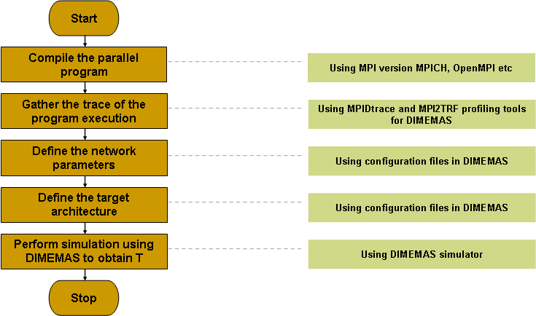

Figure 5. Simulation Steps
First, we compile the parallel program by linking it to mpidtrace library files. The compilations were done on Shark cluster. Next, we execute the program on Shark cluster to gather the trace file of the program. This is done using the MPIDTRACE program in conjunction with mpirun command. The command to gather the trace is:

$ mpidtrace mpirun –np 16 –machinefile hostfile ./cg.B.16
Once the above command is issued, the cluster will execute the parallel program (NAS CG Class B benchmark in this case) on 16 nodes that are listed in the file hostfile. Note that before issuing such a command, the nodes have to be allocated in Shark using the command salloc. For more information on how to use Shark cluster, see the documentations in [12]. After the application successfully executes, we can merge the raw trace files (16 in this case) using the MPI2TRF command. The command to merge the files is:

$ mpi2trf *.mpit –o cg.B.16.trf

This command creates a file that can be read by Dimemas to perform the simulation. The next step in the process is to create the desired target network using Dimemas. To know more about the setup and configuration of Dimemas, please see the documentation provided in [2].
Once we have the trace file in hand, we start Dimemas to begin the simulation procedure. The first step to do is to open the trace file and assign it to the initial machine configuration. This can be done by clicking on the Configuration->Initial Machine menu in Dimemas GUI. The following window opens up:
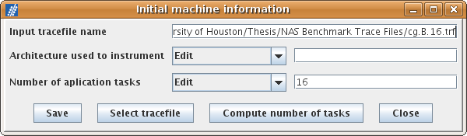
Figure 6. Initial Machine Configuration in Dimemas
As seen in Figure 6, the trace file has to be selected and then the number of tasks parameter has to be calculated. Once everything is done, the configuration has to be saved. The next step is to define the target system architecture. This can be done by clicking on the Configuration->Target Architecture menu. The target system architecture window can be used to define the target network and node properties. As seen in Figure 7, the properties for WAN, machine, node, and mapping information can be edited and configured. To configure each individual group of information, we can open a separate window by clicking on the Config! button. The WAN parameters can be configures in the window shown in Figure 8. The different parameters like number of machines, bandwidth, function of traffic, communication group model, number of dedicated connections, etc. can be input in this window and saved.
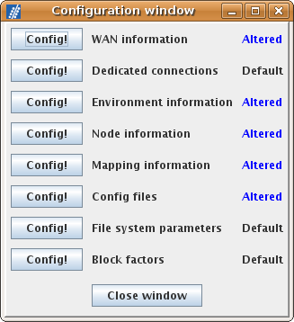
Figure 7. Target System Configuration in Dimemas

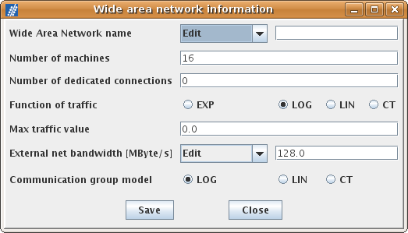
Figure 8. WAN Configuration in Dimemas
Figure 9 shows the environment information (for DOI network in this example). This window can be used to configure the properties of several machines that are connected to each other via WAN. Note that the number of machines parameter is specified in WAN configuration as shown in Figure 8.
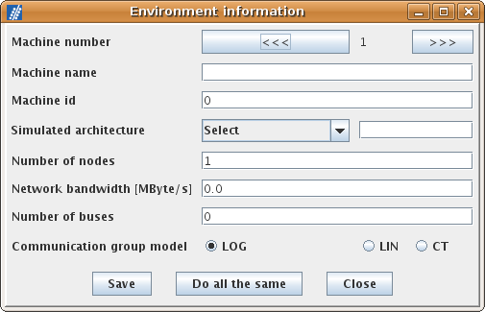
Figure 9. Environment Configuration in Dimemas
Here the assumption is that n machines are connected to each other via WAN and those n machines contain m (m>0) nodes within themselves. The internal network architecture is assumed to be similar to that of LAN. Using the environment information window, we can configure the machine level properties. As seen in the picture, we can input different parameters like number of nodes, machine name, number of buses, network bandwidth etc. We have to configure the parameters for all the n machines.
Dimemas allows us to configure the properties of individual nodes too. In Figure 10, we see that we can input different parameters like relative processor speed (compared to the source machine Shark’s nodes), local latency, remote latency, external net latency, number of processors, etc. We have to provide these parameters for all the m nodes in the machine.
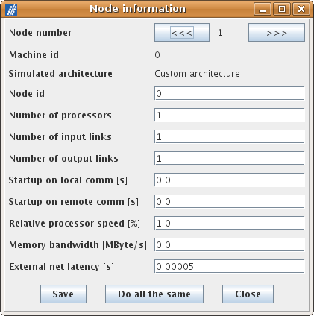
Figure 10. Node Information in Dimemas
Once the information about WAN, the machine and individual nodes have been saved, the mapping of processes to individual nodes must be saved. This can be done by using the Mapping information window. The communication properties too can be saved using the Config files window.
Once all the information has been saved, the final process is simulation. Dimemas simulates the performance of the parallel application using the trace file and the target system configuration we provide. To start the simulation, Dimemas simulator has to be started using the menu Simulator->Dimemas. Figure 11 shows the window for Dimemas simulator.
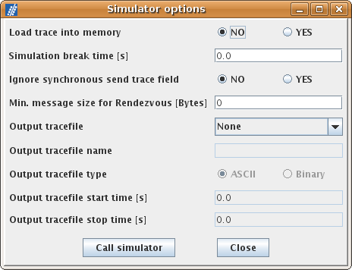
Figure 11. Dimemas Simulator
The simulator window contains a few options for simulation. The simulator provides plain textual output. It can also be configured to provide an output trace file for Paraver [13] simulation. Once all the parameters have been saved, the simulator can be started by using the Call simulator command button. This will start the simulator and the result window will be displayed in a few seconds.

4.4.2 Simulation Summary
The simulation procedure is summarized in Figure 12.

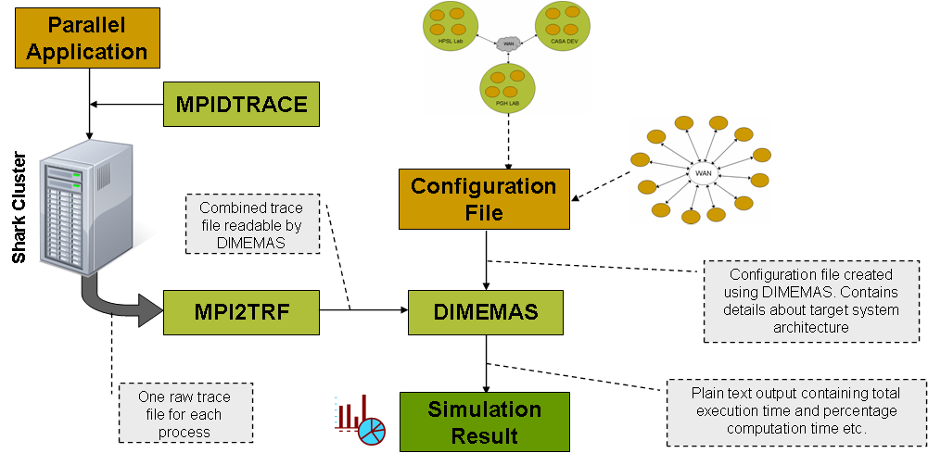
Figure 12. Simulation Procedure
The simulation procedure depicted in Figure 12 can be summarized as follows:
- Attach the mpidtrace library to the parallel application and compile it.
- Run the application and gather its trace using the MPIDTRACE tool.
- Merge the trace files thus obtained using the MPI2TRF tool.
- Start Dimemas simulator GUI
  - Select the trace file for the initial machine configuration; compute the number of tasks and save the data.
  - Configure the target architecture using the Target Architecture menu. Specify values for WAN bandwidth, LAN bandwidth, latency values, number of nodes, processing mapping and communication config values.
  - Save the configured values in a file for later use.
- Start Dimemas simulator to get the final results.
- The important information displayed in the result window are:
  - Total (simulated) execution time of the application on the specified target architecture.
  - Percentage computation time.
  - Total number of messages.

Chapter 5. Simulation and Results
This section provides the simulation results along with the analysis of result obtained. The different configurations mentioned in the experimental setup have been used to obtain the results.

5.1 Validation of Simulation Results
In order to make sure that the results Dimemas is producing are within the allowed limits, we validated the results against actual runs on Shark cluster. The procedure followed is as follows:
- Get the trace file for different benchmarks on Shark cluster.
- Record the actual execution time of the benchmarks on Shark cluster.
- Setup a configuration on Dimemas that matches the configuration of Shark cluster.
- Run the simulation using the trace files in Dimemas.
- Compare the results thus obtained.
This procedure basically helps us in knowing the difference between the execution times of different benchmarks on Dimemas and on Shark cluster.

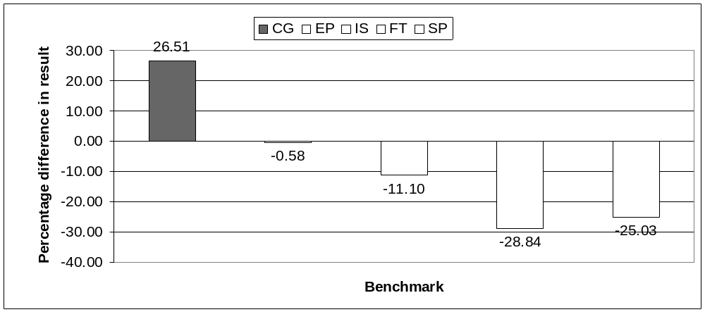
Graph 1. Validation of Dimemas’ Results
Graph 1 shows the difference in results between Dimemas simulation and execution on Shark cluster. Note that when the result is negative, simulated execution time is less than the actual execution time on Shark cluster and vice versa. The difference in results for NAS EP benchmark is almost equal to 0 and for rest of the benchmarks; it is between 26.51% to -28.84%. This means that Dimemas simulates the execution almost perfectly when there is no communication involved (EP) and that there is always certain quantity of error induced in measurement when the application has come communication in it.
In Graph 1, simulation result shows the execution time for CG as being 26.51% slower compared to actual execution. Similarly, the simulation result for execution time faster by 11.10%, 28.84% and 25.03% for IS, FT and SP respectively.

5.2 Characteristics of NAS benchmarks
The four NAS benchmarks that we are using in this experiment have unique characteristics of their own in terms of communication percentage, communication pattern, etc. The benchmarks’ behavior too depends on the network speed and some of the benchmarks are sensitive to changes in bandwidth while others are more sensitive to changes in latency.
Before getting into details about the performance of benchmarks on different configurations and varying network speeds, we shall take a quick look at the performance/characteristics of the benchmarks when the network speed is high at a bandwidth of 128 MBps and a latency of 0.05 milliseconds. Graph 2 shows the communication and computation percentage break up of different benchmarks.
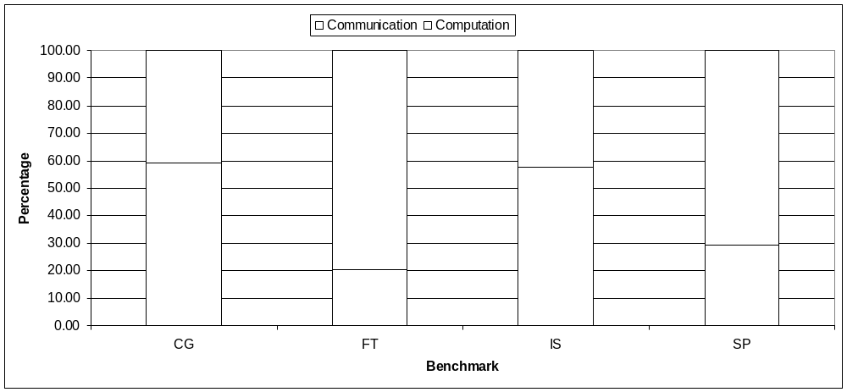
Graph 2. Percentage computation/communication time for NAS class B benchmarks for a bandwidth of 128 MBps and a latency of 0.05 milliseconds
As seen in the graph, CG and IS benchmarks are communication intensive, while FT and SP spend less time sending messages when the network speed is high (≥ 125 MBps). CG benchmark’s communication pattern for 16 processors is a CG stencil 8x2 grid [14] as shown in the figure below:

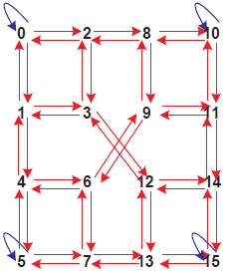
Figure 13. Communication Pattern for NAS CG (16 processors)
Figure 13 clearly shows that CG is communication intensive. Even though the number of communications is not as much as in the case of all-to-all communication pattern, CG’s communication pattern is complex enough to make it sensitive to network speed.
IS and FT benchmarks have all-to-all communication pattern. Simulation results show us that IS benchmark generates about 6.32 and 1.40 messages per second for Class B configuration on 16 and 32 processors on Shark cluster. FT benchmark, on the other hand generates 0.94 and 1.8 messages per second for the same configuration described above. SP benchmark seems to have little communication percentage compared to all other benchmarks when the network speed is high. SP benchmark has a stencil communication pattern [14].
With the performance characteristics of the benchmarks at high network speed in sight, we shall discuss more about the dynamic performance characteristics of the benchmarks when the network speed varies from fastest to slowest case in the next section.

5.3 Desktops over Internet (DOI) Configuration
The set of experiments carried out on DOI configuration are presented below. The results are shown for NAS Class B benchmarks CG, FT, IS, and SP. In these experiments, we have chosen a range of (synthetic) bandwidth and latency values for the network. The bandwidth ranges from 128 MBps to 0.125 MBps and latency ranges from 0.05 milliseconds to 10 milliseconds.

5.3.1 CG Benchmark
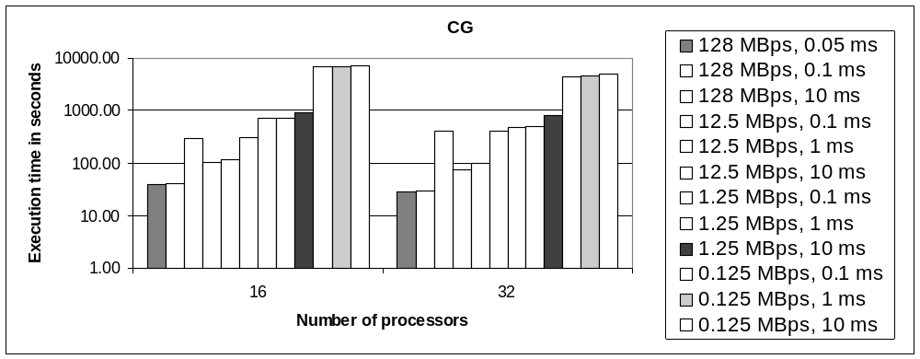
Graph 3. Total execution time for NAS CG Class B benchmark
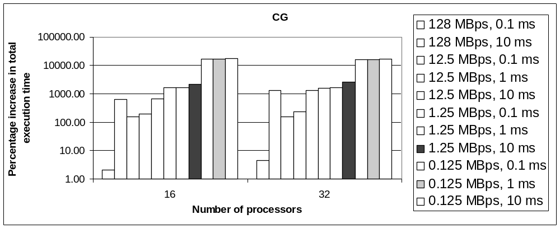
Graph 4. Percentage increase in total execution time for NAS CG Class B benchmark in comparison to execution time on a bandwidth of 128 MBps and a latency of 0.05 milliseconds
Graph 3 shows the total execution time for CG class B benchmark. As it is evident in the graph, CG is sensitive to changes in latency when executed on DOI config. It must also be noted that at low bandwidth, changes in latency has very little effect on the execution time. The benchmark’s sensitivity to latency is reflected in the computation and communication time breakup graph (Graph A.1) too. As the percentage communication time increases, the percentage computation time decreases relatively.
Graph 4 shows the percentage increase in execution time relative to the execution time with the best bandwidth/latency values. Here the execution times are compared to the execution time obtained with a bandwidth of 128 MBps (1 gigabits per second) and a latency of about 0.05 milliseconds.

5.3.2 FT Benchmark
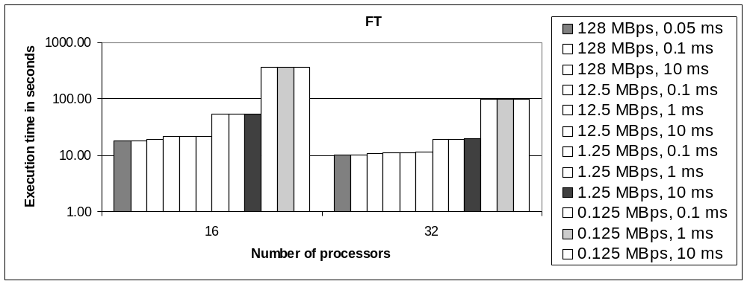
Graph 5. Total execution time for NAS FT Class B benchmark
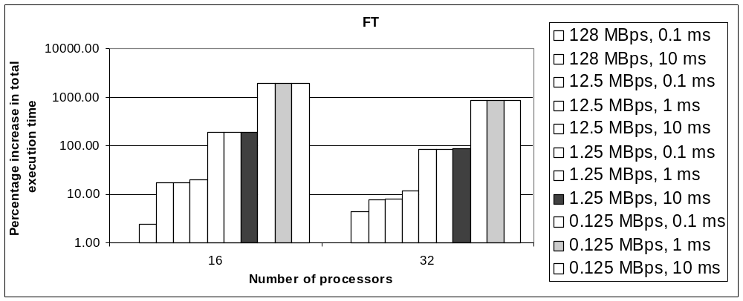
Graph 6. Percentage increase in total execution time for NAS FT Class B benchmark in comparison to execution time on a bandwidth of 128 MBps and a latency of 0.05 milliseconds
As shown in Graph 5, NAS FT Class B benchmark is clearly sensitive to changes in bandwidth. Changes in latency seem to have very little effect on the total execution time of the benchmark. This behavior is mostly due to the all-to-all communication pattern of FT benchmark.
The computation time for FT dominates the total execution time when the network speed is high (Graph A.2). But as the network speed decreases, the benchmark spends more time sending messages (of all-to-all type).

5.3.3 IS Benchmark
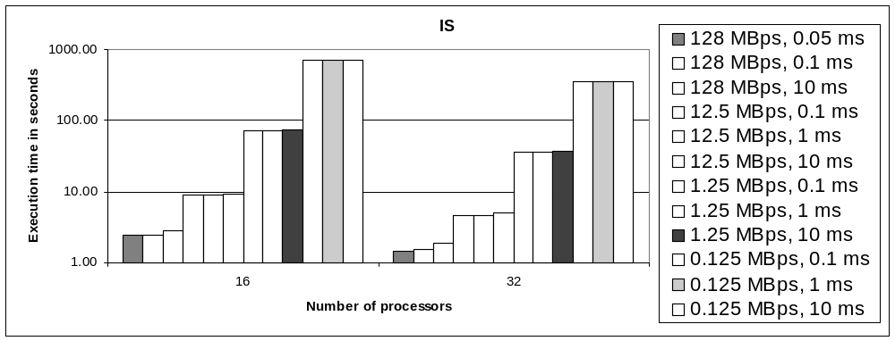
Graph 7. Total execution time for NAS IS Class B benchmark
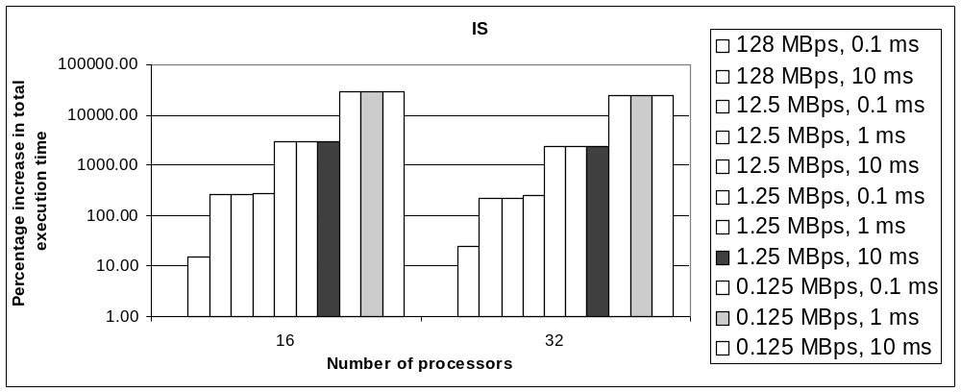
Graph 8. Percentage increase in total execution time for NAS IS Class B benchmark in comparison to execution time on a bandwidth of 128 MBps and a latency of 0.05 milliseconds
Similar to FT, NAS IS benchmark is sensitive to changes in bandwidth due to its all-to-all communication type. The computation and communication time breakup for IS is similar to that of FT, but the percentage varies. IS seems to take more communication time compared to FT at all network speeds.

5.3.4 SP Benchmark
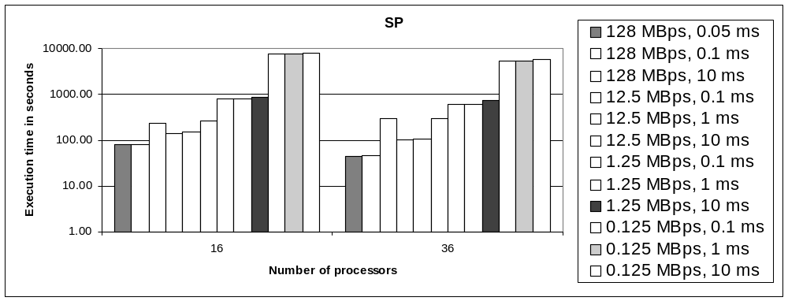
Graph 9. Total execution time for NAS SP Class B benchmark
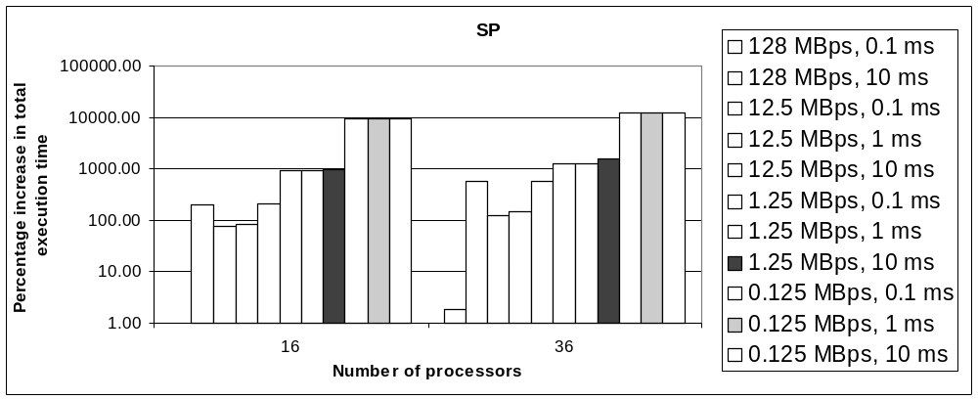
Graph 10. Percentage increase in total execution time for NAS SP Class B benchmark in comparison to execution time on a bandwidth of 128 MBps and a latency of 0.05 milliseconds
NAS SP benchmark, as clearly depicted in graphs 9 and 10, is sensitive to changes in latency. It can be noted in Graph 10 that the benchmark’s execution time increases noticeably when the latency is set to 10 ms.

5.3.5 Comparison of all the Benchmarks
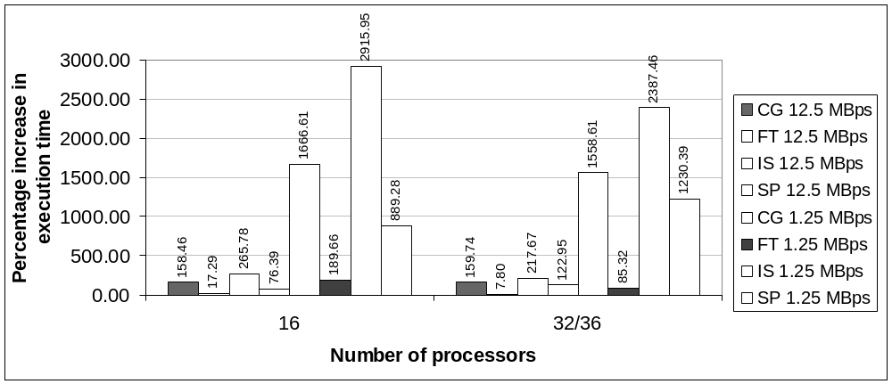
Graph 11. Percentage increase in total execution time for NAS Class B benchmarks. Assumed values: latency=0.05 milliseconds; bandwidth={12.5, 1.25} MBps. Comparison with bandwidth=128 MBps
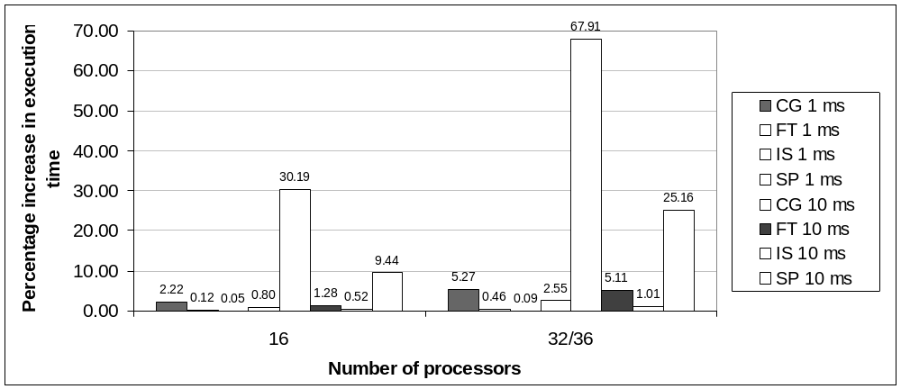
Graph 12. Percentage increase in total execution time for NAS Class B benchmarks. Assumed values: bandwidth=1.25 MBps; latency={1, 10} milliseconds. Comparison with latency=0.1 milliseconds
Graph 11 shows the percentage increase in execution time for all the benchmarks. Here, the execution times obtained with bandwidth values of 12.5 and 1.25 MBps are compared with the execution time obtained on gigabit Ethernet (128 MBps). The latency is fixed at 0.1 milliseconds. The graph clearly shows that IS benchmark is the worst affected by changes in bandwidth, followed by CG, SP and FT. The reason for this is due to the all-to-all communication pattern of IS benchmark. CG is more sensitive to latency, but when there is a decrease in bandwidth, CG is worst affected. The relative percentage decrease in execution speed is more in CG (only next to IS).
Graph 12 shows the sensitivity of the benchmarks to latency. Here, the bandwidth is fixed at 1.25 MBps and comparisons are made for various latency values against a latency value of 0.1 milliseconds. The graph clearly shows that CG benchmark is the worst affected by changes in latency.

5.4 Collection of Networked Computers (CNC) Configuration
The set of experiments carried out on CNC configuration are presented below. The results are shown for NAS Class B benchmarks CG, FT, IS and SP.

5.4.1 CG Benchmark
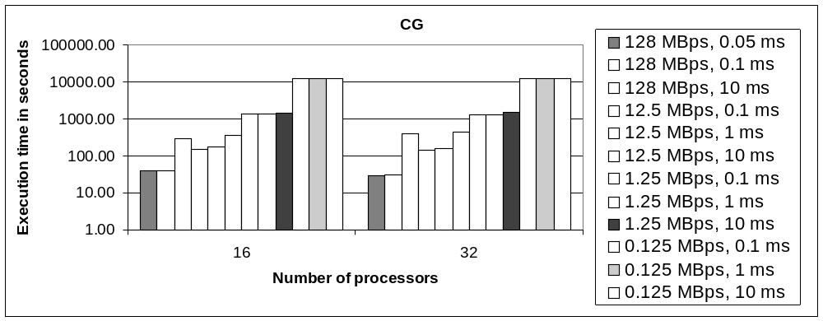
Graph 13. Total execution time for NAS CG Class B benchmark

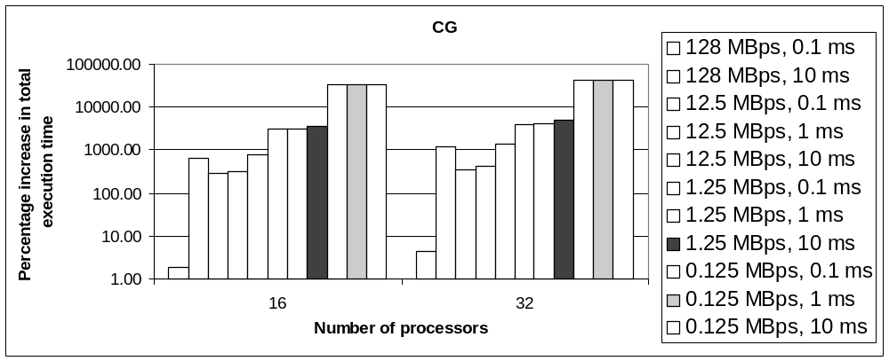
Graph 14. Percentage increase in total execution time for NAS CG Class B benchmark in comparison to execution time on a bandwidth of 128 MBps and a latency of 0.05 milliseconds
Graph 13 shows the total execution time for CG Class B benchmark. As it is evident in the graph, CG is sensitive to changes in latency when executed on CNC config (similar to DOI). It must also be noted that at low bandwidth, changes in latency has very little effect on the execution time.
The benchmark’s sensitivity to latency is reflected in the computation and communication time breakup graph too (Graph A.5). As the percentage communication time increases, the percentage computation time decreases relatively.

5.4.2 FT Benchmark
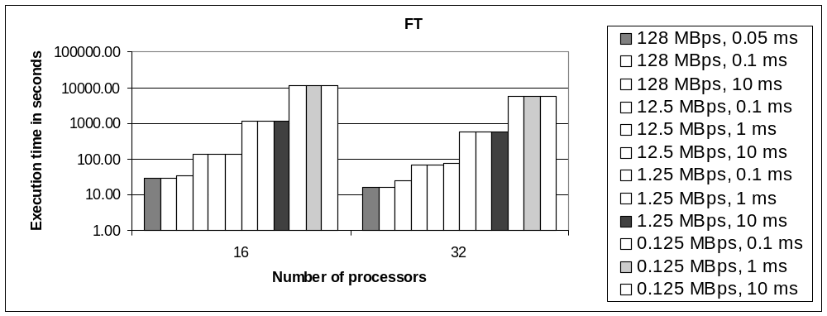
Graph 15. Total execution time for NAS FT Class B benchmark
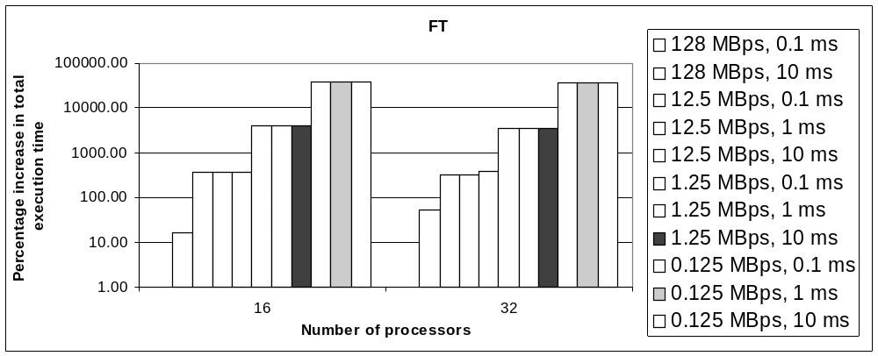
Graph 16. Percentage increase in total execution time for NAS FT Class B benchmark in comparison to execution time on a bandwidth of 128 MBps and a latency of 0.05 milliseconds
As shown in Graph 15, NAS FT Class B benchmark is clearly sensitive to changes in bandwidth. Changes in latency seem to have very little effect on the total execution time of the benchmark. This behavior is mostly due to the all-to-all communication pattern of FT benchmark.
As shown in Graph A.6, the average computation and communication times for FT are almost equal when the network speed is high. But, as the network speed decreases, the benchmark spends more time sending messages (of all-to-all type).

5.4.3 IS Benchmark
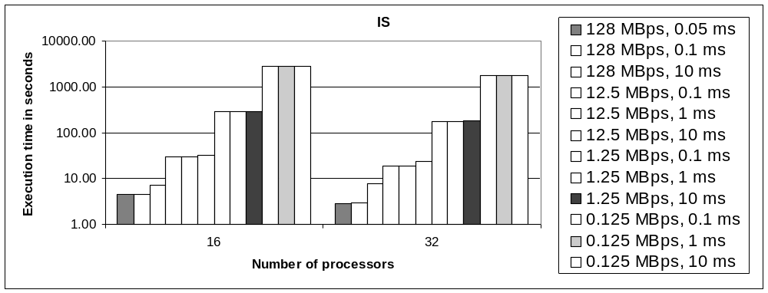
Graph 17. Total execution time for NAS IS Class B benchmark
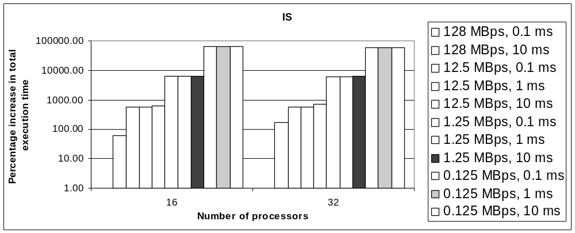
Graph 18. Percentage increase in total execution time for NAS IS Class B benchmark in comparison to execution time on a bandwidth of 128 MBps and a latency of 0.05 milliseconds

Similar to FT, NAS IS benchmark is sensitive to changes in bandwidth due to its all-to-all communication type. The computation and communication time breakup for IS is similar to that of FT, but the percentage varies. IS seems to take more communication time compared to FT at all network speeds.

5.4.4 SP Benchmark
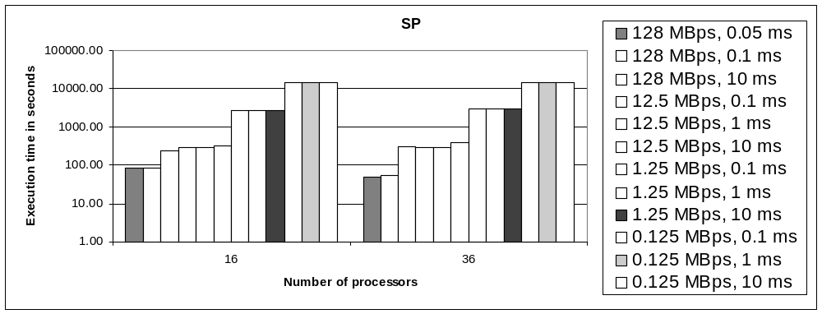
Graph 19. Total execution time for NAS SP Class B benchmark
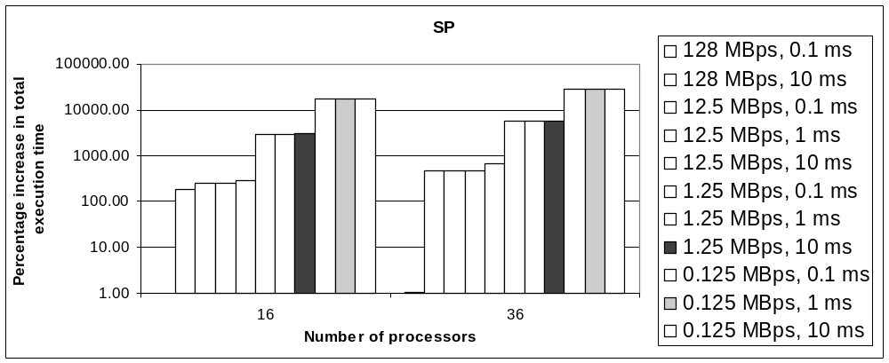
Graph 20. Percentage increase in total execution time for NAS SP Class B benchmark in comparison to execution time on a bandwidth of 128 MBps and a latency of 0.05 milliseconds
NAS SP benchmark, as clearly depicted in Graph 19, is sensitive to changes in latency. The graph also shows that the benchmark is sensitive to higher values of latency. It can be noted that the benchmark’s execution time increases noticeably when the latency is set to 10 milliseconds.

5.4.5 Comparison of all the Benchmarks
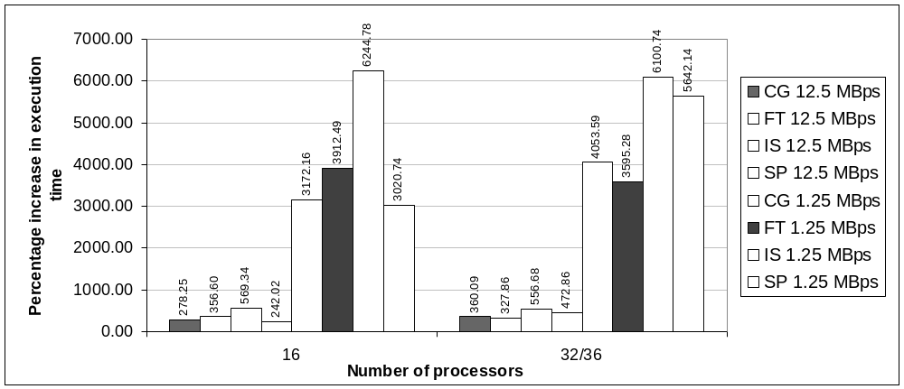
Graph 21. Percentage increase in total execution time for NAS Class B benchmarks. Assumed values: latency=0.05 milliseconds; bandwidth={12.5, 1.25} MBps. Comparison with bandwidth=128 MBps
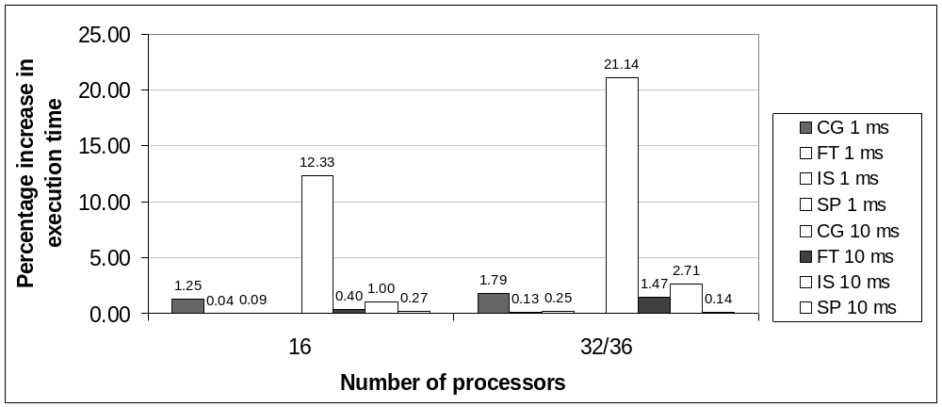
Graph 22. Percentage increase in total execution time for NAS Class B benchmarks. Assumed values: bandwidth=1.25 MBps; latency={1, 10} milliseconds. Comparison with latency=0.1 milliseconds
Graph 21 shows the percentage increase in execution time for all the benchmarks. Here, the execution times obtained with bandwidth values of 12.5 and 1.25 MBps are compared with the execution time obtained on gigabit Ethernet (128 MBps). The latency is fixed at 0.1 milliseconds.
The graph clearly shows that IS benchmark is the worst affected by changes in bandwidth, followed by FT, CG, and SP. The reason for this is due to the all-to-all communication pattern of IS benchmark. FT benchmark is affected to changes in bandwidth more than compared to its performance in DOI config. One possible explanation for this behavior is since the nodes are distributed among three machines, some of the messages have to pass through the WAN/internet connection and any changes in the connection speed in such a scenario affects the performance of the benchmark more compared to changes in network speed if the nodes were in a single machine. This holds true only when the WAN speed is slower than LAN speed.
One more point to be noted in this case is that the benchmarks are slowed down by a factor of at least 2.4x (242%) for SP and a maximum slowdown factor of 62x (6244%) for IS benchmark compared to a minimum slowdown factor of 0.78x (7.8%) for FT and a maximum slowdown factor of 29x (2915%) for IS benchmark in the DOI config. The numbers above conclude that IS benchmark is the worst affected to changes in bandwidth and latency in both the configurations.

5.4.6 α and β Setup
The basic idea of α and β setup in CNC configuration is to test the effects of varying LAN/WAN network speeds on execution time. In this experiment, α setup has higher has a bandwidth of 12.5 MBps and a latency of 0.1. β setup, on the other hand, has the bandwidth and latency values of 1.25 MBps and 1 millisecond respectively. The inference is that the execution time should be less in α setup. The reason for this is since the bandwidth and latency is better in LAN for α setup, some messages get exchanged faster than others.
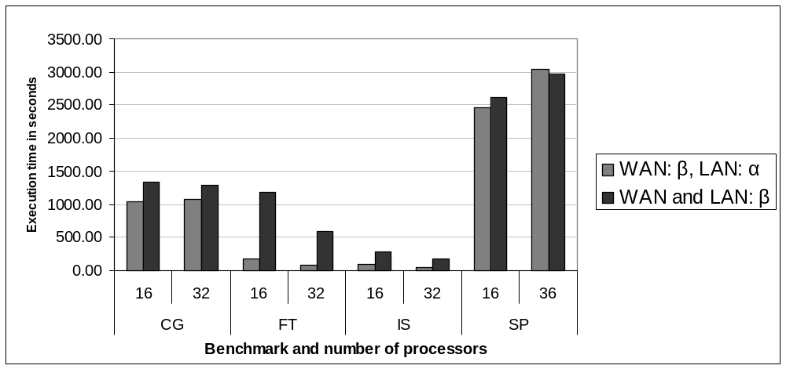
Graph 23. Execution times for NAS Class B benchmarks on α and β setup. α setup: LAN: 12.5 MBps and 0.1 milliseconds; WAN: 1.25 MBps and 1 millisecond. β setup: WAN and LAN: 1.25 MBps and 1 millisecond

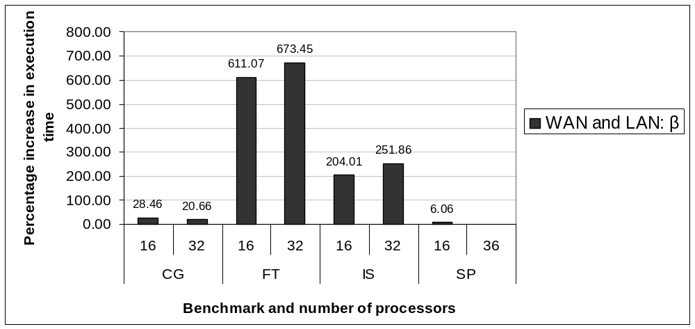
Graph 24. Percentage increase in execution times (WAN and Lan:β over WAN: β, LAN: α) for NAS Class B benchmarks on α and β setup. α setup: LAN: 12.5 MBps and 0.1 milliseconds; WAN: 1.25 MBps and 1 millisecond. β setup: WAN and LAN: 1.25 MBps and 1 millisecond
As seen in Graph 23, α setup performs better than β setup for most of the benchmarks. The difference is better highlighted in the percentage difference graph:
As seen in Graph 24, β setup is slower compared to α setup by 6 percent in the least case. The worst hit in this case is FT benchmark, again due to its all-to-all communication pattern. IS is the next slowest benchmark, also due to its all-to-all communication pattern.
The graphs Graph A.9 through Graph A.12 show the breakup of computation and communication time of all four benchmarks in α and β setups.

5.5 Comparison of DOI and CNC Configurations
DOI and CNC configurations have been compared to observe the effects of underlying network architecture on the execution time of applications.

5.5.1 CNC versus HPSL and Shark Cluster
In this experiment, the internal bandwidth of machines in the CNC config is higher compared to WAN/internet bandwidth. The WAN bandwidth/latency in CNC is fixed at 7 MBps and 0.8 milliseconds, while the bandwidth and latency values for LAN are 12 MBps and 0.4 milliseconds respectively. The DOI configuration has two machines; few nodes in High Performance Systems Lab (HPSL) represent one machine, while Shark cluster, with its 29 nodes represent another machine. The bandwidth and latency values assigned here are real measurements taken in HPSL and Shark cluster. The bandwidth and latency in HPSL are 12 MBps and 0.4 milliseconds respectively and for Shark cluster, the values are 95 MBps and 0.05 milliseconds.
The inference is that the execution time should be more in CNC config compared to other two machines in DOI config. Nodes in HPSL should perform better than CNC config since all the nodes are in the same machine and the messages do not have to go through the relatively slower WAN/internet connection.
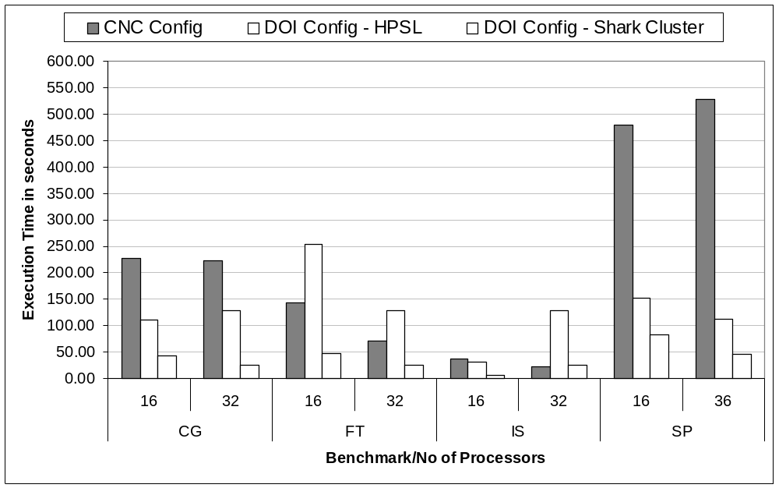
Graph 25. Execution time for NAS Class B benchmarks on CNC config, DOI config and Shark Cluster
As shown in Graph 25, Shark cluster clearly performs better than the other two configurations/machines. Nodes in HPSL perform better than CNC config in two cases and when there is all-to-all communication involved, CNC config performs better. The reason for this is due to the placement of nodes in different machines. Since the nodes are distributed among three machines in CNC config, most of the message transfers happen within the machines and hence take less time compared to that of in HPSL, wherein the underlying LAN is shared between all the nodes. But our previous results have shown that when the WAN connection is equal to or relatively slower than LAN connection, FT and IS experience degrading of performance. Hence, this particular case has to be investigated further.
The percentage difference of performance between the three types is more clearly seen in Graph 26. Here, the reference case is the best performing machine, which is Shark cluster:
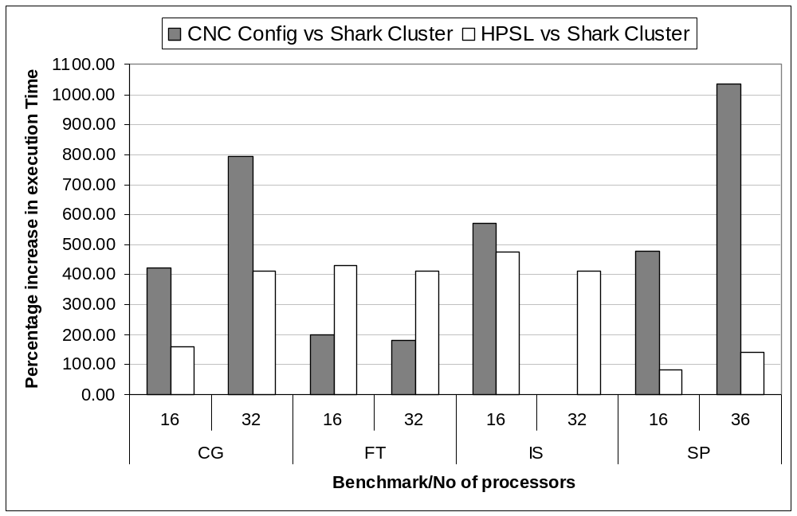
Graph 26. Percentage increase in total execution time for NAS Class B benchmarks – CNC config and HPSL versus Shark cluster
In Graph 26, we can clearly see that Shark cluster outperforms the other two machines by a minimum of 82.98%. This means that the best platform to execute parallel applications is sill the dedicated parallel machine/cluster. Graph A.13 through Graph A.16 depict the breakup of computation and communication times for different benchmarks.

5.5.2 DOI versus CNC using Synthetic Bandwidth and Latency Values
The two configurations were compared with real measurements for bandwidth and latency. In this section, we present a comparison of DOI and CNC configurations with synthetic values for bandwidth and latency.
The selected values for bandwidth are 12.5, 1.25 and 0.125 MBps respectively. For latency, the values are 0.1 milliseconds, 1 millisecond, and 10 milliseconds. All the four benchmarks have been compared for CNC and DOI in the following sections. As it can be seen in the graphs, most benchmarks perform better in CNC configuration compared to DOI configuration. The reason for this is since both the LAN/WAN network speed is the same in CNC configuration and since the nodes are distributed among three machines, the message transfer takes less time compared to that of DOI config.

5.5.2.1 CG Benchmark
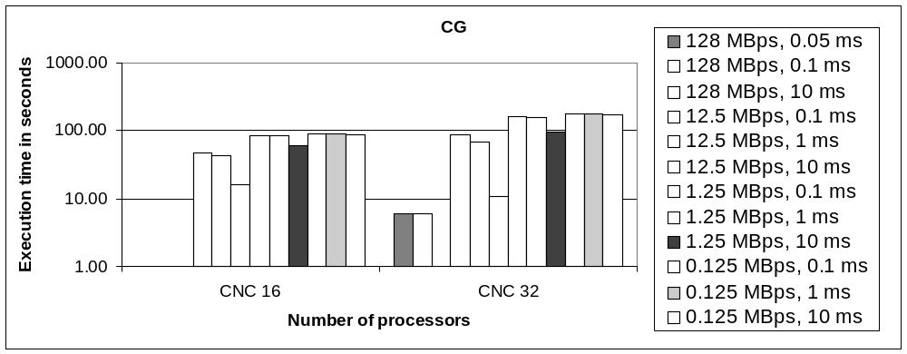
Graph 27. Percentage increase in total execution time for NAS CG benchmark – CNC config compared to DOI config
As seen in Graph 27, CG’s performance in both DOI and CNC config is almost the same when the bandwidth is high at 128 MBps. When the numbers of processors increase to 32, there is however a decrease of almost 6% in the performance of CNC config. For the rest of bandwidth/latency values, the performance is affected more by changes to both bandwidth and latency.
It can also be noted that as the latency is decreased, the two configurations come closer in terms of performance. For example, when the latency is changed to 10 milliseconds, the percentage difference in performance for a bandwidth value of 12.5 MBps is 15.91% compared to 46.73% and 42.61% for 0.1 milliseconds and 1 millisecond respectively. This reflects the fact that CG suffers from decrease in performance due to its intensive communication as the latency increases irrespective of underlying network architecture.

5.5.2.2 FT Benchmark
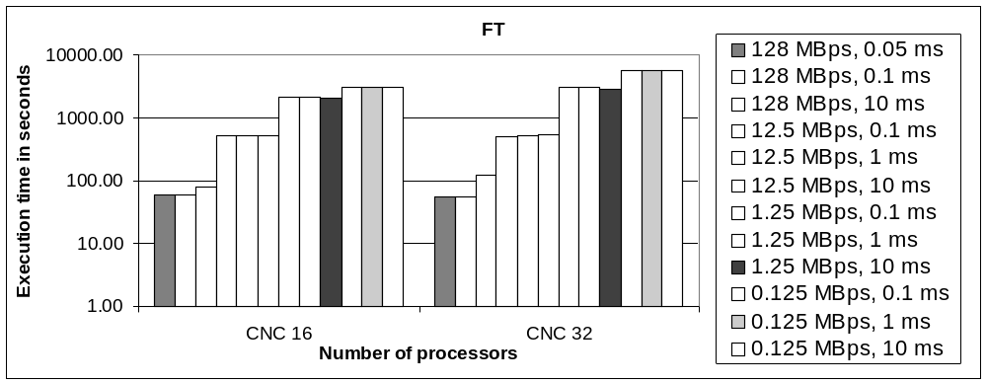
Graph 28. Percentage increase in total execution time for NAS FT benchmark – CNC config compared to DOI config
FT benchmark has all-to-all communication and our previous results have shown that it is sensitive to changes in bandwidth. Graph 28 reflects the same observation. The benchmark in DOI config is sensitive to changes in latency when the bandwidth is high. When the bandwidth is between 12.5 MBps and 0.125 MBps, changes to latency do not matter.
It can also be deduced from the results that as the number of processors increase, the performance of CNC configuration deteriorates. The reason for this is since the number of communications increase (double) from (n²-n) to 2 (2n²-n), the network becomes more sensitive to changes in bandwidth.

5.5.2.3 IS Benchmark
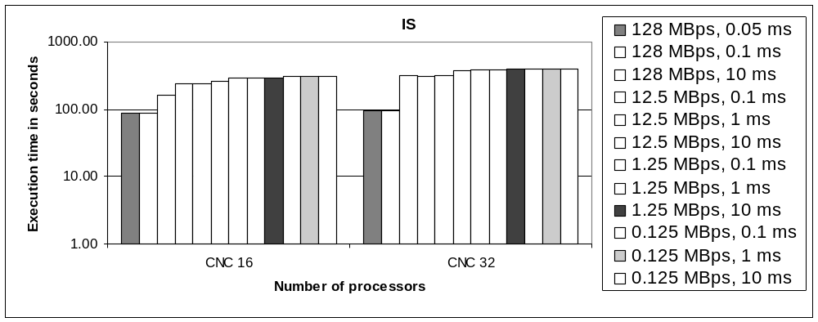
Graph 29. Percentage increase in total execution time for NAS IS benchmark – CNC config compared to DOI config
IS benchmark seems to have similar performance figures on CNC compared to FT except for the fact that the percentage difference is a little low compared to FT. CNC config gives better performance for IS compared to FT. IS still is sensitive to changes in latency when CNC configuration’s bandwidth is high.

5.5.2.4 SP Benchmark
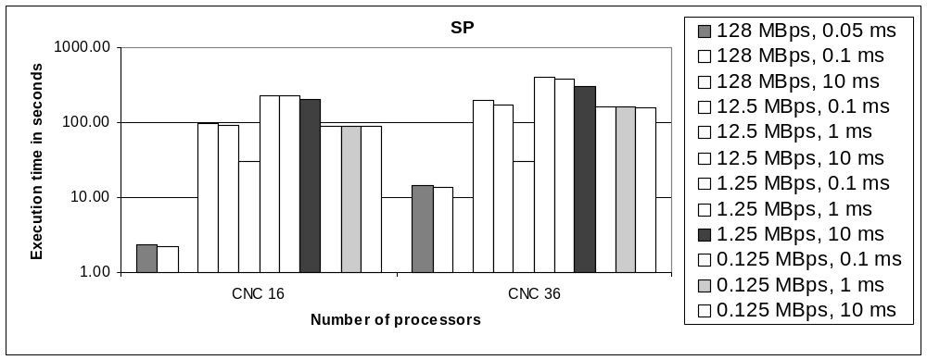
Graph 30. Percentage increase in total execution time for NAS SP benchmark – CNC config compared to DOI config
SP benchmark’s performance in DOI versus CNC configuration is similar to that of CG’s performance. As seen in Graph 30, SP’s performance on both DOI and CNC configurations are almost the same at high bandwidth (128 MBps) when run on 16 processors. It can also be noticed that SP is sensitive to changes in latency at higher bandwidths on CNC configuration.

5.6 Summary
In this chapter, we discussed about the simulations we carried out and their results. We first simulated the performance of parallel applications on DOI configuration and CNC configuration using synthetic values for bandwidth and latency. Then, we simulated the performance using the real measurement values for bandwidth and latency for DOI and CNC configurations.
We simulated the effects of varying LAN/WAN speeds on the performance of parallel applications when the application was deployed on nodes situated in distributed labs across UH campus. We observed that the applications perform better when the LAN speed is higher compared to WAN/intranet speed. We concluded the experiments by comparing the performance of benchmarks on Shark cluster versus the performance on DOI and CNC configurations.
The results show us that the applications perform better on Shark cluster compared to the other two configurations. The results also show us that the applications perform better when deployed on nodes in a single lab compared to being deployed on nodes situated in different labs.

Chapter 6. Modeling the Performance with Failure
In the previous chapter, we saw the results for performance of various benchmarks on two different network configurations. The results were obtained through simulation on an environment that was failsafe. It was assumed that failure never happens or the mean time between failure (MTBF) is very high (or infinite).
In this chapter, we shall have a look at scenarios where different parameters such as MTBF, the network speed, time to detect failure, time to restart execution etc play an important role in the performance of the parallel application. We start the discussion by defining a few terms and keywords that will be used in this chapter.

6.1 Terms
- M: MTBF for a single process
- M’: M/P => MTBF for P processors
- X: checkpoint interval
- t_{x}: time to create a checkpoint
- t_{initiate_restart}: Time taken to initiate the restart process (finding checkpoint server, finding another suitable node etc)
- t_{r}: time to recover from a checkpoint
- t_{d}: time to detect a failure
- T_{s}: time that an application takes to execute on a single processor if no failure occurs
- T: time that an application takes to execute on P processors with possible occurrence of failure

6.2 The failure model
To model the behavior of an application when it experiences failure, we use the equation suggested in [15]. The equation is given below:

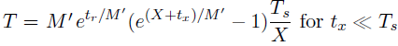

In the equation above, the value for X can be derived [15] using the equation:

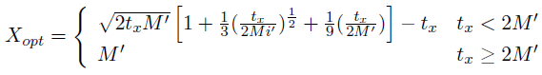

The failure model takes into account the different parameters like MTBF, time to checkpoint, time to restart, original execution time etc to calculate the estimated value for T. By slightly modifying the equation above, we can get the slowdown T/T_{s}:

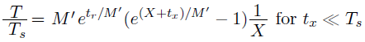

6.3 Failure Statistics
In this section, we present the failure statistics for different combinations of failure/fault tolerance parameters. The basic idea is to investigate the effects of various parameters on the slowdown of an application. The execution time depends on the careful selection of fault tolerance parameters like checkpoint interval, time to detect failure, etc. The failure and network parameters like MTBF and dynamic bandwidth that are not under our control influence the total execution time significantly.
The graphs in the following sections show the effects of various failure parameters on the slowdown of the application. The slowdown is denoted by the fraction T/T_{s}.

6.3.1 Effects of MTBF on T/T_{s}
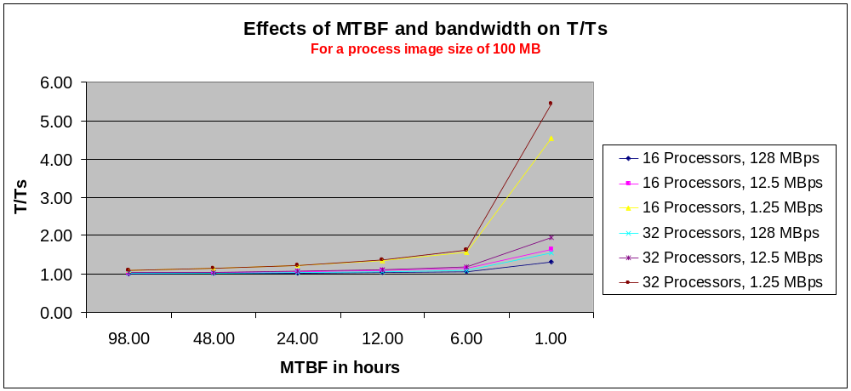

Graph 31. Effects of MTBF and bandwidth on T/T_{s}. Assumed values: process image size=100 MB; bandwidth={128, 12.5, 1.25} MBps; latency=0.1 milliseconds; t_{d}=15 seconds; t_{initiate_restart}=25 seconds; X=optimal

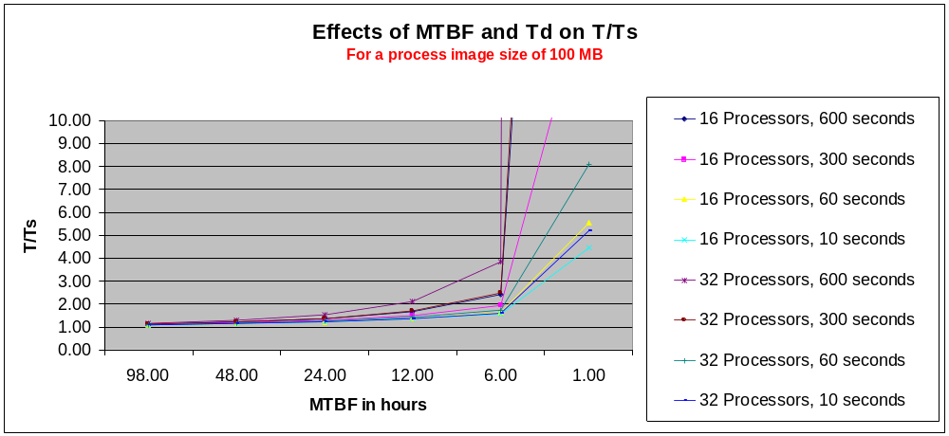
Graph 32. Effects of MTBF and t_{d} on T/T_{s}. Assumed values: process image size=100 MB; bandwidth=1.25 MBps; latency=0.1 milliseconds; t_{d}={600, 300, 60, 10} seconds; t_{initiate_restart}=25 seconds; X=optimal
Graph 31 shows the effects of MTBF on a process having a process image size of 100 MB running on 16 and 32 processors. As seen in the graph, T/T_{s} is almost equal to 1 (no slowdown) when ∞ < MTBF < 100. However, as MTBF goes below 100 hours, the execution time increases and we see a slowdown factor of more than 5 in worst case when the MTBF reaches 1 hour. Also, the slowdown factor increases rapidly with the decrease in bandwidth. The graph clearly shows that as the number of processors increase and as the bandwidth and MTBF goes below 12.5 MBps and 6 hours respectively, the slowdown shoots up.
Graph 32 shows the effects of MTBF and failure detection time on the slowdown factor. The slowdown factor is fairly low for high MTBF and low failure detection times. As the failure detection time goes up, the slowdown factor goes up with the decrease in MTBF. The reason for this is since the system takes more time to detect failure, it takes more time to recover from failure. This adds up to the overhead of fault tolerance and hence contributes significantly in the percentage increase in slowdown.
The inference from the graphs is that for practical MTBF values and for a feasible process image size, we can expect to have a slowdown of 10% to 40%. If the MTBF value is abnormal and reaches below 10 hours, then the slowdown is way too much and it cannot be assured that the application will ever see completion.

6.3.2 Effects of T_{d} on T/T_{s}
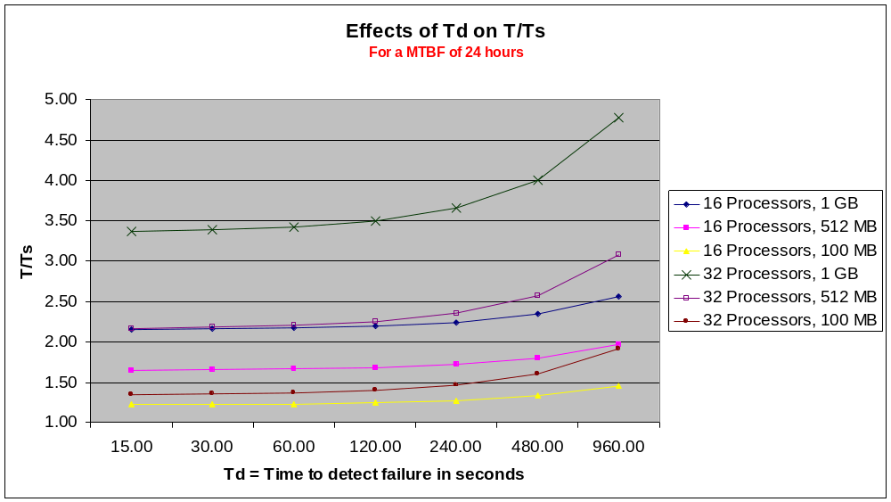
Graph 33. Effects of T_{d} on T/T_{s}. Assumed values: MTBF=24 hours; process image sizes={1024, 512, 100} MB; bandwidth=1.25 MBps; latency=0.1 milliseconds; t_{initiate_restart}=25 seconds; X=optimal
Graph 33 shows the effects of T_{d} on T/T_{s}. Here the time to detect failure has been assigned a value from 15 seconds to about more than an hour. As clearly seen in the graph, the worst hit is the process having an image size of 1 GB running on 32 processors. Clearly, since the process image size is huge, the time taken to recover from a checkpoint of that process is more. As the time to detect the failure increases, the process suffers a slowdown of 377% in the worst case. As the process size decreases and as the time to detect failure decreases, we see much less slowdown compared to worst cases.

6.3.3 Effects of Checkpoint Interval (X) on T/Ts
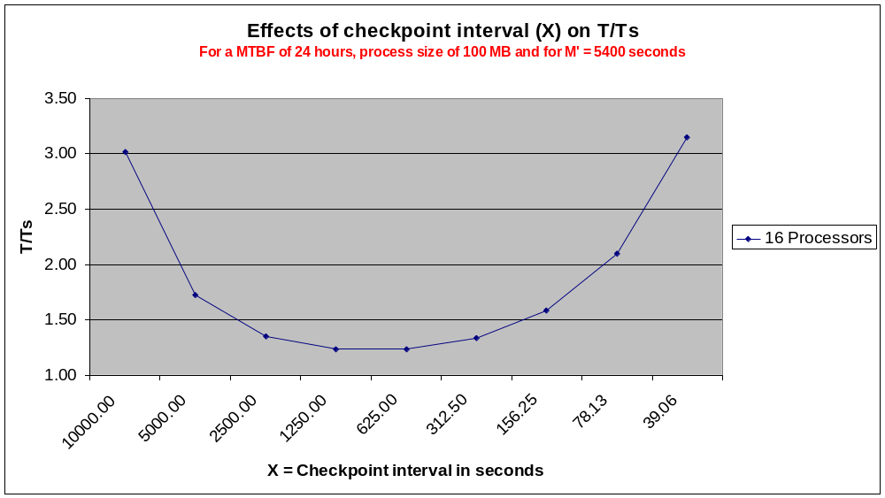
Graph 34. Effects of X on T/T_{s}. Assumed values: MTBF=24 hours; process image size=100 MB; bandwidth=1.25 MBps; latency=0.1 milliseconds; t_{d}=15 seconds; t_{initiate_restart}=25 seconds; number of processors=16
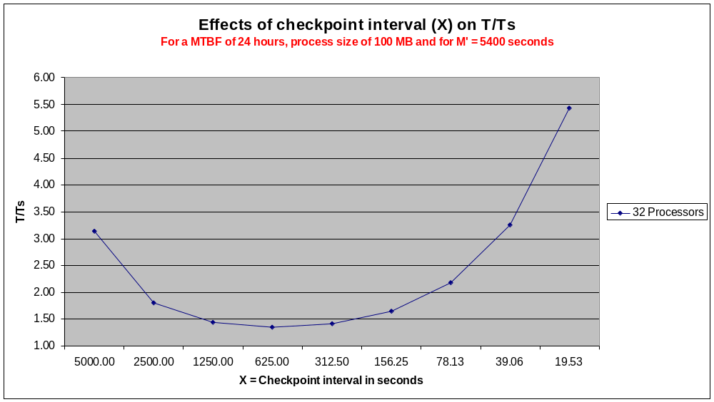
Graph 35. Effects of X on T/T_{s}. Assumed values: MTBF=24 hours; process image size=100 MB; bandwidth=1.25 MBps; latency=0.1 milliseconds; t_{d}=15 seconds; t_{initiate_restart}=25 seconds; number of processors=32
Graphs 34 and 35 show the effects of choosing a value for X. in all the previous experiments, we chose the value for X dictated by the equation in § 6.2. In this experiment, we chose different values for X to determine how it affects the slowdown. The selection of a value for X affects the execution time very much.
If the checkpoint interval is large, the application will spend more time in re-executing sections of code more often. This is because since the checkpoint interval is large, the application creates less number of checkpoints and hence the distance between the checkpoints is large. But the advantage of this method is that the application does not spend much of its time in creating checkpoints and in overheads related to checkpointing.
On the other hand, if the checkpoint interval is small, the application doest not suffer from being restarted from an earlier stage of execution since the checkpoint is taken at regular intervals and will be fairly recent. But the drawback is that the application spends too much time in creating checkpoints and the overheads associated with it are huge.
Both the above cases are evident in graphs X and X. In both cases, the checkpoint interval that falls between 800 seconds and 400 seconds is said to be the optimal checkpoint interval. The slowdown is high in other extreme cases as seen in the graphs. It must also be noted that the checkpoint interval must be greater (by a certain percentage) than the time it takes to create a checkpoint.

6.3.4 Effects of Bandwidth on T/T_{s}
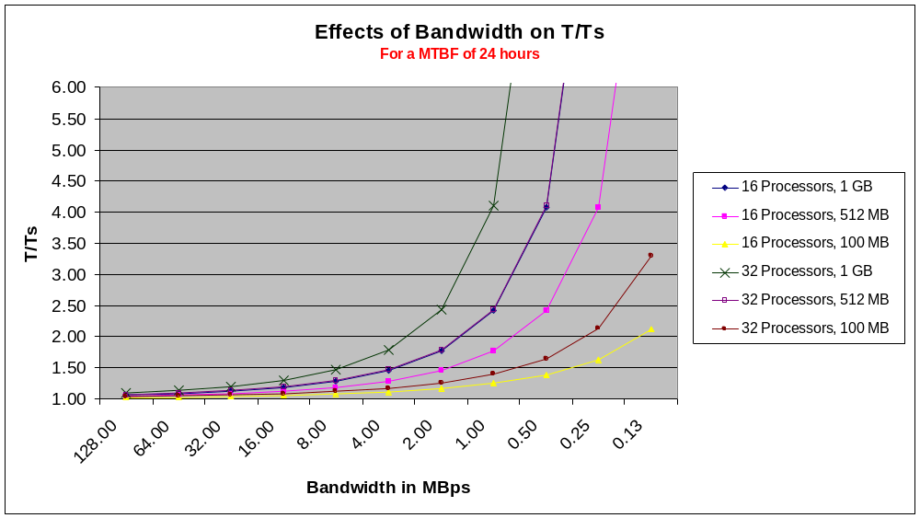
Graph 36. Effects of bandwidth on T/T_{s}. Assumed values: MTBF=24 hours; process image sizes={1024, 512, 100} MB; bandwidth=128 to 0.125 MBps; latency=0.1 milliseconds; t_{d}=15 seconds; t_{initiate_restart}=25 seconds; X=optimal
The bandwidth of the underlying network plays an important role in the percentage slowdown of the application execution time. The bandwidth is one of the parameters used while calculating the amount of time it takes for an application to checkpoint its image and ship the image across to the checkpoint server. Hence, the checkpoint time is determined by the process image size and the bandwidth of the underlying connection.
As seen in Graph 36, the process having a 1 gigabyte image is the worst hit when the bandwidth is at all time low. This is because the time to checkpoint is added to the final execution time of the application. If the time to checkpoint increases, so will the application execution time.
For internet bandwidths which are most commonly available nowadays (in the range of 10 Mbps to 6 Mbps), the slowdown is tolerable. But for an all time low bandwidth, the application sees a minimum slowdown of 113%.

Chapter 7. Conclusion
In this work, we have demonstrated a method to estimate the performance of parallel applications on desired target architecture without actually deploying the application. The advantages of this method are:
- Simulation is more viable.
- This method provides an easy way to manipulate the dynamic properties of the target architecture without having to invest in relevant hardware.
- Variety of target architectures can be designed and used for simulation.
- The behavior of applications on different target architectures can be easily estimated.
- This method provides an easy way to compare the performance of applications on different types of target architectures. Having done so, the system administrator/programmer can fine-tune the target architecture and/or the application to suit their needs.
- This method serves as acid test before deciding to deploy an application on any kind of target architecture.
The simulation results for actual bandwidth and latency measurements show us that on average, the applications perform 2x, 4x, and 6x slower in the minimum, average and maximum case when deployed on desktop grids consisting of machines in a single lab compared to Shark cluster, which is a dedicated parallel machine. Parallel benchmarks perform faster by 2x, 3x, and 5x in the minimum, average, and maximum case on machines in a single lab environment compared to being deployed on machines in distributed labs connected through WAN/intranet. The results show that desktop grids are a suitable platform to deploy and run parallel applications by incurring minimal performance degradation.
We have seen from our experiments that choosing an optimal checkpoint interval increases the fault tolerance efficiency. For MTBF of more than 5 hours and for bandwidth/latency values better than 1.25 MBps and 1 millisecond, the slowdown is ranges from 10% to 57% for an application containing 16 processes with each process size being 100 MB. The slowdown ranges from 1% to 10% for an application containing 32 processes with each process size being 50 MB.
Considering the volatile nature of desktop grids, the results show us that applications perform reasonably well when deployed on networked computers situated in a single lab environment and in distributed lab environment. In this experiment, NAS benchmarks performed reasonably well even though the benchmarks are communication intensive.
While the results obtained in this work are promising, we still have to solve some cases where benchmarks like FT and IS show different results for certain sets of bandwidth/latency values. The fact that Dimemas has a simulation error of about 25% on average plays an important role in the results obtained. There is still much to be done in bringing that simulation error close to zero.

References

[1] Barcelona Super Computing, “Performance Tools,” Performance Tools. [Online]. Available: http://www.bsc.es/plantillaF.php?cat_id=52. [Accessed: Jul. 1, 2009].

[2] Barcelona Super Computing, “Dimemas: predict parallel performance using a single cpu machine,” Performance Tools. [Online]. Available: http://www.bsc.es/plantillaA.php?cat_id=478. [Accessed: Jul. 1, 2009].

[3] Wikipedia, “Volunteer Computing,” [Online]. Available: http://en.wikipedia.org/wiki/Volunteer_computing. [Accessed: Jul. 1, 2009].

[4] BOINC, “BOINC Open Source Software,” [Online]. Available: http://boinc.berkeley.edu/. [Accessed: Jul. 1, 2009].
[5] Boinc Stats, “Credit Overview,” [Online]. Available: http://boincstats.com/stats/project_graph.php?pr=bo.[Accessed: Jul. 1, 2009].

[6] SETI@HOME, “SETI@HOME,” [Online]. Available: http://setiathome.berkeley.edu/. [Accessed: Jul. 1, 2009].

[7] A. Faraj and X. Yuan, “Communication Characteristics in the NAS Parallel Benchmarks,” Fourteenth IASTED International Conference on Parallel and Distributed Computing and Systems (PDCS 2002), 2002.

[8] A. Iosup, M. Jan, O. Sonmez and D.H.J. Epema, “On the Dynamic Resource Availability in Grids,” 8th IEEE/ACM International Conference on Grid Computing, 2007, pp. 26-33.

[9] A. Bouteiller, P. Lemarinier, K. Krawezik and F. Capello, “Coordinated checkpoint versus message log for fault tolerant MPI,” Proceedings of IEEE International Conference on Cluster Computing, 2003, 2003, pp. 242-250.

[10] Wikipedia, “Application Checkpointing,” [Online]. Available: http://en.wikipedia.org/wiki/Application_checkpointing. [Accessed: Jul, 1, 2009].

[11] G. Bosilca, A. Bouteiller, F. Cappello, S. Djilali, G. Fedak, C. Germain, T. Herault, P. Lemarinier, O. Lodygensky, F. Magniette, V. Neri and A. Selikhov, “MPICH-V: Toward a Scalable Fault Tolerant MPI for Volatile Nodes, Supercomputing,” ACM/IEEE 2002 Conference, 2002.

[12] Parallel Software Technologies Laboratory (PSTL), “Resources,” [Online]. Available: http://pstl.cs.uh.edu/resources.shtml. [Accessed: Jul. 4, 2009].

[13] Barcelona Super Computing, “Paraver: Obtain Detailed Information from Raw Performance Traces,” Performance Tools. [Online]. Available: http://www.bsc.es/plantillaA.php?cat_id=485. [Accessed: Jul. 9, 2009].

[14] Q. Xu, R. Prithivathi, J. Subhlok, R. Zheng, “Logicalization of MPI Communication Traces,” Technical Report UH-CS-08-07, Department of Computer Science, University of Houston, 2008.

[15] R. Zheng and J. Subhlok, “A quantitative Comparison of Checkpoint with Restart and Replication in Volatile Environments,” Technical Report UH-CS-08-06, Department of Computer Science, University of Houston.

[16] SimBOINC, "SimBOINC: A Simulator for Desktop Grids and Volunteer Computing Systems," [Online]. Available: http://simboinc.gforge.inria.fr/index.html. [Accessed: Jul. 13, 2009].

[17] SimGrid, "SimGrid," [Online]. Available: http://simgrid.gforge.inria.fr. [Accessed: Jul. 13, 2009].

[18] EmBOINC, "Emulator of BOINC Projects," [Online]. Available: http://gcl.cis.udel.edu/projects/emboinc/index.php. [Accessed: Jul. 13, 2009].

[19] Condor, "Condor," [Online]. Available: http://www.cs.wisc.edu/condor. [Accessed: Jul. 13, 2009].

[20] Condor, "High Througput Computing," [Online]. Available: http://www.cs.wisc.edu/condor/htc.html. [Accessed: Jul. 13, 2009].

[21] Wikipedia, "Berkeley Open Infrastructure for Network Computing," [Online]. Available: http://en.wikipedia.org/wiki/Berkeley_Open_Infrastructure_for_Network_Computing. [Accessed: Jul. 13, 2009].

Appendix
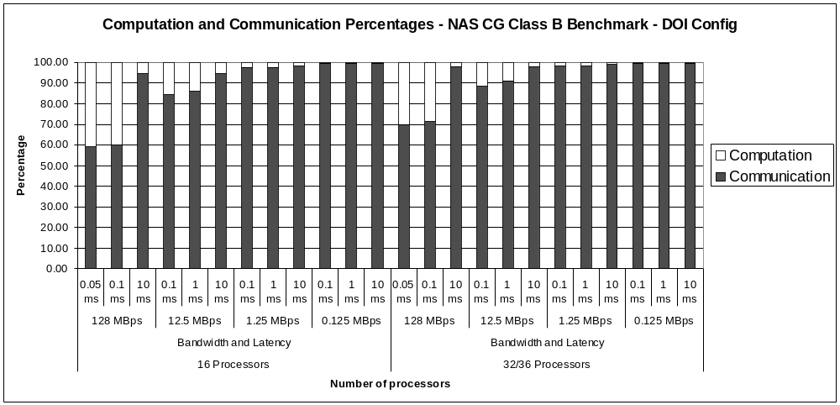

Graph A. 1. Computation and communication percentage for NAS CG Class B benchmark – DOI config

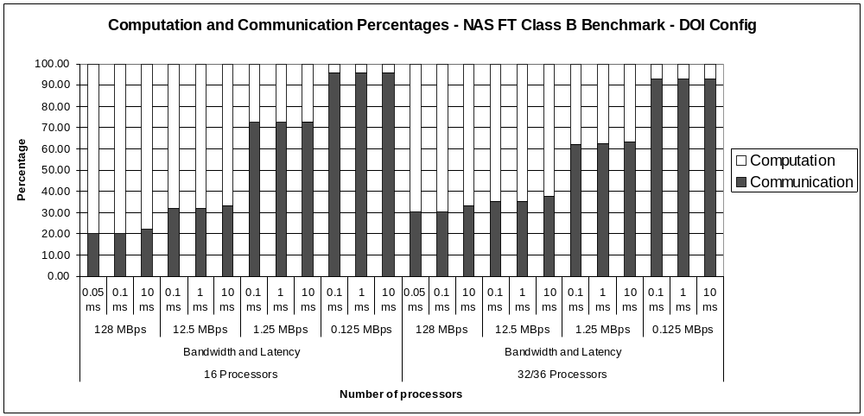

Graph A. 2. Computation and communication percentage for NAS FT Class B benchmark – DOI config

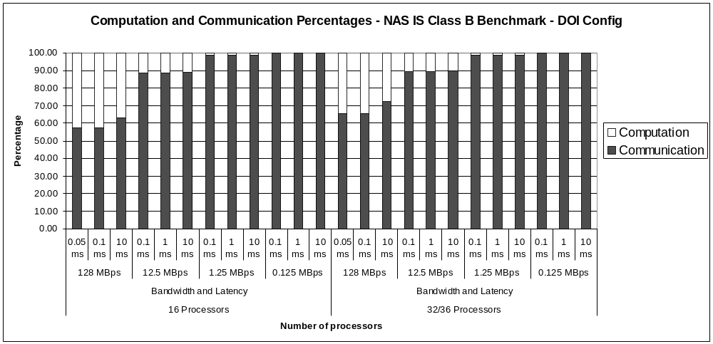

Graph A. 3. Computation and communication percentage for NAS IS Class B benchmark – DOI config

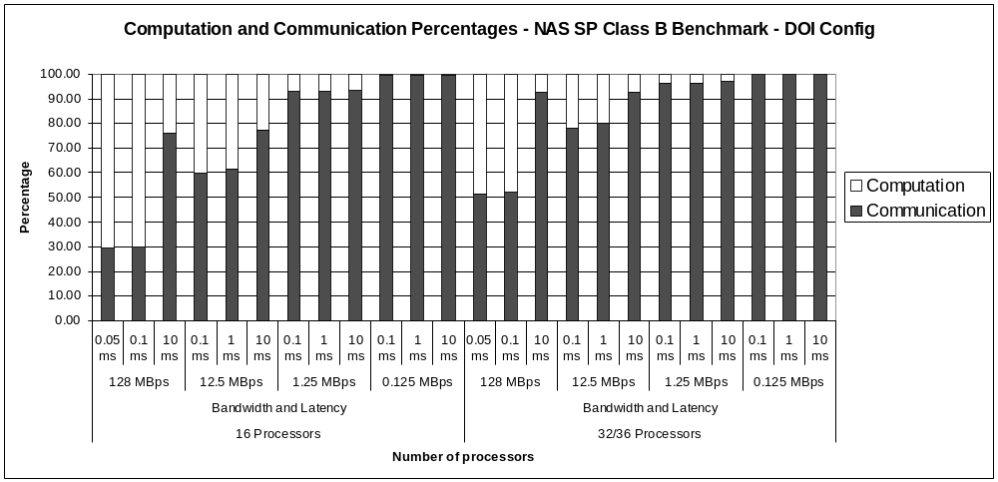

Graph A. 4. Computation and communication percentage for NAS SP Class B benchmark – DOI config

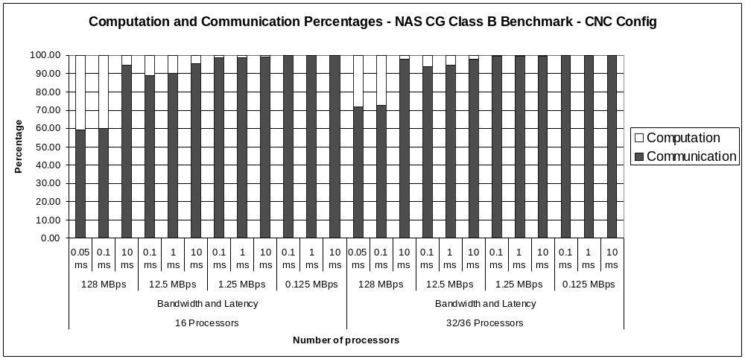

Graph A. 5. Computation and communication percentage for NAS CG Class B benchmark – CNC config

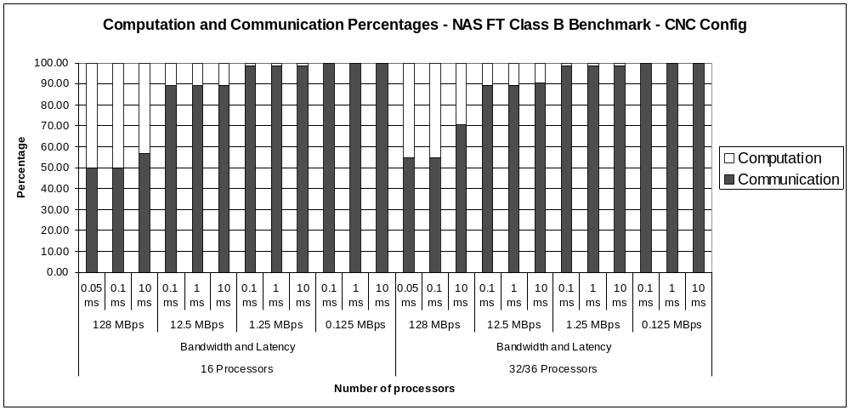

Graph A. 6. Computation and communication percentage for NAS FT Class B benchmark – CNC config

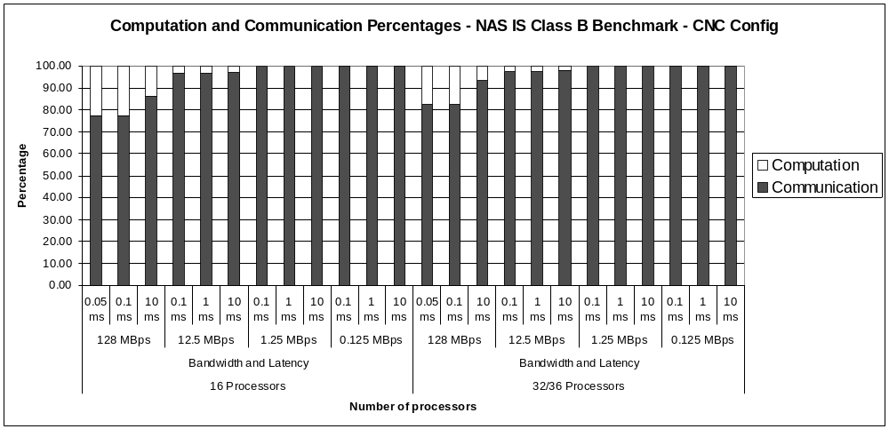

Graph A. 7. Computation and communication percentage for NAS IS Class B benchmark – CNC config

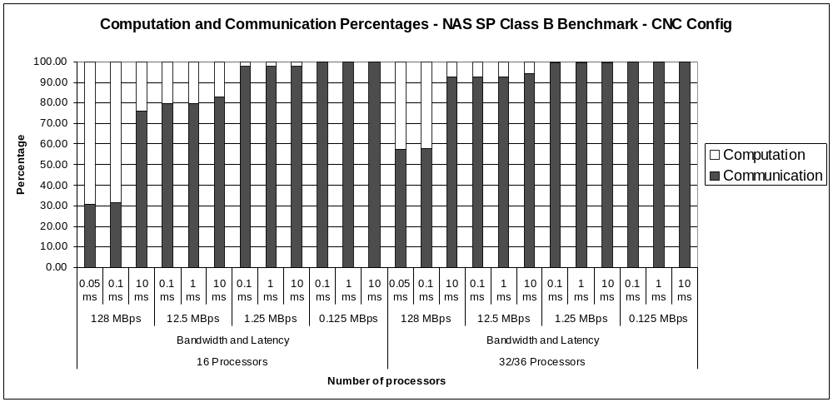

Graph A. 8. Computation and communication percentage for NAS SP Class B benchmark – CNC config

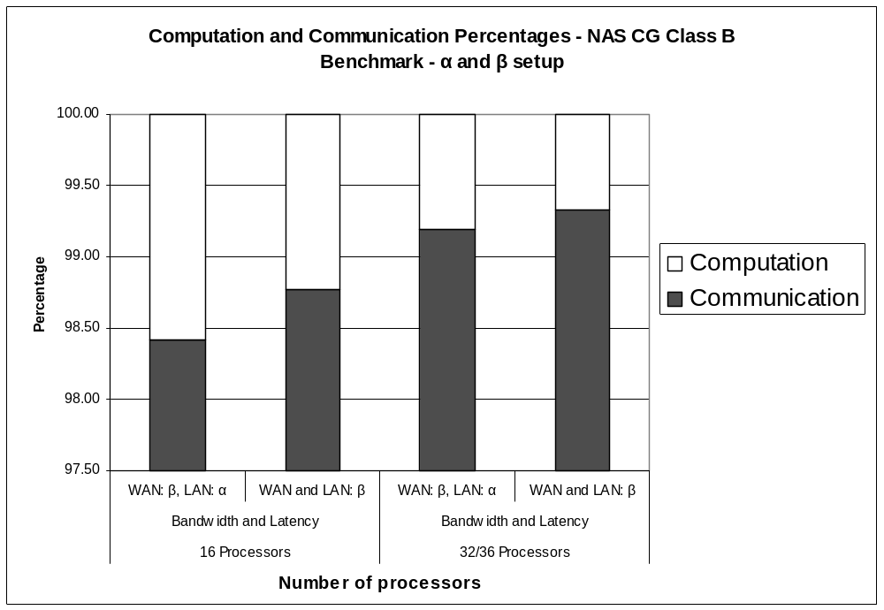

Graph A. 9. Computation and communication percentage for NAS CG Class B benchmark – α and β setup

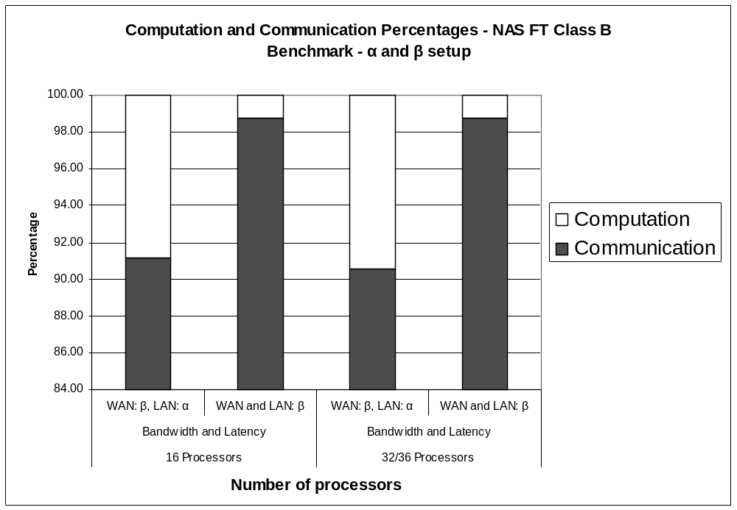

Graph A. 10. Computation and communication percentage for NAS FT Class B benchmark – α and β setup

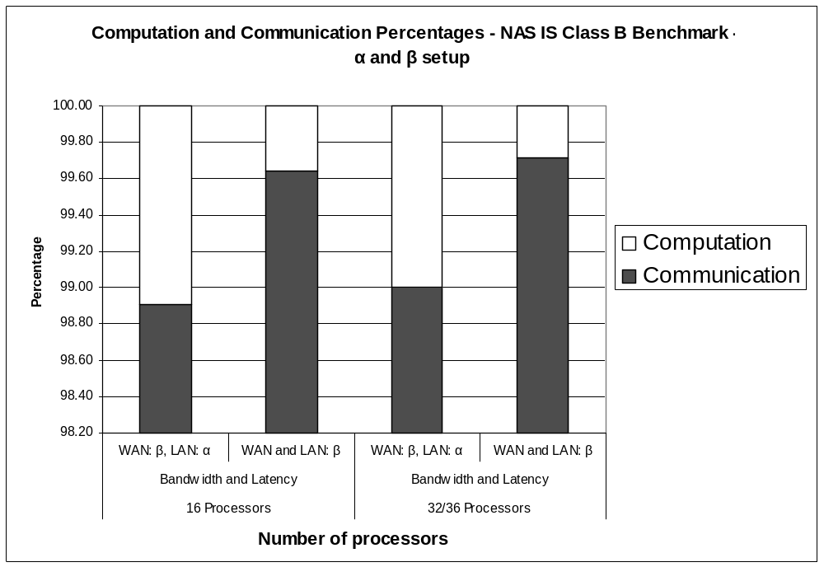

Graph A. 11. Computation and communication percentage for NAS IS Class B benchmark – α and β setup

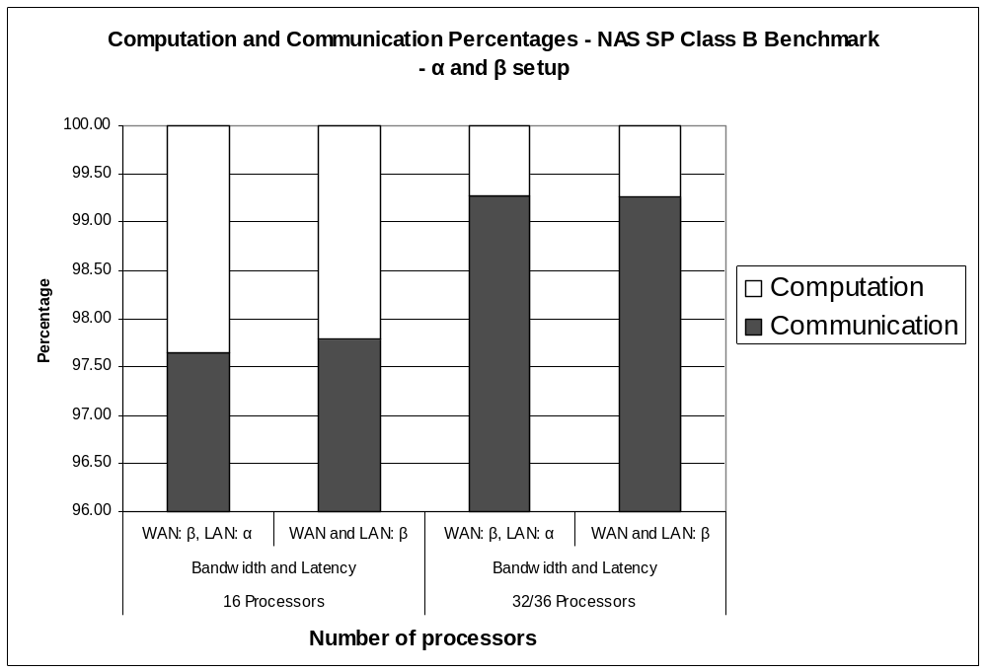

Graph A. 12. Computation and communication percentage for NAS SP Class B benchmark – α and β setup

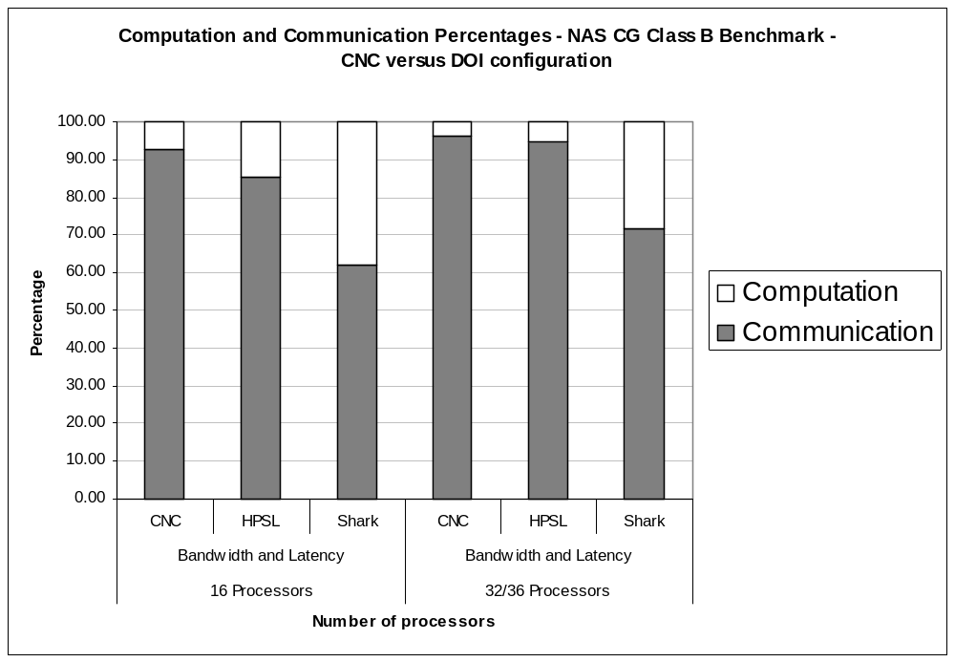

Graph A. 13. Computation and communication percentage for NAS CG Class B benchmark – CNC versus DOI config

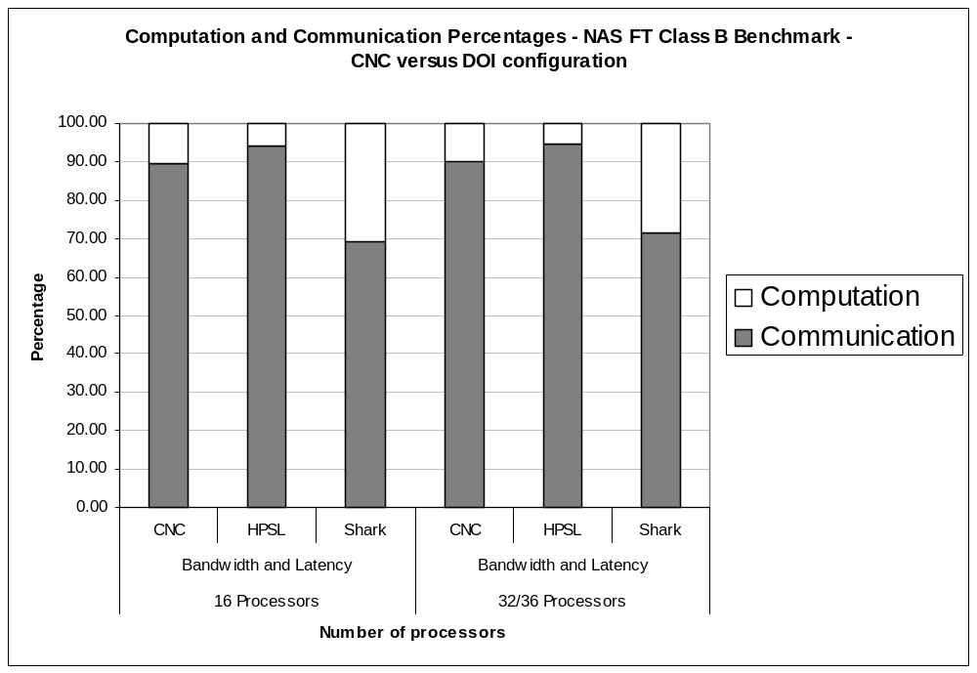

Graph A. 14. Computation and communication percentage for NAS FT Class B benchmark – CNC versus DOI config
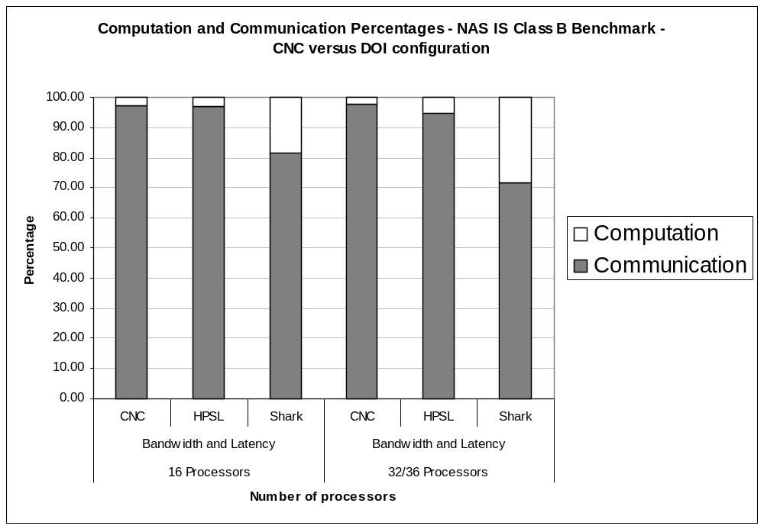

Graph A. 15. Computation and communication percentage for NAS IS Class B benchmark – CNC versus DOI config

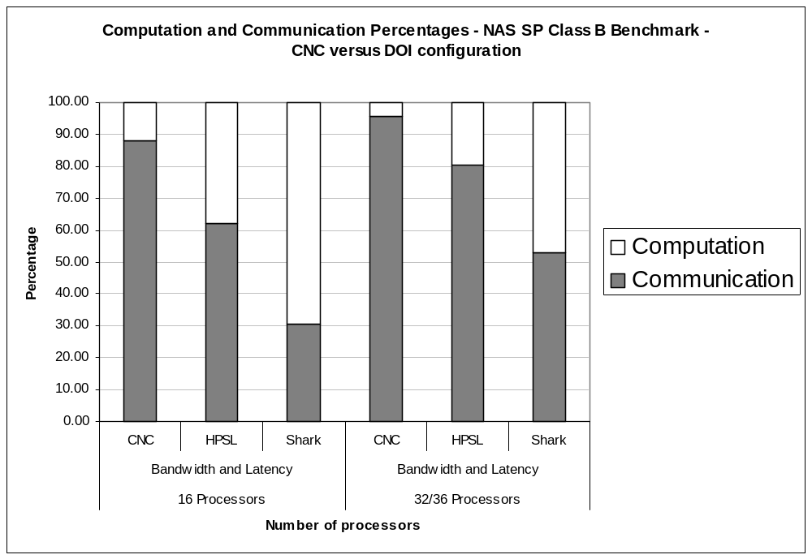

Graph A. 16. Computation and communication percentage for NAS SP Class B benchmark – CNC versus DOI config

