COSC 6335 Fall 2023
Group Homework Credit
Group B Task
To be presented Th., Sept. 14, 2023

- The median line of the boxplot depicted below, which has been created for an attribute x, is far below the center of the boxplot; what does this tell you about the distribution of attribute x?
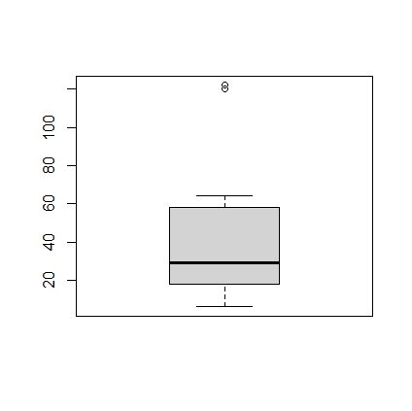
- Comparing Histograms
x<-c(18, 58, 22, 50, 44, 64, 14, 15, 58, 6, 26, 29, 26, 18, 44, 120, 122)
y<-c(0, 1, 2, 22, 23, 24, 34, 55, 55, 56, 57, 58, 60, 50, 70, 72, 111)
Compare the boxplots for datasets x and y which have been created using the R-commands: boxplot(x) and boxplot(y); if you like to see both boxplots lined up use: boxplot(x,y)

Group C Task
To be presented Tu., Sept. 14, 2023

Suppose we create the following histograms to compare the exam scores for 2 groups of students of equal size which were taught using two different methods.
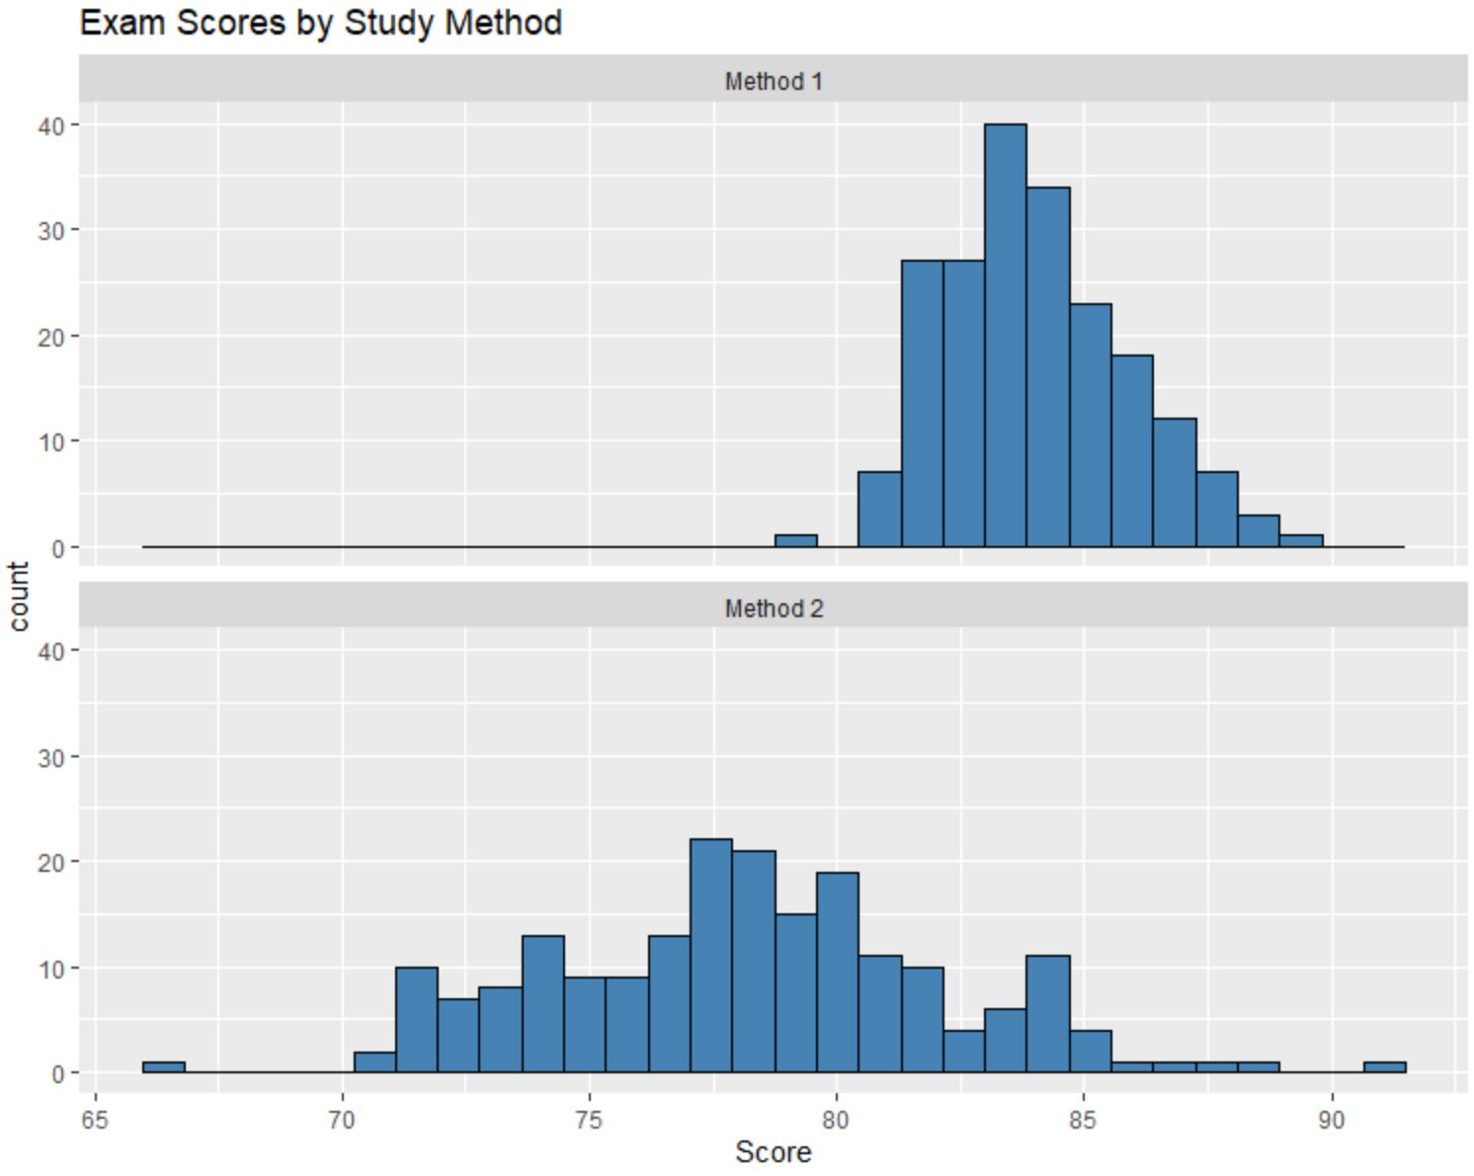
Characterize the 2 histograms! Next, compare the two histograms! What do they tell you concerning the effectiveness of Method1 and Method2?

