Abstract

This document consists of density estimation for different datasets using Non-parametric density estimation (Gaussian Kernel)

Results:

Datasets:

D1=(10,15,18,51,51,52,52,54,54,54,56,58,58,60,60,61,61,62,63,63,64,65,65,67,67,68,68,69,73,130)
D2=(35,74,75,76,76,76,85,87,87,88,88,92,95,96,97,100,105,106,107,108,109,110,111,111,115,115,116,116,175,180)
D3 = (20,36,38,39,40,41,42,44,48,51,52,54,55,56,58,63,65,66,67,68,69,73, 78,81,84,85,87,88,92, 105)

Tool:
R Density Plot: [https://www.rdocumentation.org/packages/stats/versions/3.6.2/topics/density]

Datasets | With Outliers
D1 | 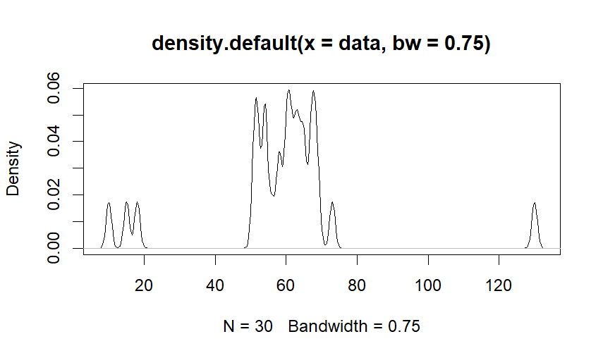
 | 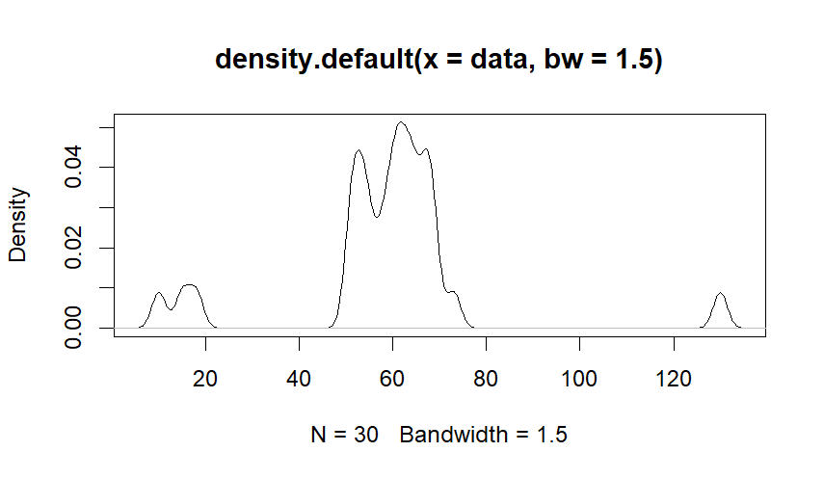
 | 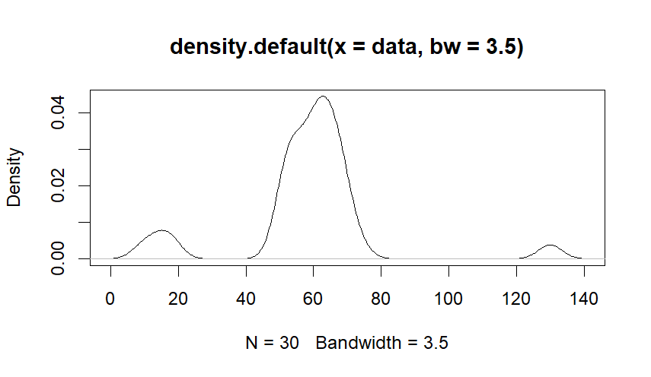
 | 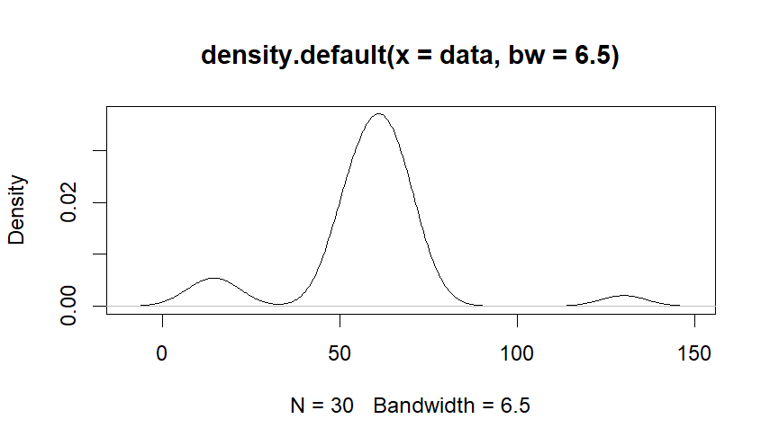
 | 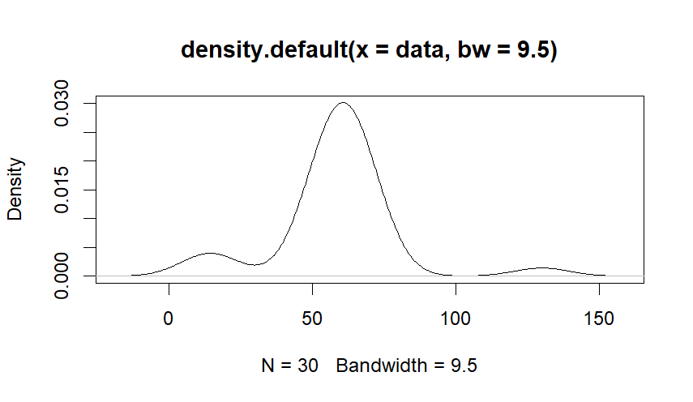
 | 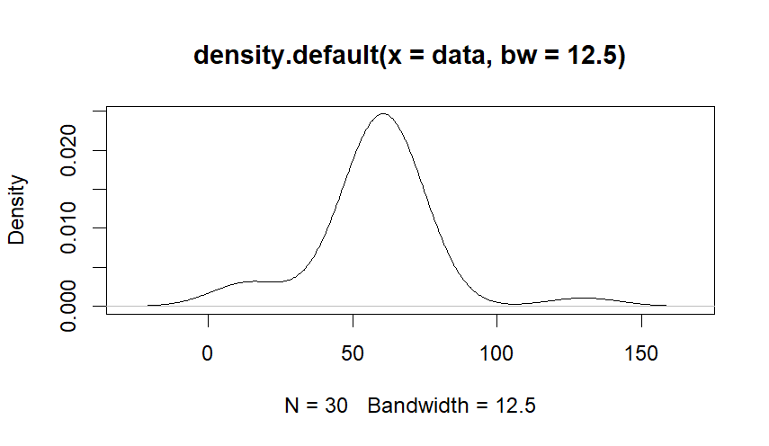
 | 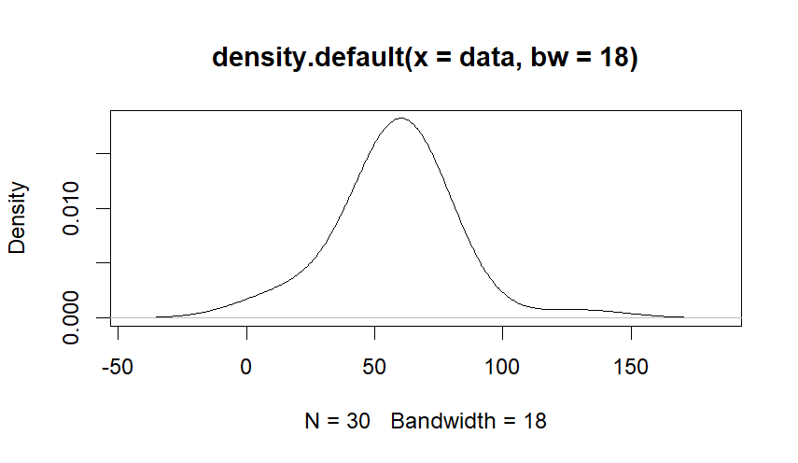
D2 | 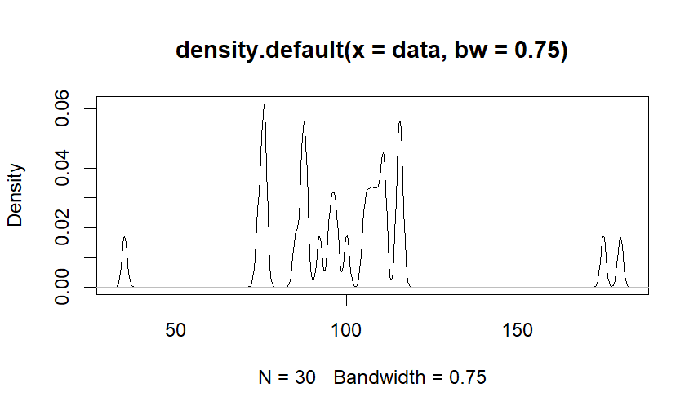
 | 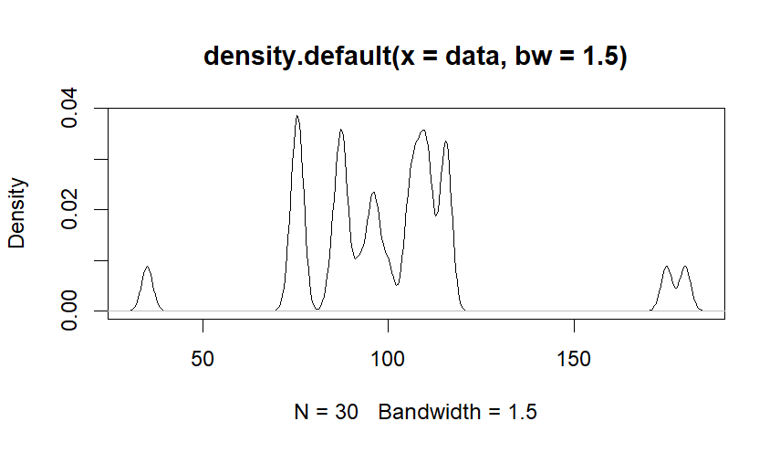
 | 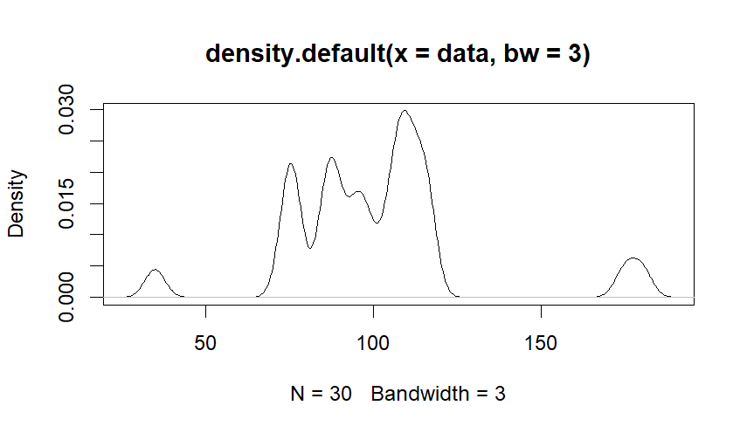
 | 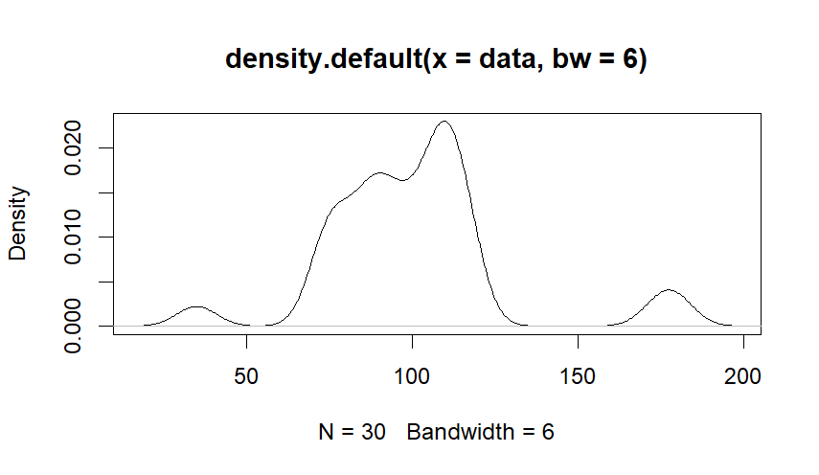
 | 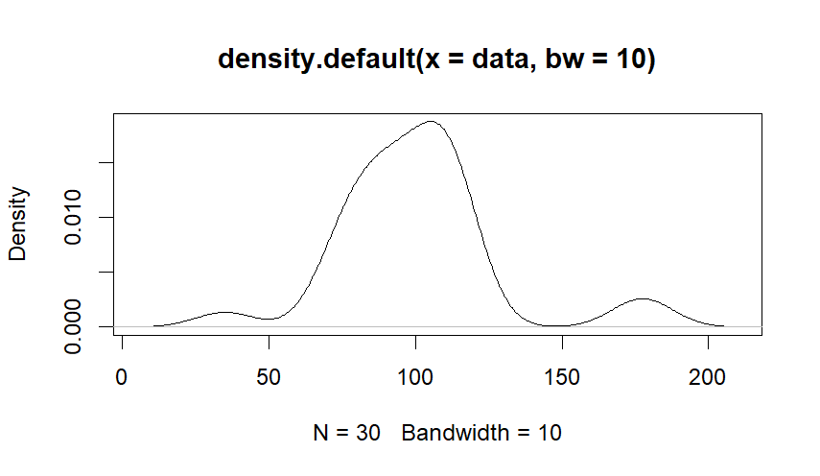
 | 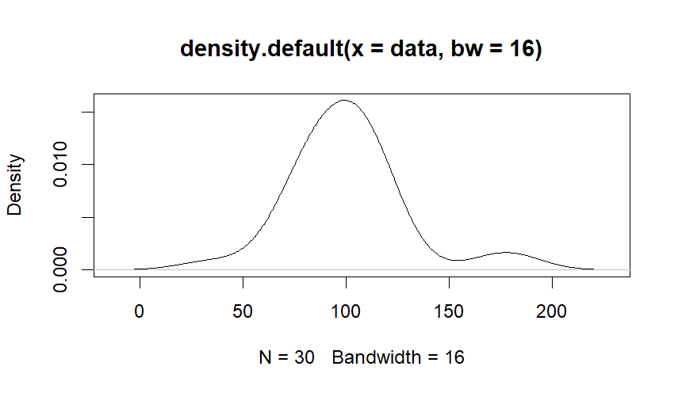
 | 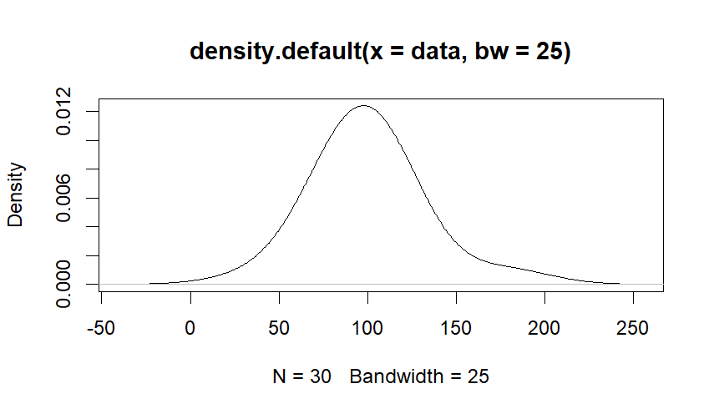
D3 | 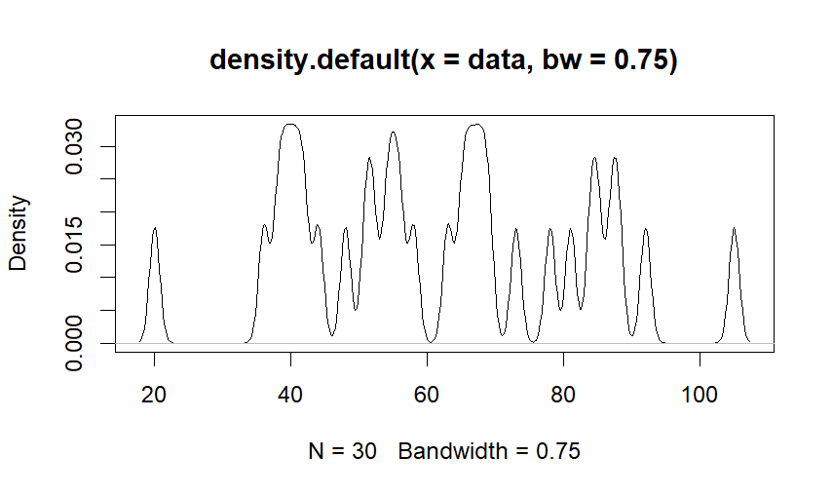
 | 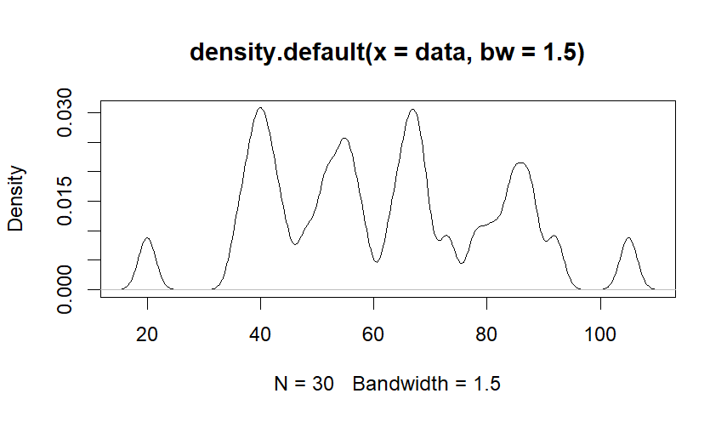
 | 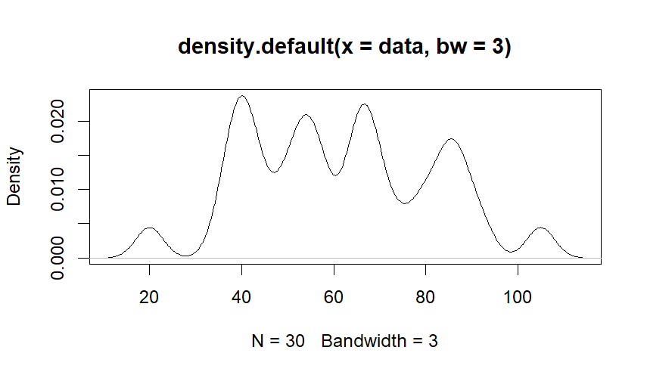
 | 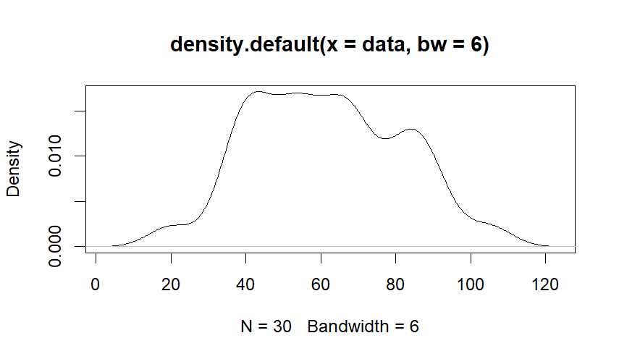
 | 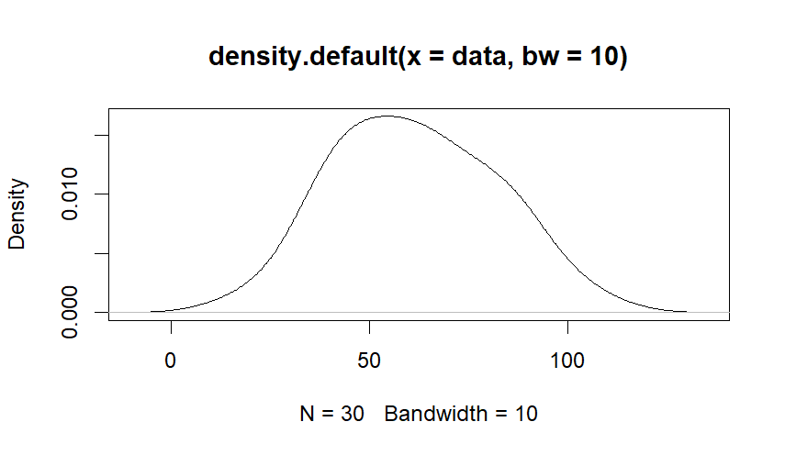
 | 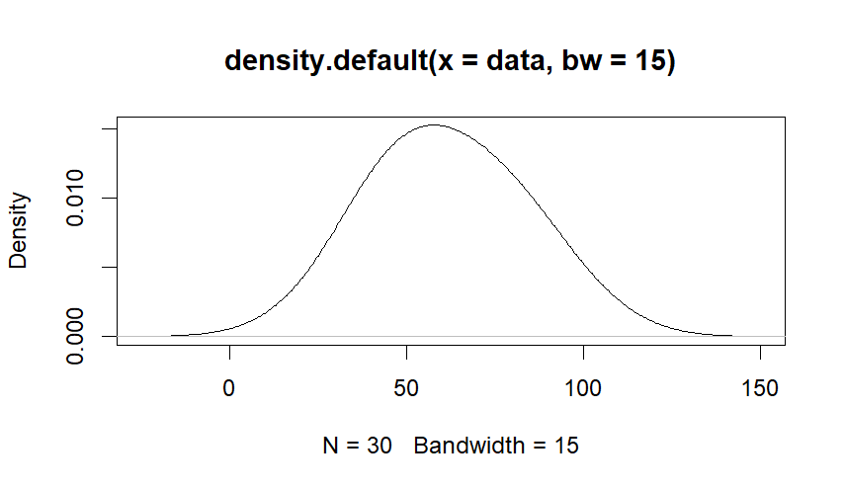
 | 