Technology for Discovering Interesting Regions in Spatial Data Sets
Christoph F. Eick,...
Last update: Sept. 9, 1:50p
Department of Computer Science, University of Houston
Houston, Texas 77204-3010, U.S.A
ceick@cs.uh.edu
1 Motivation and Problem Definition
Finding interesting documents on the internet has been major focus of recent focus of many research and commercial projects. For example, GOOGLE became famous for building search engines that can navigate through millions of documents and return a ranked set of documents based on user interests and user feedback. Earth scientists are interested to have similar capabilities to find interesting regions on the planet earth based on knowledge that s stored in multiple databases. The Data Mining and Machine Learning Group of the University of Houston (UH-DMML) centers on developing technologies that can satisfy this very need. The focus of this document is to describe in more detail what techniques, tools, and methodologies we have to offer to scientists that face challenging region discovery problems and are looking for search-engine style capabablities to find interesting subregions on the planet earth.

Data mining has been identified as a key technology to automate the extraction of interesting, useful, but implicit patterns in large spatial dataset. As mentioned in the previous paragraph, we are particularly interested in assisting scientists in finding interesting regions in spatial data sets. There are many applications of region discovery in science. For example, scientists are frequently interested in identifying disjoint, contiguous regions that are unusual with respect to the distribution of a given class, i.e. a region that contains an unusually low or high number of instances of a particular class. Many applications of this task exist, such as identifying crime hotspots, cancer clusters, and wild fires from satellite photos. A different, second region discovery task is finding regions that satisfy particular characteristics of a continuous variable. For example, someone might be interested in finding regions in the state of Wyoming (based on census 2000 data) with a high variance of income --- poor people and rich people are living next two each other. A third example is co-location mining in which we are interested in finding regions that have an elevated density of instances belonging to two or more classes. For example, a region discovery algorithm might find a region where there is a high density of polluted wells and farms. This discovery might lead to conducting a field study that explores the relationship between farm use and well pollution in the particular region. Finally, region discovery algorithms are also useful for data reduction and sampling. For example, let us assume a European company wants to test the suitability of a particular product for the US market. In this case, the company would be very interested in finding small sub-regions in the US that have the same or quite similar characteristics as the US as a whole. The company would then try to market and sell their product in a few of those sub-regions, and if this works out well, would extend its operations to the complete US market.

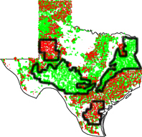
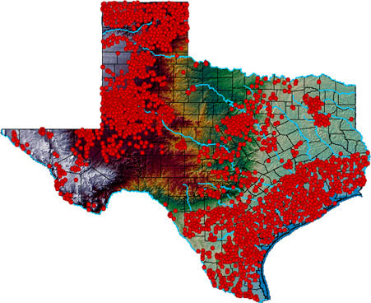

Fig. 1: Finding regions with a very high and low density of “good” and “bad” wells

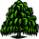
Global Answer: and
Task: Find Co-location patterns for the following data-set.
Fig. 2: Finding regions with interesting co-locaton characteristics

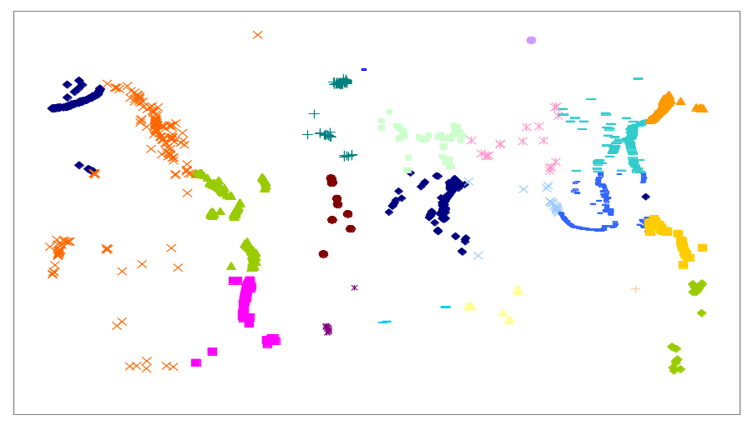
Fig. 3: Finding groups of violent vulcanos and groups of non-violent vulcanos

Figures 1-3 depict results of using our region discovery algorithms for some examples application. Fig. 1 depicts depicts water wells in Texas. Wells that have high levels of arsenic are in red, and wells that have low in green. As a result of the application of a region discovery algorithm [DEWY06] 4 majors regions in Texas were identified, two of which have a high density of good wells and two of which have a high density of bad wells. Fig. 2 gives an example of co-location region discovery result in which regions are identified in which the density of two or more classes is elevated. Fig. 3 [EVDW06] depicts the results of identifying groups/regions of violent and non-violent vulcanos.

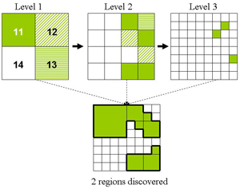
Figure 4: The SCMRG algorithm

In general, our particular approach is viewing region discovery as a clustering problem. The goal of region discovery is to find a set of clusters (regions) that maximize an externally given fitness function. Fig. 4 depicts the running of divisive region discovery algorithm named SCMRG searches for interesting regions (depicted in dark green) at a particular level of granularity and drills down, looking at subregions by splitting regions using rectangular grids, if such an exploration shows some “promise”. During the process the algorithm collects interesting regions at three different levels of resolution, and merges the regions to obtain the final region discovery result that consists of 2 regions (more details how the algorithm works are given in section 3.3)

As of now 5 different clustering algorithms for region discovery already exist and 3 more are currently under development. In general, the different clustering algorithms have different characterics, some are very good in detecting clusters at different levels of granularity, some are fast and therefore can cope with very large datasets, some are good in identifying relatively small clusters. More details about the employed clustering framework are given in Section 2, and some of the clustering algorithms we developed are described in Section 3.


Spatial Databases
Data Set
Domain
Expert
Measure of
Interestingness
Acquisition Tool
Fitness Function
Family of
Clustering Algorithms
Visualization
Tools
Ranked Set of Interesting Regions and their Properties
Region Discovery
Display
Database
Integration Tool

Figure 4: Region Discovery System Architecture

The ultimate vision of this research is the development of region discovery engines that assist scientist in finding interesting regions in a highly automated fashion. Fig. 4 depicts the architecture of a region discovery system. The key-component of the system a family of clustering algorithms that detect interesting regions based on the domain experts’ interest that are captured in fitness functions. Additionally, the Measure of Interestingness Acquisition Tool assists domain experts in selecting the approapriate fitness functions and in selecting the proper paramters for the chosen fitness function. Region discovery usually involves data that are stored in multiple spatial databases. Therefore, before the region discovery algorithms can be applied data from different databases have to integrated, which is the task of the Database Integration Tool. Finally, a visualization tool displays the discovered regions and their properties in an understandable form and iteractively allows the domain expert to change what is visualized and how it is visualized.

In summary, key contribution of our work is the proposal of a generic region discovery framework that is augmented with families of measures of interesting that are capable what domain scientist are interested in, and families of clustering algorithms that find regions the user is looking for. Region discovery faces several challenges that do not exist in information retrieval, such as the need to find regions of arbitrary shape and at arbitrary levels of resolution, the definition of suitable parameterized measures of interestingness to instruct discovery algorithms what they are supposed to be looking for, and the need to reduce computational complexity due to the large size of most spatial datasets. The next section will discuss in more detail our proposed region discovery framework. Table 1 summarizes the notations used in this paper.

Table 1. Notations used
Notation | Description
O={o₁, …, o_{n}} | Objects in a dataset (or training set)
n | Number of objects in the dataset
c_{i}⊂ O | The i-th cluster
X={c₁, …, c_{k}} | A clustering solution consisting of clusters c₁ to c_{k}
q(X) | Fitness function that evaluates a clustering X
C | A class label
2 A Region Discovery Framework
As we explained earlier, our approach uses supervised clustering algorithms to identify interesting regions in a dataset. A region, in our approach, is defined as a surface containing a set of spatial objects; e.g. the convex hull of the objects belonging to a cluster. Moreover, we require regions to be disjoint and contiguous; that is, for each pair of objects belonging to a region, there always must be a path within this region that connects the pair of objects. Furthermore, we assume that the number of regions is not known in advance, and therefore finding the best number of regions is one of the objectives of the clustering process. Therefore, our evaluation scheme has to be capable of comparing clusterings that use a different number of clusters.
Our approach employs a reward-based evaluation framework. The quality q(X) of a clustering X is computed as the sum of the rewards obtained for each cluster c∈X. Cluster rewards are weighted by the number of objects that belong to a cluster c. In general, we are interested in finding larger clusters if larger clusters are equally interesting as smaller clusters. Consequently, our evaluation scheme uses a parameter β with β>1 and fitness increases nonlinearly with cluster-size dependent on the value of β, favoring clusters c with more objects.
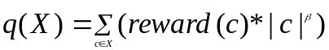 | (1)

Selecting larger values for the parameter β usually results in a smaller number of clusters in the best clustering X. The proposed evaluation scheme is very general; different reward schemes that correspond to different measures of interestingness can easily be supported in this framework, and the supervised clustering algorithm that will be introduced in the second half of the paper can be run with different fitness functions without any need to change the clustering algorithm itself.
In this section, we introduce a single measure of interestingness that centers on discovering hotspots and coldspots in a dataset. In section 4 we will introduce other measures of interestingness for other region discovery tasks. The measure is based on a class of interest C, and rewards regions in which the distribution of class C significantly deviates from its prior probability, relying on a reward function τ. τ itself, see Fig. 1, is computed based on p(c,C), prior(C), and based on the following parameters: γ1, γ2, R+, R− with γ1≤1≤γ2; 1≥ R+,R−≥0, η>0 .
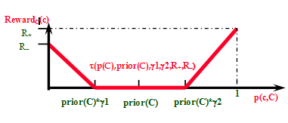
Fig. 1. The reward function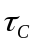for η=1
The fitness function q(X) is defined as follows:

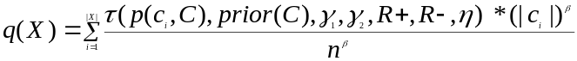 | (2)

with

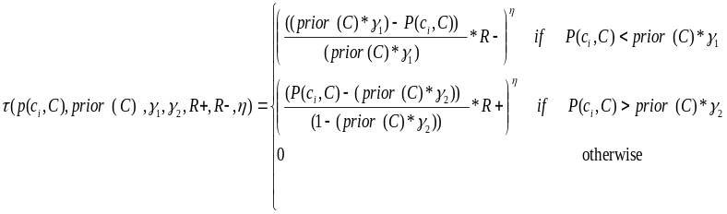 | (3)

In the above formula prior(C) denotes the probability of objects in dataset belonging to the class of interest C. The parameter η determines how quickly the reward grows to the maximum reward (either R+ or R−). If η is set to 1 it grows linearly; in general, if we are interested in giving higher rewards to purer clusters, it is desirable to choose larger values for η; e.g. η=8.
Let us assume a clustering X has to be evaluated with respect to a class of interest “Poor” with prior(Poor) = 0.2 in a dataset that contains 1000 examples. Suppose that the generated clustering X subdivides the dataset into five clusters c1, c2, c3, c4, and c5 with the following characteristics: |c1| = 50, |c2| = 200, |c3| = 200, |c4| = 350, |c5| = 200; p(c1, Poor) = 20/50, p(c2, Poor) = 40/200, p(c3, Poor) = 10/200, p(c4, Poor) = 30/350, p(c5, Poor) = 100/200. Moreover, the parameters used in the fitness function are as follows: γ1 = 0.5, γ2 = 1.5, R+ = 1, R− = 1, β = 1.1, η=1. Due to the settings of γ1 = 0.5, γ2 = 1.5, clusters that contain between 0.5 x 0.2 = 10% and 1.5 x 0.2 = 30% instances of the class “Poor” do not receive any reward at all; therefore, no reward is given to cluster c2. The remaining clusters received rewards because the distribution of class “Poor” in the cluster is significantly higher or lower than its prior distribution. For example, the reward for c1 that contains 50 examples is 1/7 x (50)^{1.1}; 1/7 is obtained as follows: τ(c1) = ((0.4-0.3)/(1-0.3)) * 1 = 1/7.

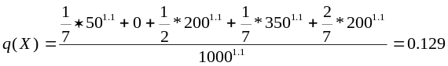

3 Clustering Algorithms that Discover Interesting Regions
As part of our research, we have designed and implemented seven supervised clustering algorithms three of which will be described in this Section.
3.1 Supervised Clustering Using Agglomerative Hierarchical Techniques (SCAH)
SCAH is an agglomerative, hierarchical supervised clustering algorithm. Initially, it forms single object clusters, and then greedily merges clusters as long as the clustering quality improves. In more detail, a pair of clusters (c_{i}, c_{j}) is considered to be a merge candidate if c_{i} is the closest cluster to c_{j} or c_{j} is the closest cluster to c_{j}. Distances between clusters are measured by using the average distance between the objects belonging to the two clusters. The pseudo code of the SCAH algorithm is given in Fig. 2.

Inputs:
A dataset O={o₁,...,o_{n}}
A dissimilarity Matrix D = {d(o_{i},o_{j}) | o_{i},o_{j} ∈ O },
Output:
Clustering X={c₁, c₂, …, c_{k}}

Algorithm:
- Initialize:
Create single object clusters: c_{i} = {o_{i}}, 1≤ i ≤ n;
Compute merge candidates
- DO FOREVER
  - Find the pair (c_{i}, c_{j}) of merge candidates that improves q(X) the most
  - If no such pair exist terminate, returning X = {c₁, c₂, … c_{k}}
  - Delete the two clusters c_{i} and c_{j} from X and add the cluster c_{i} U c_{j} to X
  - Update merge candidates
Fig. 2. The SCAH Algorithm
In general, SCAH differs from traditional hierarchical clustering algorithms which merge the two clusters that are closest to each other in that it considers more alternatives for merging clusters. This is important for supervised clustering because merging two regions that are closest to each other will frequently not lead to a better clustering, especially if the two regions to be merged are dominated by instances belonging to different classes.
3.2 Supervised Clustering Using Hierarchical Grid-based Techniques (SCHG)
Grid-based clustering methods are designed to deal with the large number of data objects in a high dimensional attribute space. A grid structure is used to quantize the space into a finite number of cells on which all clustering operations are performed. The main advantage of this approach is its fast processing time which is typically independent of the number of data objects, and only depends on the number of occupied cells in the quantized space.
SCHG is an agglomerative, grid-based clustering method. Initially, each occupied grid cell is considered to be a cluster. Next, SCHG tries to improve the quality of the clustering by greedily merging two clusters that share a common boundary. The algorithm terminates if q(X) cannot be improved by further merging.
3.3 Supervised Clustering Using Multi-Resolution Grids (SCMRG)
Supervised Clustering using Multi-Resolution Grids (SCMRG) is a hierarchical grid based method that utilizes a divisive, top-down search: each cell at a higher level is partitioned further into a number of smaller cells in the next lower level, but this process only continues if the sum of the rewards of the lower level cells is higher than the obtained reward for the cell at the higher level. The returned cells usually have different sizes, because they were obtained at different level of resolution. The algorithm starts at a user defined level of resolution, and considers three cases when processing a cell:
- If a cell receives a reward, and its reward is larger than the sum of the rewards associated of its children and larger than the sum of rewards of its grandchildren, this cell is returned as a cluster by the algorithm.
- If a cell does not receive a reward and its children and grandchildren do not receive a reward, neither the cell nor any of its descendents will be included in the result.
- Otherwise, all the children cells of the cell are put into a queue for further processing.
The algorithm also uses a user-defined cell size as a depth bound; cells that are smaller than this cell size will not be split any further. The employed framework has some similarity with the framework introduced in the STING Algorithm [13] except that our version centers on finding interesting cells instead of cells that contain answers to a given query, and only computes cell statistics when needed and not in advance as STING does.
4 Measures of Interestingness for Different Region Discovery Tasks
3.1 Class Density-based/Purity-based/Entropy-based
Reward0_{C}(c)= τ_{C}(…)

Reward1(c)= (1-Entropy(c))^{η} with η>0.

Binary Co-location:
Reward2(c)= IF λ_{second}(c)<1 THEN 0 ELSE log₁₀(λ_{second}(c)∗λ_{second}(c)∗λ_{max}(c))

Reward3(c)= IF λ_{second}(c)<1 THEN 0 ELSE λ_{seond}(c)

Co-location with respect to a class of Interest C (γ≥1):
Reward4(c)= IF λ_{C}(c)<1*γ THEN 0 ELSE log₁₀(λ_{C}(c)∗λ_{other_max_not(C)}(c))

Co-location additionally considering prior(C):

increase_{C}(r)= If λ_{C}(r)≤1 then 0
else ((λ_{C}(r)– 1)/((1/(prior(C))-1)))^{δ}
κ_{C1,C2}(r) = increase_{C1}(r)∗increase_{C2}(r)
Reward5(r)= max_{C1,C2;C1≠C2} (κ_{C1,C2}(r))

Case additionally considering a class hierarchy:
Reward5a(r)= maxC1,C2; C1≠C2 and C1∉sup(C2) and C2∉sup(C1) (κ_{C1,C2}(r))

N-ary Co-location:
Reward6(c)= ????

Other forms of Co-location:
Inverse-Co-Location: λ_{C1} high λ_{C2} low
Reward7(c)=…
Anti-Co-Location: λ_{C1} low λ_{C2} low
Reward8(c)=…
Co-location with Cross-K Function:
Reward9(c)= ????

3.2 For Sampling
Entropy-based Measure of Interest for Sampling (1>δ≥0)
Reward10(c)=If entropy(c) < δ
Then 0
Else (entropy(c)-δ) / (1-δ))

Class Stratified Sampling:
Reward11-(c)=max(0,1−|log(λ_{C1}(c))| −... − |log (λ_{Ccl}(c))|)

3.3 Measures involving continuous variables

Variance-based Measures of Interestingness (γ≥1):
Reward12_{att}(c)= IF (var_{att}(c)/var_{att}(O))<1*γ THEN 0 ELSE log₁₀(var_{att}(c)/(var_{att}(O)*γ))
Reward13... (just switch var(c ) and var(O) in the previous formula)

Correlation-based Measures of Interestingness
Reward14(c)
5 Summary
In this paper, we introduced a supervised clustering approach and a reward-based evaluation framework for region discovery. Finding interesting regions in spatial datasets is viewed as a clustering problem, in which the sum of rewards for the obtained clusters is maximized, and where the reward associated with a cluster reflects its degree of interestingness for the problem at hand. We explained that this approach is quite different from most other work in spatial data mining that mostly uses association rules. Different measures of interestingness can easily be supported in the proposed framework by designing different reward-based fitness functions; in this case, neither the supervised clustering algorithm itself nor our general evaluation framework has to be modified. We also discussed how hierarchical, and grid-based clustering algorithms can be adapted for supervised clustering in general, and for region discovery in particular, and presented evidence concerning the usefulness of the proposed framework for hotspot discovery problems. Finally, the paper identified some shortcomings of agglomerative clustering algorithms, such as SCAH. Our current work explores the use preprocessing techniques to speed up SCAH, and on the use of proximity graphs to merge clusters more intelligently.

References
- Basu, S., Bilenko,M., Mooney, R.: Comparing and Unifying Search-based and Similarity-Based Approaches to Semi-Supervised Clustering. in Proc. ICML03 Workshop on The Continuum from Labeled to Unlabeled Data in Machine Learning and Data Mining, Washington DC (2003) 42-29.
- Brimicombe, A.J.: Cluster Detection in Point Event Data Having Tendency Towards Spatially Repetitive Events, 8th International Conference on GeoComputation, Ann Arbor, Michigan (2005).
- Chou, Y.: In Exploring Spatial Analysis in Geographic Information System, Onward Press, (ISBN: 1-56690-119-7), (1997).
- Cressie, N.: In Statistics for Spatial Data, Wiley-Interscience, (ISBN: 0-471-00255-0), (1993).
- Demiriz, A., Benett, K.-P., and Embrechts, M.J.: Semi-supervised Clustering using Genetic Algorithms, in Proc. ANNIE, St. Louis, Missouri (1999).
- Eick, C., Zeidat, N.: Using Supervised Clustering to Enhance Classifiers, in Proc. 15th International Symposium on Methodologies for Intelligent Systems, Saratoga Springs, New York (2005).
- Eick, C., Zeidat, N., Zhao, Z.: Supervised Clustering - Algorithms and Benefits, UH-Technical Report UH-CS-05-10; short version appeared in Proc. International Conference on Tools with AI (ICTAI), Boca Raton, Florida (2004) 774-776.
- Klösgen, W. and May, M.: Spatial Subgroup Mining Integrated in an Object-Relational Spatial Database. In Proc. Principles of Data Mining and Knowledge Discovery Conference (PKDD), Springer-Verlag, Berlin (2002) 275-286.
- Koperski, K., Han, J.: Discovery of Spatial Association Rules in Geographic Spatial Data bases, in Proc. 4th Int. Symp. Advances in Spatial Databases, Maine (1995) 47-66.
- Shekhar, S., Huang, Y.: Discovering Spatial Co-location Patterns: A Summary of Results, in Proc. of 7th International Symposium on Spatial and Temporal Databases (SSTD01), L.A., CA (2001).
- Tay S.C., Lim, K.H., Yap, L.C.: Spatial Data Mining: Clustering of Hot Spots and Pattern Recognition, IEEE (2003).
- UH Data Mining & Machine Learning Group: http://www.tlc2.uh.edu/dmmlg/Datasets.
- Wang, W., Yang, J., Muntz, R.: STING: A Statistical Information Grid Approach to Spatial Data Mining, Proceedings of the 23rd VLDB Conference, Athens, Greece (1997).
- Williams, G.J.: Evolutionary Hot Spots Data Mining, An Architecture for Exploring for Interesting Discoveries, Pacific Asia Conference on Knowledge Discovery and Data Mining, Beijing, China (1999).

.

