Group Homework Credit
Group A Task
1. What does the size of the box of a boxplot measure; what statistical measure is it related to?

2. A R-boxplot (also called Turkey boxplots) of an attribute A has whiskers at 2 and 10; what does this tell you about attribute A? What attribute values are typically considered to be outliers in boxplots?
- Comparing Histograms
x<-c(1,2,2,2,4,4,8,9,9,10,20,30, 31, 32, 34, 35, 35, 36, 40,42)
y<-c(0,1,1,1, 4,5,5,5,8,9,9,10,11,12, 13,18,19,19,20,30)
Compare the boxplots for datasets x and y which have been created using the R-commands: boxplot(x) and boxplot(y).

Summarize your findings in a slide/set of slides!

Group Homework Credit
Group B Task
Interpret the supervised scatter plot depicted below that consists of instances of 3 classes called 70, 76 and 82; moreover, assess the difficulty of separating instances of the 3 classes using attributes MPG and Weight based on the scatter plot!
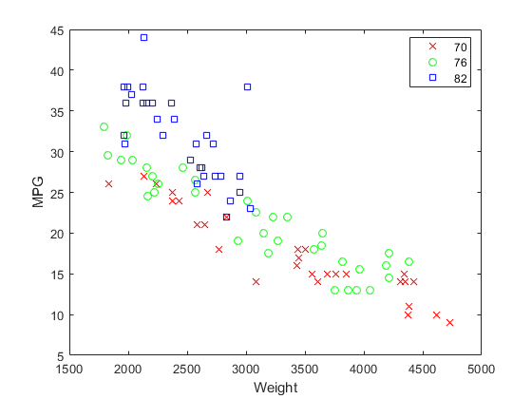

Group Homework Credit
Group C Task

Suppose we create the following histograms to compare the exam scores for 2 groups of students of equal size which were taught using two different methods.
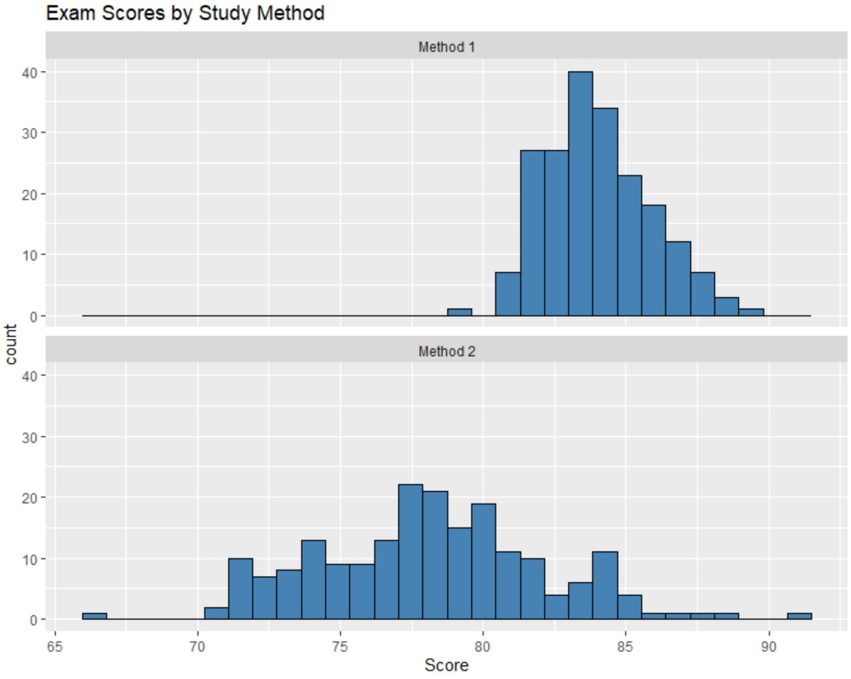
Characterize the 2 histograms! Next, compare the two histograms! What do they tell you concerning the effectiveness of Method1 and Method2?

