Group C Homework Group Credit Task
To be presented during the lecture on Tuesday, Sept. 19.

Characterize and compare the following 3 histograms for the attribute sepal length that have been created for instances of Setosa, Virginica, and Versicolor Iris flowers. Also briefly assess the difficulties in separating the 3 types of Iris flowers using sepal length. You can assume in your analysis that the number of Setosas, Virginicas and Versicolors in the dataset that was analyzed is the same.

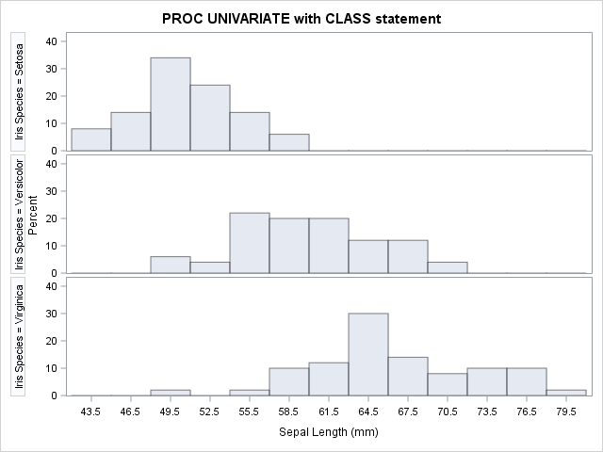

Group D Homework Group Credit Task
To be presented during the lecture on Thursday, Sept. 21

Compute the GINI-gain and information gain for the following decision tree split:

(10,5,5) (3,4,0)
(7,0,0)
(0,1,5)

We assume we have a classification problem involving 3 classes C1, C2, C3. The above information can be interpreted as follows: Before the split there are 10 examples belonging to class C1, 5 examples of class C2, and 5 examples of C3 associated with the node. After a 3-way split 3 new nodes are introduced and 3 examples of class A and 4 examples of class B are associated with the first new node, 7 examples of class C1 are associated with the second new node, and 1 example of C2 and 5 examples of C3 are associated with the third new node.

(GINI before the split) minus (GINI after the split)
Entropy before the split minus entropy after the split.

