Christoph F. Eick

Group Homework Credit
Fall 2023
Tasks E and F (both will present on Sept. 28, 2023)

Group E Task(s)
A confusion Matrix of a classification model for distinguishing classes A, B, C, D, E and F is depicted below:
What does the entry containing the number six mean? What is the accuracy of the classification model. What is its precision for the classes B and C? What is its recall for the classes B and C? What is the F-measure score for the class C? What advantages/disadvantages do you see in computing F-measure scores instead of computing accuaracy?

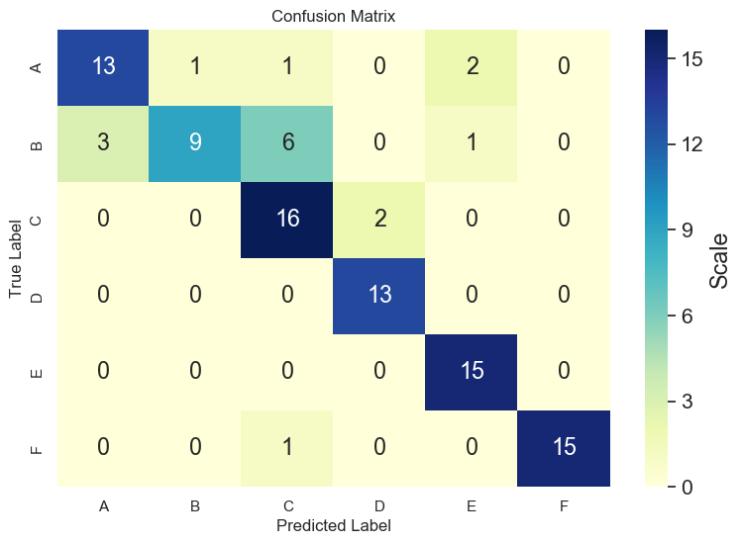

Group Homework Credit
Group F Task
Non-parametric Density Estimation

Dataset O={x₁,x₂,x₃,x₄}
Data Points:
x₁=(1,1), x₂=(4,4), x₃=(6,4), x₄=(4,6)
Query Points:
q₁=(1,2) and q₂=(4,5)

Assume Manhattan distance is used as the distance function.
a. Compute f_{Gauss (}q₁₎ assuming bandwidth σ=1
b. Compute f_{Gauss (}q₂₎ assuming bandwidth σ=1
c. Compute f_{Gauss (}q₂₎ assuming bandwidth σ=3
d. Interpret the 3 results!

Give both the formulas and their actual value for all your answers!
d((x1,y1),(x2,y2))= |x1-x2| + |y1-y2|

