Solution Sketches Midterm Exam1
COSC 4335 Data Mining
March 3, 2016
Your Name:
Your student id:

Problem 1 --- K-means, K-medoids and Clustering in General [16]
Problem 2 --- Similarity Assessment [10]
Problem 3 --- Hierarchical Clustering [8]
Problem 4 --- Data Mining in General [4]
Problem 5 --- Data Analysis [16]

Σ [54]:
Grade:

The exam is “open books” and you have 75 minutes to complete the exam. The exam will count approx. 16-19% towards the course grade.

- K-Means, K-medoids, and Clustering in General [16]

a. What are the goal and objectives of clustering? Limit your answer to 2-4 sentences! [3]

The goal of clustering is to partition a dataset/a set of objects into homogenous, non-overlapping groups in such a way that objects in the same group (called a cluster) are more similar (in some sense or another) to each other than to those in other groups (clusters)[2.5]; that is, its goal is to discovery meaningful groupings [1]. Moreover, identifying outliers—objects do not belong to any group—is important [0.5].

At most 3 points; other observations might receive credit!

b. When does K-means terminate? When does K-medoids terminate? [2]

when there is no more change in the set of centroids/clustering[1.5]; when the objective function/SSE function does not improve[1.5]

c. When using K-means, it is recommended to run K-means multiple times—starting with different initial clusters in each run. What is the reason for this? [3]

K-means employs a steepest decent hill climbing strategy with respect to SSE and climbs the nearest valley from the stating position/initial clustering; consequently, using different initializations K-means ends up on different valleys that differ differ with respect to the SSE of the obtained clustering.

d. Assume we use K-medoids to cluster six objects 1,…,6 and k=2 and our current set of representatives is {1,6} and the object distance matrix is:
0 1 2 3 4 5 object 1’s distance
0 7 7 2 2
0 3 3 2
0 3 6
0 3
0

What cluster does K-medoids form for this set of representatives and what is the
SSE error of the obtained clustering? [3] {1,2,3,4} or {1,2,4} and {5,6} or {3,5,6} and
SSE=1**2+3**2+2**2+3**2=23
No partial credit!
Problem1 Continued
f) Assume the following dataset is given: (1,1), (4,4), (5,5), (7,7), (9,9), (0,6), (6,0). K-Means is used with k=3 to cluster the dataset. Moreover, Manhattan distance is used as the distance function (formula below) to compute distances between centroids and objects in the dataset. Moreover, K-Means’ initial clusters C1, C2, and C3 are as follows:
C1: {(1,1), (4,4), (7,7)}
C2: {(0,6), (6,0)}
C3: {(5,5), (9,9)}
}
Now K-means is run for a single iteration; what are the new clusters and what are their centroids? [5]
d((x1,x2),(x1’,x2’))= |x1-x1’| + |x2-x2’|

Centroids and newly formed clusters
C1: (4,4): (0,6) (6,0) (4,4) (5,5) — assigning (0,6) and (6,0) to cluster C2 is also correct!
C2: (3,3): (1,1)
C3: (7,7): (7,7) (9,9)
Centroids of newly formed clusters: C1: (15/4,15/4) C2: (1,1) C3: (8,8)
One error: at most 3 points two errors: 0-1 points
2. Similarity Assessment [10]
Design a distance function to assess the similarity of gradute students; each customer is characterized by the following attributes:
- Ssn
- qud (“quality of undergraduate degree”) which is ordinal attribute with values ‘excellent’, ‘very good’, ‘good’, ‘fair’, ‘poor’, ‘very poor’.
- gpa (which is a real number with mean 2.8 standard deviation is 0.8, and maximum 4.0 and minimum 2.1)
- gender is an nominal attribute taking values in {male, female}.

Assume that the attributes qud and gpa are of major importance and the attribute gender is of a minor importance when assessing the similarity between students. Using your distance function compute the distance between the following 2 students: c1=(111111111, ‘good’, 2.9, male) and c2=(222222222, ‘very poor’, 3.7, female)!

We convert the Oph rating values ‘excellent’, ‘very good’, ‘good’, ‘fair’, ‘poor’, ‘very poor’ to 5:0 using φ; then we compute the distance by taking L-1 norm and dividing by the range, 5 in this case.
Normalize gpa using Z-score and find distance by L-1 norm
d_{gender}(a,b):= if a=b then 0 else 1
Assign weights 1 to qud, 1 to Power-used and 0.2 to Gender
Now[8]: one error: 2.5-5 two errors: 0-2 distance functions not properly defined: at most 3 points
d(u,v) = 1*|(u.gpa)/0.8 – (v.gpa)/0.8| + 1*|φ(u.qud) – φ(v.qud)|/5 + 0.2*d_{gender}(u.gender, v.gender) /2.2

2 students: c1=(111111111, ‘good’, 2.9, male) and c2=(222222222, ‘very poor’, 3.7, female)!
d(c1,c2)= (1 + 3/5 + 0.2)/2.2= 1.8/22=9/11=0.82 [2]
3. Hierarchical Clustering [8]
A dataset consisting of object A, B, C, D, E with the following distance matrix is given:
distance | A | B | C | D | E
A | 0 | 9 | 2 | 3 | 1
B |  | 0 | 8 | 6 | 5
C |  |  | 0 | 7 | 10
D |  |  |  | 0 | 4
E |  |  |  |  | 0

a) Assume single link hierarchical clustering is applied to the dataset? What dendrogram will be returned? [4]

A-E, A-E-C, A-E-C-D. A-E-C-D, A-E-C-D-B
One error: at most 1 point

b) Hierarchical clustering computes dendrograms; what is the dendogram? What is the value of creating dendrograms—what can they be used for? [4]
A dendrogram is a tree diagram frequently used to illustrate the arrangement of the clusters produced by hierarchical clustering. Edges of the dendrogram represent split/merge relationships between the nodes of the tree which represent clusters[2]

Dendograms organize dataset hierarchically---identifying homogeneous groups at differerent levels of granularity---which is important in bio-informatics and social sciences as it allows for discovering meaningful categories/classes in data.[2]

4. Data Mining in General [4]
What are the goals and objectives of data mining? Limit yourself to 3-5 sentences!

Finding something interesting (patterns/associations), models, groupings, summaries,…) in large amounts of data [2.5]. descriptive and predictive techniques, possibly listing what they do [1], use of interesting measures[1], scalable algorithms that can deal with large amounts of data [1]

At most 4 points; other observations might deserve credit!

5. Data Analysis [18]
a) Assume you have an attribute A with mean value 4 and standard deviation 2; make an estimate of the probability that a value of the attribute A lies in the interval [0,8]—Hint assume that A follows normal distribution! Also give a reason for your answer [3]

If we convert variable A into the into its zscore z_{A}, we obtain
P(0<A<8)=P( 8-4/2 < z_{A} < 0-4/2) = P( -2 < z_{A} <2) = about 95% see http://en.wikipedia.org/wiki/Standard_score

b) The following boxplot has been created using the following R-code for an attribute x:
> x<-c(1,2,2,2,4,4,8,9,9,10,18,22)
> boxplot(x)
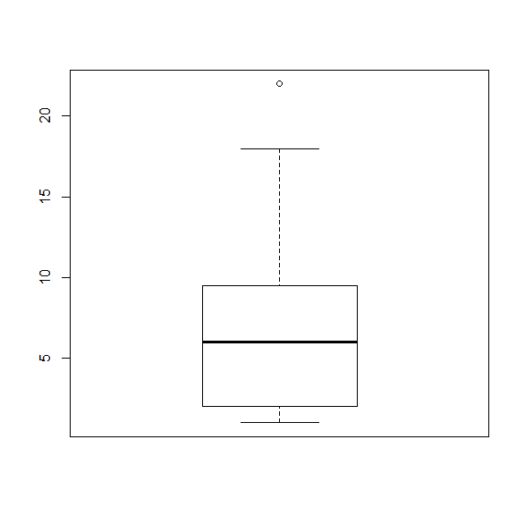
What is the median for the attribute x? What is the IQR for the attribute x? The lower whisker of the boxplot as at 1; what does this tell you? According the boxplot 18 is not an outlier and 22 as an outlier; why do you believe this is the case? [5]

Median is 6=(4+8)/2 [1]
IQR=9.5-2=7.5 [1]
1 is the lowest value in the dataset that is not an outlier [1] Every value that is 1.5*IQR above the 75th percentile is an outlier; that is, for the particular boxplots values above 9.5+1.5*7.5=20.75 and below -9.25 are outliers; consequently, 22 is an outlier and 1 and 18 is not, and the whiskers are therefore at 1 and 18! [2] No partial credit for incorrect answers!

c) Interpret the following histogram that captures the percentage of body-fat in a testgroup [4]:

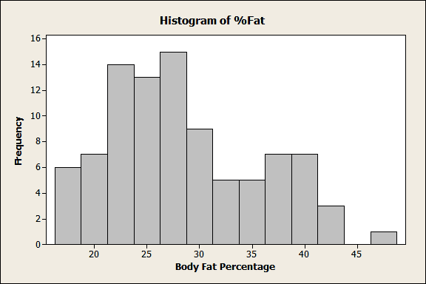

Bimodal, peaks at 27.5 and 37.5 [2.5], one gap/outlier at 45/50[1], somewhat skewed [0.5], somewhat continous, no large jumps in the frequency[1] at most 4 points

d) Interpret the supervised scatter plot depicted below; moreover, assess the difficulty of separating signals and background using attributes x and y based on the scatter plot! [4]

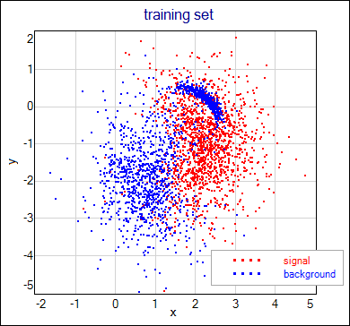

The signal class is centered in a single area (uni-modal) near (2.5,-1) [1] the background class is centered in 2 areas (bi-modal) and focused in two separate regions at (0.5, -2.25) and (2, 0.5) [1] with in=between regions dominated by red examples[0.5]; the classes are separated although some overlap/contamination with example of other classes occurs, particularly near the boundaries [1]; the second region of the background class is very dense[0.5] has a moon-like shape [0.5] and is enclosed by region dominated by signal examples [0.5]. The variable x seems to be more useful in separating the 2 classes; for example, most points less than 1 belong to the background class [1]; however, the variable y is still necessary to correctly classify the examples in moon-like dense are of the background class [0.5].

At most 4 points; slightly varying interpretations might deserve full credit

When assessing the distance between clusters the minimum distance is used.
Triomodal is also correct distinguishing between hills at 20 and 25 is also fine!

