Midterm2
COSC 3337 Data Science I
November 14, 2023
Your Name:
Your student id:

Problem 1 --- DBSCAN [12]
Problem 2 --- Miscellaneous Questions [17]
Problem 3 --- Clustering [16]
Problem 4 --- Density Estimation [11]
Problem 5 --- Neural Networks [12]

Σ [68]:
Grade:

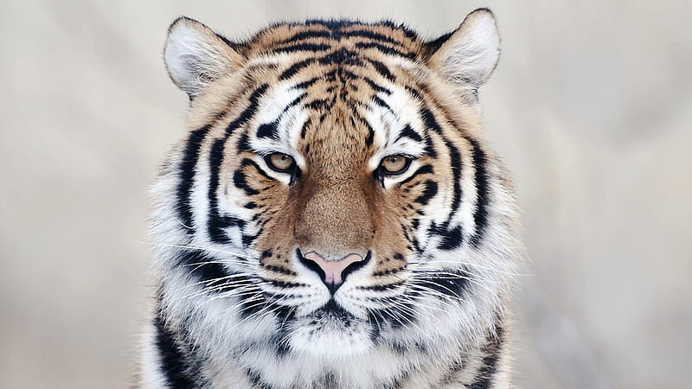

The exam is “open books” and you have 75 minutes to complete the exam. The exam will count approx. 15% towards the course grade. You can use calculators but the use of computers and cell phones is strictly prohibited.
Write your answers on the exam paper; if you need more space use back of exam paper!

1) DBSCAN [12]
A dataset consisting of object A, B, C, D, E, F, G, I and J with the following distance matrix is given:
distance | A | B | C | D | E | F | G | H | I | J
A | 0 | 3 | 9 | 8 | 9 | 10 | 8 | 3 | 9 | 6
B |  | 0 | 9 | 7 | 8 | 9 | 8 | 6 | 8 | 4
C |  |  | 0 | 6 | 6 | 6 | 7 | 6 | 7 | 7
D |  |  |  | 0 | 14 | 15 | 7 | 7 | 7 | 8
E |  |  |  |  | 0 | 4 | 2 | 6 | 7 | 9
F |  |  |  |  |  | 0 | 4 | 7 | 8 | 8
G |  |  |  |  |  |  | 0 | 6 | 9 | 7
H |  |  |  |  |  |  |  | 0 | 8 | 6
I |  |  |  |  |  |  |  |  | 0 | 8
J |  |  |  |  |  |  |  |  |  | 0

- Assume DBSCAN is run for this dataset with MINPOINTS=3 and epsilon=ε=5
How many clusters will DBSCAN return and how do they look like? Which objects are outliers and border points in the clustering result you obtained? Give reason for your answers! [7]

{A,B,H,J} {E,F,G} 4 points at most 1.5 points partial credit for incorrect solutions

Borderpoints: H and J 1.5 points; no partial credit
Outliers: C, D, I 1.5 points no partial credit

b) How does DBSCAN form clusters? [3]

Starting from an unprocessed core points it creates a new cluster and adds points that are density-reachable from this core point to the cluster[2], and continues this procedure for core points that have not been processed yet[1].

Other answers might deserve full or partial credit

c) What is a border point in DBSCAN? [2]
A point which is in the radius of a core point but is not a core point itself.

2. Miscellaneous Questions [17]
a. Describe the role and interactions of narrative, visuals and data in data storytelling! [4]

See slide of Data Storytelling lecture on this subject; they should give a short version of what is discussed on this slide!

b What are the characteristics of a “good data storyteller”? [4]

Essay-style questions; create a rubric based on your own preference and then grade using common sense.

c. How does model-based outlier detection work? Limit your answer to at most 4 sentences! [4]

Basic points they should mention: a. fit a model M to the dataset [2] b. using the model D compute the density of each point o in the dataset and use this density as the outlier score [2].

d. How does the APRIORI algorithm compute k+1 itemset candidates from frequent k itemsets? [3]

Find pairs of frequent K items which share the same k-1 prefix and combine the items to form a K+1 item candidates.

Other answers might deserve partial credit.
e. What is the goal of association analysis? [2]

Finding interesting patterns in a dataset [1] based on an intererestingness function. [1]

Other answers might deserve full credit!

3. Clustering [16]
a) Assume you cluster a 2-dimensional dataset with K-means. Can K-means obtain spatial clusters with the shape a) of an ellipse b) with the shape of a letter T? Give reasons for your answer! [4]
a. T is not a convex shape, cannot be found [2]
b. If they say ellipse is a convex but not a convex polygon cannot be found is correct; if they say ellipse can be quite precisely approximated and there K-means can obtain this shape, this is also correct.

b) Assume you run K-Medoids/PAM for the following dataset consisting of objects A,…,G whose distance function is given below:
distance | A | B | C | D | E | F | G
A | 0 | 1 | 3 | 4 | 19 | 10 | 12
B |  | 0 | 6 | 5 | 8 | 9 | 11
C |  |  | 0 | 6 | 6 | 6 | 2
D |  |  |  | 0 | 14 | 15 | 9
E |  |  |  |  | 0 | 4 | 8
F |  |  |  |  |  | 0 | 7
G |  |  |  |  |  |  | 0
We run PAM for k=2 and the current representative set is {B, C}. What clusters does PAM create from this representative set and what is the SSE of the obtained clustering? [4]
{B, A, D} [2]
{C, E, F, G} [2]

SSE= 1**2+5**2+6**2+6**2+2**2

c) Assume you apply single link/min hierarchical clustering to the following dataset, consisting of objects A,…F whose distances are given below:
distance | A | B | C | D | E | F
A | 0 | 1 | 3 | 4 | 19 | 10
B |  | 0 | 6 | 5 | 8 | 9
C |  |  | 0 | 2 | 7 | 6
D |  |  |  | 0 | 14 | 11
E |  |  |  |  | 0 | 12
F |  |  |  |  |  | 0

What dendrogram is created? [4]
Should give a histogram
Join A and B; Join C and D; Join (A and B) and (C and D); join F with (ABCD); join E with ABCDF

One error at most 1.5 pomts

d) Compute the Silhouette for the point (4,4) for the following clustering which consists of 2 clusters: {(0,0), (0,1), (2,3)} and {(3,3), (4,4)}; use Manhattan distance for distance computations. Interpret the result! [4]
(((3+7+8)/3-2)/6=4/6=2/3 [3] one error at most 1 points
Good [1]

4. Density Estimation [11]
a. How do parametric density estimation techniques find the parameters of models they try to fit to a dataset? For example, if we fit a Gaussian Model to a 1D dataset how does this approach choose the mean value μ and the standard deviation σ? [4]

The idea is to select parameters; e.g. value μ and the standard deviation σ in the case of a Gaussian 1D- distribution---which maximizes the probability of the examples in D: Maximize the sample that is: ∏_{d∈D} P(d|μ,σ)
where P is the density function of the distribution whose parameter need to be selected.

Other solution might deserve credit.

b) Assume a dataset O={x₁,x₂,x₃} with data points x₁=(1,2), x₂=(5,7), x₃=(7,7), is given; moreover, assume Manhattan distance is used as the distance function and q₁=(6,6) is a query point. Compute f_{Gauss (}q₁₎ assuming bandwidth σ=1! [4]
Remark: it is okay to use an expanded formula as your answer; e.g “e⁻¹² + e^{--2.5}…” as your answer; it is not necessary to report the exact value!
f_{Gauss (}(6,6)₎ = e^{−81/2} + e^{−4/2} + e^{−4/2}= e^{-81/2}+ 2* e⁻²

Solutions which use the normalized 2D KDE function also deserve full credit.
c) If you change the bandwidth when using non-parametric density estimation, how does this impact the underlying density function? [3]

It changes how quickly/slowly the influence of a point in the dataset on a query points is reduced when the distance increased.

5) Neural Networks [12]
a) Neural networks employ gradient decent for weight learning. Describe in 3-4 sentences how this approach works! [4]

Things they should mention: a) start with a randomly chosen weight vectore, b) find the gradient for the current weight vector c) take a (small) step in the direction of the inverse gradient d) repeat steps b and c until some convergence is reached.

Problem 5 continued
b) The step size in neural network learning depends—among other factors—on the gradient of the error function; explain why this is important! [4]

If the gradient is large you like to take large steps for faster convergence [2]; on the other hand, if you are close to a local minimum which is characterized by a low gradient you like to take small steps in order not to overshoot the local maximum. [2]

c) Take a look at the sub neural network consisting of nodes A, B, C, and D in the figure below; give a formula that computes the associated error Δ_{A} for a node A. Assume the used activation function is g and its derivative is denoted by g’, and the activation of a node X is denoted by a_{X} and the linear input of a node X is denoted by z_{X}. First provide a general formula; then, replace general variables in the formula by their actual known values. [4]

w_{A,B}=0.2
0.82.0.
0.22.0.
Δ_{B}=0.4

A B
w_{C,A}=1 w_{D,A}=0.5

0.4
0.2

C D
Δ_{A} depends on: the associated error Δ_{B} in the node B, the weight of the connection between A and B and the derivative g’ of the activation function g for the linear input of node A z_{A}.

Formula: Δ_{A}=g’(z_{a})*w_{AB}*Δ_{B}=g’(z_{A})*0.2*0.4=g’(0.4)*0.2*0.4=g’(0.4)*0.2*0.4

The object itself counts towards the number of objects in its ε-radius when determining core points!
E.g. how does it create 4 itemset candidates from frequent 3 itemsets?
d((x1,y1),(x2,y2))= |x1-x2| + |y1-y2|
The direction in which the error function decreases the most.
Also called loss or cost function in some textbooks.

