Christoph F. Eick
Review1 COSC 4335 Fall 2018
September 24 and 26, 2018
- What is the main difference between ordinal and a nominal attributes?
The values of ordinal attributes are ordered; this fact has to be considered when assessing similarity between two attribute values!
- What role does exploratory data analysis play in a data mining project?
create background knowledge about the dataset and the task at hand [1], assess difficulty [1], provide knowledge to help select appropriate tools for the task[1], assess quality of data [1], validate data [1], help to form hypothesis [1], find issues, patterns and errors in data [1]
- What does the size of the box of a boxplot measure; what statistical measure is it related to?
The difference between the 25th and 75th quantile, also called IQR, of the attribute; the size of the box is used as an estimator of the standard deviation of the attribute.
- A R-boxplot (also called Turkey boxplots) of an attribute A has whiskers at 2 and 10; what does this tell you about attribute A? What attribute values are typically considered to be outliers in boxplots?
The largest attribute value that is not an outlier is 10, and the smallest attribute value that is not an outlier is 2; all attribute values that are 1.5IQR or more above the 25% quantile or 1.5IQR below the the 75% quantile of the attribute are considered outliers.
- 5. Interpret the supervised scatter plot depicted below; moreover, assess the difficulty of separating males from females using Factor 1 / Factor 2 based on the scatter plot! [5]

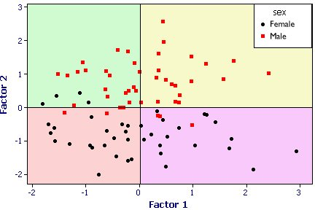
Both the female and male class have a uni-modal distribution; no gaps in data density are visible. Factor2 does mostly a good job in separating females and males; there is only overlap close to 0; Factor1 does a poor job separating the 2 classes. The classification task should not be too difficult as the examples are well separated although there are a few exceptions.
- What is (are) the characteristic(s) of a good histogram (for an attribute)?
It captures the most important characteristics of the underlying density function
- Interpret the following 2 histograms and their relationships which describe the male and female age distribution in the US, based on Census Data.
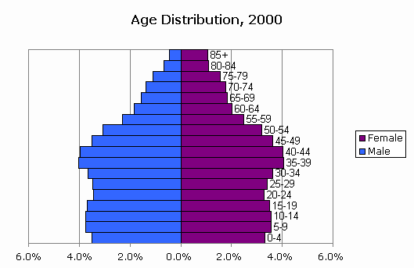
Both histograms: curves are continuous with no gabs or outliers, and somewhat smooth[1], bimodal with 2 (1??; 0??) not well separated maxima at 5-19 and 35-44 [1.5], values significantly drop beyond age 55[1]skewed distribution
Comparison: Curves are somewhat similar until age 55 [1] (although there are more males initially [0.5]); decline in the male curve is significantly steeper---women live longer[1]. Other observations might receive credit; points will be subtracted if you write things which do not make any sense or are false.

- Assume you find out that two attributes have a correlation of 0.02; what does this tell you about the relationship of the two attributes? Answer the same question assuming the correlation is -0.98!
0.02:= no linear relationships exists between the two attributes—but other relationships might exist; 0.98:=a strong linear relationship exists—if the value of one attribute goes up the value of the other goes down
- What of the following cluster shapes K-means is capable to discover? a) triangles b) clusters inside clusters c) the letter ‘T ‘d) any polygon of 5 points e) the letter ’I’
In general, the shapes k-means can discover are convex polygons; consequently, it can only discover triangles and clusters if the shape of the depicted letter I; it will not be able to discover shapes of concave polygons of 5 points!
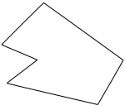concave polygon
- What are the characteristics of clusters K-Medoids/K-means are trying to find? What can be said about the optimality of the clusters they find? Both algorithms a sensitive to initialization; explain why this is the case!
Looking for: compact clusters [1] which minimize the MSE/SSE fitness function[1]
Suboptimal, local minima of the fitness function [1]
Employ hill climbing procedures which climb up the hill the initial solution belongs to; therefore, using different seeds which are on the foot of different hills (valleys) will lead to obtaining different solutions which usually differ in quality [2].

- K-means is probably the most popular clustering algorithm; why do you believe is this the case?
Fast; runtime complexity is basically O(n); also saves time by minimizing an “implicit” objective function
Easy to use; no complex parameter values have to be selected…
Its properties are well understood!
Can deal with high-dimensional datasets
The properties of clusters can be “tweaked” by using different kind of distance functions/Kernel approaches

12. Assume the following dataset is given: (2,2), (4,4), (5,5), (6,6), (8,8),(9,9), (0,4), (4,0) . K-Means is used with k=4 to cluster the dataset. Moreover, Manhattan distance is used as the distance function (formula below) to compute distances between centroids and objects in the dataset. Moreover, K-Means’s initial clusters C1, C2, C3, and C4 are as follows:
C1: {(2,2), (4,4), (6,6)}
C2: {(0,4), (4,0)}
C3: {(5,5), (9,9)}
C4: {(8,8}}
Now K-means is run for a single iteration; what are the new clusters and what are their centroids? [5]
d((x1,x2),(x1’,x2’))= |x1-x1’| + |x2-x2| Manhattan Distance

Centroids:
c1: (4, 4)
c2: (2, 2)
c3: (7, 7)
c4: (8, 8)

Clusters:
C1 = {(4, 4), (5, 5)}
C2 = {(2, 2), (0, 4), (4, 0)} assigning (0,4) and (4,0) to cluster C1 is also correct!
C3 = {(6, 6)}
C4 = {(8, 8), (9, 9)}

13. Assume we apply K-medoids for k=3 to a dataset consisting of 5 objects numbered 1,..5 with the following distance matrix:
Distance Matrix:
0 2 4 5 1 object1
0 2 3 3
0 1 5
0 2
0
The current set of representatives is {1,3,4}; indicate all computations k-medoids (PAM)
performs in its next iteration!
The following cluster is formed: {1,2,5} {3} {4} or {1,5} {2,3} {4} as object 2 has the same distance of 2 to representatives 1 and 3. Let us assume {1,5} {2,3} 5 is selected as the current cluster its SSE is:
1**2+2**2=5; in the next iteration six clusters for representative sets {2,3,4}, {5,3,4},{1,2,4},{1,5,4},{1,3,2},{1,3,5} and the cluster with the lowest SSE is selected, which is
{1,5} {2} {4,3} which orginated from the representative set {1,2,4}; it has a SSE of 1**+1**2=2 and as it is better than the cluster of the previous iteration it becomes the new current cluster and the algorithm continues for at least one more iteration.

14. DBSCAN
a) What are the characteristics of a border point in DBSCAN [2]?

A border point has fewer than MinPts points within Eps but is in the neighborhood of a core point [2].

b) Assume you run DBSCAN with MinPoints=6 and epsilon=0.1 for a dataset and I obtain 4 clusters and 2% of the objects in the dataset are classified as outliers/noise points. Now you run DBSCAN with MinPoints=8 and epsilon=0.1. How do expect the clustering results to change? [4]

Some clusters might disappear [1]
Some bigger cluster might be broken up into several smaller clusters [1]
Some clusters might shrink in size

There will be a decrease in the number of core points. [1]
There will be an increase in the number of outliers. [1]

c) How does DBSCAN form clusters
No answer given!

15. Similarity Assessment
Design a distance function to assess the similarity of gradute students; each customer is characterized by the following attributes:
- Ssn
- qud (“quality of undergraduate degree”) which is ordinal attribute with values ‘excellent’, ‘very good’, ‘good’, ‘fair’, ‘poor’, ‘very poor’.
- gpa (which is a real number with mean 2.8 standard deviation is 0.8, and maximum 4.0 and minimum 2.1)
- gender is an nominal attribute taking values in {male, female}.

Assume that the attributes qud and gpa are of major importance and the attribute gender is of a minor importance when assessing the similarity between students. Using your distance function compute the distance between the following 2 students: c1=(111111111, ‘good’, 2.9, male) and c2=(222222222, ‘very poor’, 3.7, female)!

We convert the Oph rating values ‘excellent’, ‘very good’, ‘good’, ‘fair’, ‘poor’, ‘very poor’ to 5:0 using φ; then we compute the distance by taking L-1 norm and dividing by the range, 5 in this case.
Normalize gpa using Z-score and find distance by L-1 norm
d_{gender}(a,b):= if a=b then 0 else 1
Assign weights 1 to qud, 1 to Power-used and 0.2 to Gender
Now[8]: one error: 2.5-5 two errors: 0-2 distance functions not properly defined: at most 3 points
d(u,v) = (1*|(u.gpa)/0.8 – (v.gpa)/0.8| + 1*|φ(u.qud) – φ(v.qud)|/5 + 0.2*d_{gender}(u.gender, v.gender)) /2.2

2 students: c1=(111111111, ‘good’, 2.9, male) and c2=(222222222, ‘very poor’, 3.7, female)!
d(c1,c2)= (1 + 3/5 + 0.2)/2.2= 1.8/22=9/11=0.82 [2]

A subset of the problems 1-8 and 15 will be discussed on September 24, and a subset of problems 9-14 will be discussed on the lecture on September 26.
If there are any ties, break them whatever way you want!
The one that originates from {1, 3, 2} is identical and therefore equally good.

