Group I GHC Task

To be presented in the lecture on Monday, April 3, 2013

Answer the following questions with respect to support vector machines
a) How do SVMs classify an example?

b) The soft margin support vector machine solves the following optimization problem:
1) What does the first term minimize? 2) What is the purpose of C? 3) Depict all non-zero ξ_{i} in Fig, 3 below! How many examples are classified incorrectly by the SVM in Fig. 1? 6) If ξ_{i} is greater than 0; does this mean example i being classified incorrectly? If we instead apply the hard margin SVM to the dataset depicted in Fig. 1; what will be the result?

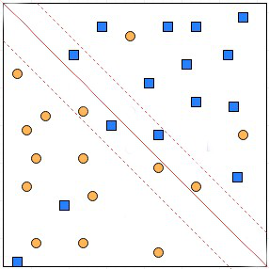

Fig.1: SVM Decision Boundaries for a Dataset containing Two Classes.

