Natnael Sinshaw and Christoph F. Eick

COSC 4368: Fundamentals of Artificial Intelligence Spring 2026
Task2
First Draft
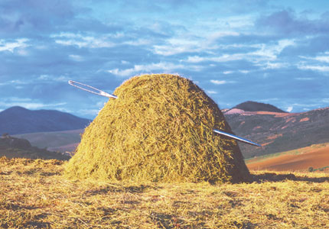
Fig. 1: Finding a Needle in a Large Haystack with Intelligent Search

Submission Deadlines: March 7 end of the day
Last Updated: Feb. 5 at noon

Task2: Probabilistic Search Algorithms: Implementing and Experimenting with Randomized Hill Climbing with Resampling

Implement a randomized hill climbing algorithm with resampling, called RHCR2 in the following, and conduct a set of experiments, minimizing the following function f:

f_{Frog}(x,y)= x∗cos(sqrt(|x+y+1|))∗sin(sqrt(|y−x+1|)) +
(1+y)∗sin(sqrt(|x+y+1|))∗cos(sqrt(|y−x+1|))

with x,y∈[−512,512]

Your procedure should be called RHCR2 and have the following input parameters:
- sp: is the starting point of the Randomized Hill Climbing Resampling2 (RHCR2) run
- p: the number of neighbors of the current solution that will be generated
- z: neighborhood size: for example, if z is set to z=15, p neighbors for the current solution s are generated by adding vectors v = (z₁, z₂) with z₁ and z₂ being random numbers in [-15, +15] uniformly distributed
- seed: which is an integer that will be used as the seed for the random generator you employ in your implementation.

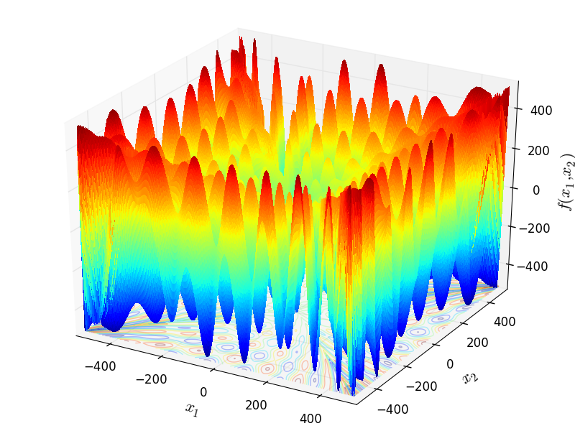
Figure 2: Visualization of f_{Frog}

RHCR2 runs Randomized Hill Climbing 3 times, using sp as the starting position for the first run, the result of the first run sol1 as the start position of the second run which uses a smaller neighborhood size of z/20, and uses the result of the second run sol2 as the starting position of the third run which uses a much smaller neighborhood size of z/400, returning sol3. RHCR2 returns sol1, sol2, and sol3 as well as f(sol1),f(sol2) and f(sol3) and reports how often function f was called in the three runs of RHC and the total number of calls.

RHCR2(sp,z,p,seed);
sol1=RHC(sp,z,p,seed);
sol2=RHC(sp,z/20,p,sol1,seed);
sol3=RHC(sp,z/400,p,sol2,seed);
Return {(sol1,f(sol1)),(sol2,f(sol2)),(sol3,f(sol3))};
Algorithm1: Pseudo code of RHCR2

Run your randomized hill climbing procedure RHCR2 twice for the following parameters:
sp = (-300,-500), (0,0),(-222,-222), (-510,400)
p = 150 and 400; z = 12 and 60

REPORT
- For each of the 32 runs report:
a. the best solution (x, y) found and its value for f
b. number of solutions generated during the run.

- Summarize your results in 4 tables using the format depicted in Fig. 2; one for each p and z combination ⁽see example below).

- Finally, run RHCR2 two more time with “your preferred choice” of values for sp, p, z, and report the result; students, who find better solutions in the 33rd and 34th run will get more points for the this subtask.

- Interpret the obtained results evaluating solution quality, algorithm speed, impact of sp, p, and z on solution quality and algorithm speed. Summarize and interpret the complexity of the RHCR2 runs!

- Did the resampling option lead to better solutions? Do you believe with other values for p and z better results could be accomplished? Finally, assess if RHCR2 did a good, medium, or bad job in computing a (local) minimum for f.

p/z for sp = (-300,-500),  p=150 & z=12 | Run1 |  |  | Run2
p/z for sp = (-300,-500),  p=150 & z=12 | Number of solutions searched in the first, second and third run of RHC, and the sum of the 3 numbers  in  S s | <SOLUTION 1, SOLUTION 2,  SOLUTION 3> | Result f(sol1),f(sol2),f(sol3) | … | Bes … | F …
p=150 & z=60
p=400 & z=12
p=400 & z=60
Fig. 3: Table Template to report the results of the 34 runs of RHCR2

You should summarize your results in 4/8 tables formatted as the above, for each of the 4 combinations of p & z. Don’t forget to summarize the results of your 33rd and 34th run and to provide the other information asked for in the task specification!

/* FROG FUNCTION DEFINITION in C++
AUTHOR: Raunak Sarbajna*/

#include <cmath>
#include <iostream>

double frog (const double x[])
{
double x1 = x[0];
double x2 = x[1];

double term1 = x1 * sin (sqrt (fabs (x2 + 1 - x1))) * cos (sqrt (fabs (x1 + x2 + 1)));
double term2 = (x2 + 1) * cos (sqrt (fabs (x2 + 1 - x1))) * sin (sqrt (fabs (x1 + x2 + 1)));

return term1 + term2;
}

int main ()
{
double x[] = { -100, 100 };
double result = frog (x);
std::cout << "f4(x) = " << result << std::endl;
return 0;
}

PYTHON:
import numpy as np

def frog(x):
x1, x2 = x
return (x1 * np.sin(np.sqrt(np.abs(x2 + 1 - x1))) * np.cos(np.sqrt(np.abs(x1 + x2 + 1))) +
(x2 + 1) * np.cos(np.sqrt(np.abs(x2 + 1 - x1))) * np.sin(np.sqrt(np.abs(x1 + x2 + 1))))

# Example usage
x = np.array([-100,100])
result = frog(x)
print(result)

Fig. 4: C++ and Python Code for f_{Frog}

Submission Guidelines:
The followings are expected for submission:
- A clearly written report. The report should include the followings:
- All 4 tables of obtained results
- Random seed used for your experiments
- Expected results interpretation and conclusions as described above
- Summary of your 33rd run and 34th run
- Source code (Implemented in any language of your choice with a README file of program instructions)
- Submission will be on MS Teams (Submission link will be available once the assignment is created)

Failure to follow all instructions will lead to point deductions!

Useful Links:
Random Number Generator: How Do Computers Generate Random Numbers? (freecodecamp.org)

A vector (x₁,x₂)∈[-512,+512]×[-512,+512]; sample code to visualize f can be found in MS Teams!
If you run RHCR2 with the same values for sp, p, z and seed, it will always return the same solution; if you run if with the same values for sp, p, z and a different seed, it likely will return a different solution and the number of solutions searched is almost always different.
Make sure you use a different seed for your random generator to get a different sequence of random numbers for the 2 runs!
Count the number of times function f is called during the search!
At least 25% of the available points will be allocated to interpreting the results.
Also briefly explain why you chose the particular input parameters for sp, p and z for the two additional runs.

