Christoph F. Eick and Natnael Sinshaw

CNN-Based Clothing Classification
COSC 4368: Fundamentals of Artificial Intelligence | Spring 2026

Task 4 (Individual)
Submission Deadline: April 24, 2026
Last updated: April 12, 2p
Responsible TA: Natnael Sinshaw
Task Weight: 16-22 % of the assignment points

Overview
Build, train, and evaluate Convolutional Neural Networks (CNNs) for classifying clothing images. You'll develop multiple architectures, apply data augmentation, and compare performance using comprehensive metrics.

Learning Objectives
- Design and implement CNN architectures from scratch
- Apply data augmentation and regularization techniques
- Analyze model performance using metrics, confusion matrices, and visualizations
- Compare different CNN architectures
- Document findings effectively in a Jupyter notebook

Dataset: Clothing Dataset (Kaggle)
Source: https://www.kaggle.com/datasets/agrigorev/clothing-dataset-full
The Clothing Dataset contains approximately 5,000 colored images across 10 clothing categories (t-shirt, dress, jeans, shoes, etc.). Unlike Fashion-MNIST, these are real-world RGB images with varying backgrounds, poses, and lighting conditions.
Key Characteristics:
- Format: RGB color images (varied resolutions)
- Size: ~5K images total, but use only 1K images
- Categories: 10 clothing types
- Challenge: Real-world complexity with natural variations
- Usage: Use the following subset of the dataset instead the full dataset (1000 images) for Task4: https://github.com/alexeygrigorev/clothing-dataset
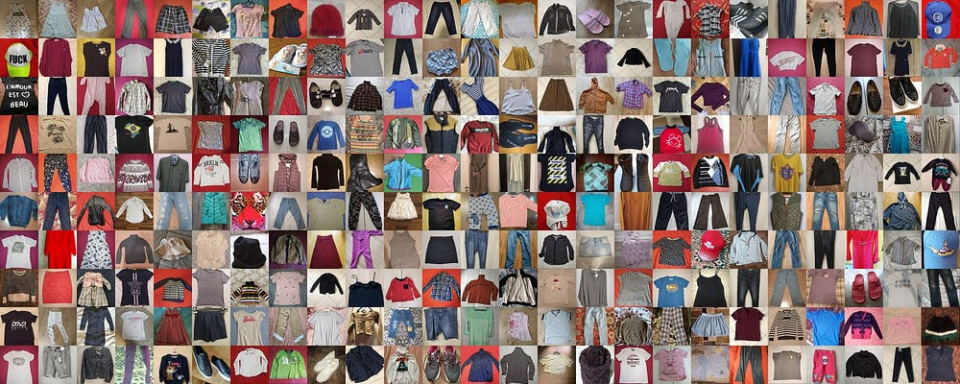

Task Requirements

SECTION 1: Data Preprocessing and Basic CNN (20 points)
1.1 Data Loading and Preprocessing (5 points)
- Load images from Kaggle dataset subset and organize by class
- Resize to consistent dimensions (128x128 recommended)
- Normalize pixel values to [0, 1] range
- Split into 70% train, 15% validation, 15% test
- Visualize sample images from each category
1.2 Basic CNN Architecture (10 points)
Design a CNN with:
- Convolutional layers: Minimum 2 layers with ReLU activation
- Pooling: Max pooling after conv layers
- Regularization: Batch normalization + Dropout (0.2-0.5)
- Dense layers: Fully connected layers before output
- Output: 10 units with softmax activation
- Print model summary showing parameter count
1.3 Model Training (5 points)
- Optimizer: Adam or SGD
- Loss: Categorical cross-entropy
- Epochs: 10-20 with batch size 32/64/128
- Early stopping: Monitor validation loss
- Save: Best model based on validation accuracy
- Visualize: Training/validation accuracy and loss curves

SECTION 2: Evaluation and Analysis (20 points)
2.1 Performance Metrics (20 points)
- Test set accuracy, precision, recall, and F1-score per class
- Classification report in table format
- Generate and visualize confusion matrix for all classes
- Identify most commonly confused category pairs
- Show 5 correct predictions (one per random class)
- Show 10 misclassified examples with predicted vs. true labels
- Written analysis: 1 paragraph explaining misclassification patterns (e.g., why certain items are confused)

SECTION 3: Advanced Techniques (40 points)
3.1 Data Augmentation (15 points)
- Implement: rotation (45degree)
- Train new model with same architecture using augmentation
- Compare performance with/without augmentation
- Visualize augmented image examples
- Written analysis: 1 paragraph on how augmentation affected performance and generalization
3.2 Architecture Comparison (25points)
- Design deeper CNN with 4 convolutional layers
- Experiment with kernel sizes (3x3, 5x5), filter counts
- Train and compare with basic model (models built from the scratch vs augmentation applied models)
- Comparison table: Model name, parameters, training time, test accuracy, F1-score

SECTION 4: Final Analysis (20 points)
Comprehensive Report:
- Summary comparing all models (basic, augmented, deeper architecture)
- Discussion of which categories are easier/harder to classify and why
- Challenges encountered and solutions implemented
- Key insights and recommendations

Deliverables
Submit to Canvas (do not zip):
- Jupyter Notebook (.ipynb) with code, outputs, visualizations, and markdown explanations
- Code comments for key implementation details
- Saved best-performing model with loading instructions
Academic Integrity:
- Cite all external sources and code references
- If using LLMs (ChatGPT/Claude/Gemini) for code assistance, cite in code comments
- Do not use LLMs for written analysis - demonstrate your own understanding

Resources
- Clothing Dataset: https://www.kaggle.com/datasets/agrigorev/clothing-dataset-full
- TensorFlow/Keras: https://www.tensorflow.org/api_docs/python/tf/keras
- PyTorch: https://pytorch.org/docs/stable/index.html
- Image Data Loading: ImageDataGenerator (Keras) or ImageFolder (PyTorch)

Conduct four new experiments for architectural comparison!

