Review on April 28, 2026
For the April 30, 2:30p Second Course Exam
1) Belief Networks and Naïve Bayes
a) Consider the following belief network that consists of variables A, B, C, D, E all of which have two states {true, false} and whose structure is depicted below is given.

B
A D E
C
- Is A|∅ d-separable from E|∅. Given reasons for your answer! [4]

There are two paths:
A-C-D-E and A-B-D-E

The first path is blocked in node C (pattern3 as C in not in evidence) and
The second path is blocked in B (pattern3 as B is not in evidence)
As both paths are blocked, A and E are independent

- Is B|A d-separable from C|A. Give reasons for your answer! [4]

There are two paths: B-D-C and B-A-C
The first path is not blocked in node D, as D is not in evidence
The second path is blocked in A (pattern2 as A is not in evidence) if they do not write that line they still deserve full credit
As the first path is not blocked B|A is not d-separable (independent) from C|A
Bbn.pptx

- What advantage you see in using Belief Networks instead of using a naïve Bayesian approach? [4]

Using Belief-networks you can express dependencies between random variables that are not independent of each other, using domain specific knowledge. By doing that BBNs will obtain “better”, more accurate predictions than the naïve Bayesian approach, as making conditional independence assumptions that are violated by the observed data will increase prediction errors.

- Assume P(D)=0.02, P(S1)=0.2 P(S1|D)=0.4 P(S2)=0.1 P(S2|D)=0.3. Compute P(D|S1,S2) using a Naïve Bayesian approach! [3]

P(D|S1,S2)=0.02*2*3=0.12

2) All kind of Questions

a) Neural networks that use at least one (or a lot) intermediate layers have been much more successful than 2-layer neural networks which directly link inputs with outputs. Why do you believe this is the case? [3]

The intermediate layer allows to create new features that facilitate getting high accuracy models. [3].
Other answers might deserve partial credit to up to 2 points.
b) How does stochastic gradient decent (SGD) work?

Determine batch size (e.g. we choose batch size of 2000 for a dataset D with 10000 examples).

Batches are created as follows: D’:=D obtain 2000 example using sampling without replacement from D’; this is your new batch; if D’ is empty replace by D before sampling!

Weight Learning:
DO UNTIL FINISHED
Get next batch
Update Weights using the next batch
ENDDO

Notes:
- As batches are different, SGD works with slightly different loss functions
- This allows SGD to escape “bad” local minima, which is an advantage over classical gradient decent.
- However, the fact stated in a makes it challenging for SGD to converge—classical gradient decent converges more quickly; therefore optimizers such as ADAM use learning rate reduction schedules which reduce the learning rate from its original value to close to 0 at the end of the run, to guarantee convergence.
- Using Sampling with Replacement guarantees that each training exams is used equally
c) Why did generators—e.g. obtained using a variational autoencoder—gain a lot of importance recently:
a. Can create novel design, novel faces, novel stories,…
b. Can be used to augment train sets to alleviate the problems of overfitting
Moreover, Autoencoder can also be used for dimensionally reduction and outlier detection

3) Hidden Markov Models
1. What HMM are mathematically: λ = (A, B, Π), parameter set of HMM
2. Take a look at the weather activity HMM in https://en.wikipedia.org/wiki/Hidden_Markov_model
3. What kind of questions can be answered using HMMs? What are popular algorithms used in conjunction with HMM (need not to know, how the algorithms work)

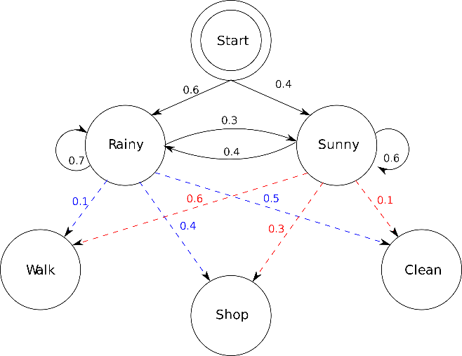
Assume the above hidden Markov Model C is given (taken from the HMM Wikepedia page) with states Rainy (R for short) and Sunny (S for short) and outputs Walk (W for short), Shop (S for short) and clean (C for short).

- What does the edge labled with 0.4 going from the node Sunny to node Rainy mean? [1.5]
The probability of going from state Sunny to state Rainy in the next step is 0.4.

- What does the edge labeled with 0.6 going from node Sunny to node Walk mean? [1.5]
The probability of outputing Walk when in state Sunny is 0.6.

- What kind of problems can be solved with HMMs? Also mention one important application of HMMs. [4]

HMMs allow the prediction of “most” likely state sequences/being in a single state of a probabilistic state space (Markov chain) based on observed output sequences whose probabilities to occur are state dependent. [3] Viterbi algorithm - Wikipedia
HMM allow to infer the likelihood of hidden state sequences (in probabilistic state space) based on observed outputs sequences whose probabilities to occur are state dependent.
There are also algorithms that learn HMMs from training data.

Hidden Markov Model (HMM) is a statistical Markov model in which the system being modeled is assumed to be a Markov process — call it X — with unobservable ("hidden") states. As part of the definition, HMM requires that there be an observable process Y whose outcomes are "influenced" by the outcomes of X in a known way. [2]
Applications: Gene Sequence Analysis, speech recognition, robot localization [1]

- What does the forward algorithm compute and how does it compute it

α_{k}(s) seeing y₁,…,y_{r}

Where k is a point of time, s is a state of the HMM and y₁,…,y_{r} is the observed output sequence

Probability being in s at timestep k (additionally) seeing y₁,…,y_{k} (with k≤r)

SHMM.pptx

4) Neural Networks
a) Describe how multi-layer neural networks, consisting of 3+ layers learns a model for a training set! Limit you answer to at most 9 sentences! [7]

Neural network learning tries to find weights that minimize the error in the neural network prediction for a training set [1]. Neural networks employ gradient decent hill climbing to find the “best” weights. [1]. In particular, Neural network learning adjust weights using the gradient of the error function of the training set [1]; the search starts with a random initial weight vector and weights are adjusted in the direction of the steepest negative gradient of this error function---that is weights are updated accordingly moving in the direction that reduces the error the most [2]; The step width of this weight update depends on the learning rate and other factors [1]. In order to apply this procedure the error for each none-input node has to be known. As this error is not initially given intermediate for intermediate layer nodes, it is computed using the back-propagation algorithm [2].

Other observation might deserve credit. At most 7 points!

b) Assume the following subset of a neural network is given:

w_{A,B}=0.2
0.82.0.
0.52.0.
Δ_{B}=0.4

A B

Assume that B is an intermediate node of a neural network, the forward propagation activation values of nodes a_{A} and a_{B} are 0.5 and 0.8 and the current value of W_{A,B} is 0.2; the associated error Δ_{B} of node B that was computed by the back propagation algorithm is 0.4, the learning rate γ is assumed to be 0.5. First give the general weight update formula and then compute the new value of weight w_{A,B}! [5]

Formula: w_{AB}= w_{AB} + γ*a_{A}*Δ_{B} [1]

where a_{A} denotes the activation of node A; we receive as the new weight of W_{AB}:

W_{AB}=0.2 + 0.5*0.5*0.4=0.2+0.1=0.3 No Partial Credit.

c) How does dropout training for neural network work?

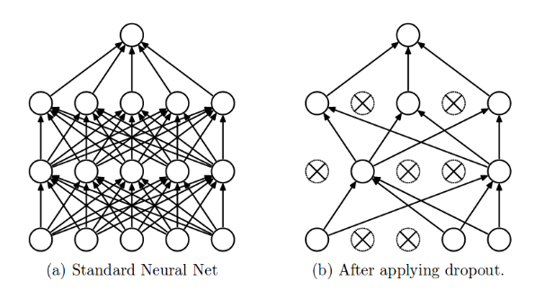Figure 1: Dropout applied to a Standard Neural Network (Image by Nitish)
What is a Dropout?
The term "dropout" refers to dropping out the nodes (input and hidden layer) in a neural network (as seen in Figure 1). All the forward and backwards connections with a dropped node are temporarily removed, thus creating a new network architecture out of the parent network. The nodes are dropped by a dropout probability of p.

Dropout training adjust the weights for a subset of the connections and this subset changes over during the course of the training.

Drop out reduces model complexity as the model complexity is reduced as only a subset of neurons is used in training and therefore overfitting. Moreover it reduces co-adaptation:

When overfitting occurs, the model learns the statistical noise. To be precise, the main motive of training is to decrease the loss function, given all the units (neurons). So in overfitting, a unit may change in a way that fixes up the mistakes of the other units. This leads to complex co-adaptations, which in turn leads to the overfitting problem because this complex co-adaptation fails to generalize on the unseen dataset.
Now, if we use dropout, it prevents these units to fix up the mistake of other units, thus preventing co-adaptation, as in every iteration the presence of a unit is highly unreliable. So by randomly dropping a few units (nodes), it forces the layers to take more or less responsibility for the input by taking a probabilistic approach.

d) What is a kernel (filter) in CNN?

Kernel in Convolutional Neural Networks (CNNs)
Study carefully the lecture taught by Natnael; there will be also 1-2 Task4 specific questions.

A kernel (also referred to as a filter) is a small matrix used in Convolutional Neural Networks (CNNs) to extract features from input data, such as images. Kernels play a crucial role in enabling CNNs to detect patterns like edges, textures, and shapes, which are essential for tasks like image classification, object detection, and segmentation.
How Kernels Work in CNNs
Kernels slide across the input data (e.g., an image) and perform element-wise multiplication followed by summation. This operation, known as convolution, generates an output called a feature map or activation map, which highlights the detected features.
- Structure: Kernels are typically small (e.g., 3x3, 5x5) compared to the input size. Their depth matches the number of input channels (e.g., 3 for RGB images).
- Learning: Kernel values are not predefined but are learned during training through backpropagation, enabling the network to adapt to specific tasks.
- Feature Hierarchy: Multiple kernels are used in each layer, allowing the network to capture simple features (e.g., edges) in early layers and more complex patterns (e.g., shapes) in deeper layers.

e) What do pooling layer in CNN do?

A Pooling Layer in Convolutional Neural Networks (CNNs) is used to reduce the spatial dimensions (width and height) of feature maps while retaining the most important information. This is achieved by sliding a filter over the input feature map and applying a pooling operation, such as taking the maximum or average value within the filter's region.f)

5. AutoEncoders

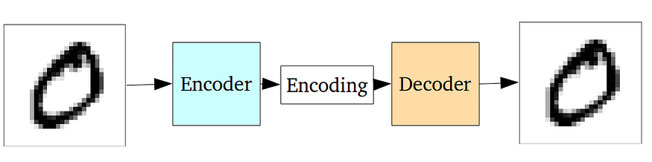
A standard Autoencoder

What is the loss function for auto encoders? How is it different from the loss functions used by neural network for prediction and classification tasks?

The entire network of an autoencorder is usually trained as a whole. The loss function is usually either the mean-squared error, Euclidian or other loss functions or cross-entropy between the output and the input, known as the reconstruction loss, which penalizes the network for creating outputs different from the input. Often loss functions are additionally regularized. Regularization in Machine Learning - GeeksforGeeks

Loss functions of prediction and classification tasks on the other hand compute the differences between the computed output and the expected output for training examples.

b) What happens if we reduce the dimensionality of the hidden layer (e.g. from 12D to 8D)

The reconstruction error goes up!

6. Supervised Learning

a. What are the characteristics of overfitting when learning decision trees? What can be done to deal with overfitting? [3]

The tree is too large, the training error is 0 or very low but; the testing error is not optimal
To alleviate overfitting
1. reduce the size of the tree
2. increase the size of the training set by adding new training examples

b) A confusion Matrix of a classification model for distinguishing dogs, cats and rabbits is given below:
What is the accuracy of the classification model; what is its precision for class rabbit? What is its recall for class rabbit? It is okay to represent your answers as fractions; e.g. 17/36! [3]
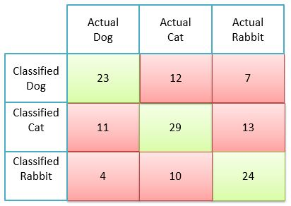

Accuracy=23+29+24/(total number of examples)
Precision rabbit: 24/(24+10+4)=24/38
Recall rabbit: 24/(24+13+7)

∅ represents “no evidence”; question i basically asks if A and E are independent; that is, if P(A∧E)=P(A)*P(E)

