In-class Activity Thursday, Feb. 5 COSC 4368

Consider the following World called DEF is given:

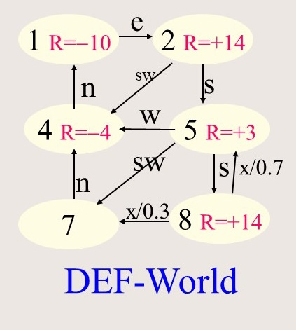
- Give the Bellman equations for states 2 and 8, assuming γ=0.4.
U (s) = R(s) + γ*max_{a}Σ_{s’} T(s,a,s’)*U (s’)

U(2)=…
U(8)=…
- Assume we apply Q-learning, assuming the agent starts in state 2 and applies the operator sequence sw-n-e-sw; assume the initial q-values are all 0; what are the new q-values that will be computed by Q-Learning? Assume α=0.5 and γ=1 in your computations. [4]
Remark: Assume that the reward R(a,s) of applying a to s reaching s’ is the reward associated with state s’; e.g. the reward for applying n in state 7 is -4.
Q(a,s) Q(a,s) + α [ R(a,s) + γ*max_{a’}Q(a’,s’) - Q(a,s) ]
Q(sw,2) =
Q(n,4) =
Q(e,1) =
Q(sw,2) =

- What does the discount rate γ in the above two equations determine? What happens if we set γ to 0?

Solution Sketches
a)
U(2)=…14+0.3*max(U(4),U(5))
U(8)=…14+0.4*(0.3*U(7)+0.7*U(5))

b)
Q(sw,2) = 0 + 0.5(-4+1*0-0)= -2
Q(n,4) = 0 + 0.5(-10+0-0) = −5
Q(e,1) = 0+ 0.5(14+max(0,-2) -0) = 7
Q(sw,2) = -2+0.5*(-4+ −5 +2)=-2-3.5=−5.5

c) it determines how important ‘the future’ is in utility calculations—in the case of Bellman Update it is the sum of utility of the best successor state and the reward obtained in s, whereas in the case of q-learning it is the sum of the utility of the best action applied to the successor state s’ and the reward obtained by apply a to s reaching s’. If gamma is set to 0, we just care about rewards and not about the highest q-value for s’.

