Dr. Eick
COSC 6335 “Data Mining” Spring 2026
Task3—Individual Task
Analyzing Collocation Patterns Involving Building Types in a City

Deadline: April 24, 2026
Last updated: April 8, 9a
Weight: Task3 has 50-58% of the weight of Task1.

This tasks centers on mining collocation patterns in Point of Interest (POI) Datasets where examples are assumed to have the form: <longitude, latitude, category or class>. For example, the City of Chicago has such a POI dataset that contains every building in Chicago which can be found at: https://data.cityofchicago.org/Buildings/Building-Footprints-current-/hz9b-7nh8

Figure 1 visualizes such a building dataset that contains the buildings and building type information of three neighborhoods of a city named after the lost city of Zinj. The Zinj.kml dataset can be found at: http://www2.cs.uh.edu/~ceick/DM/Zinj.kml
The dataset is a kml file that can be opened using Google Earth, Notepad, and probably using ArcGIS; the dataset needs to be preprocessed and converted into a POI dataset, called Z in the following, extracting the relevant information, before it can be used for Task3.

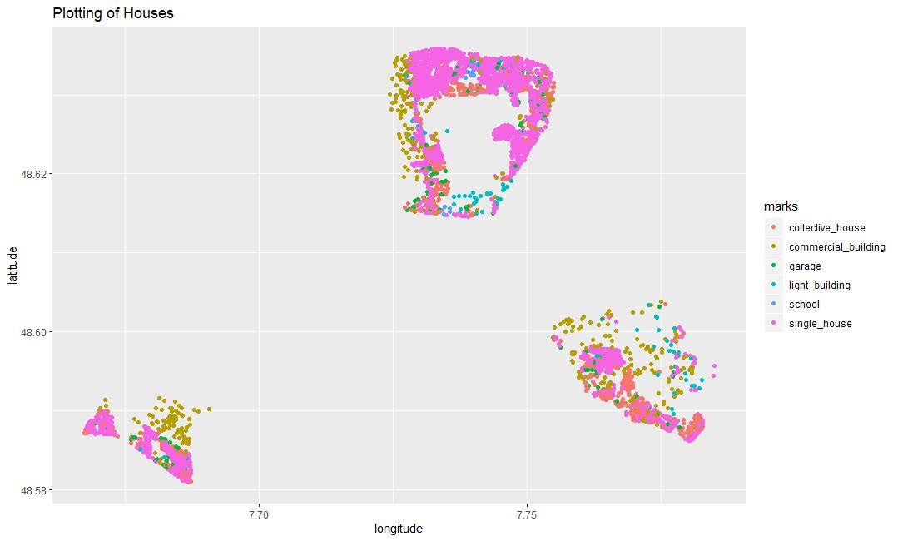
Fig. 1: Visualization of the buildings in Zinj.kml.
Task3 centers on analyzing collocation patterns with respect to the following six building types in the dataset: single_house, garage, commercial_building, light_building, collective_house, and school. Questions we might be interested in answering include:
- Are buildings randomly distributed or is there some clustering?
- Are buildings of the same type collocated, anti-collocated or randomly distributed?
- Are building belonging to different building types collocated, anti-collocated or are their locations independent of each other—for example, you will try to answer the question if garages are collocated with commercial buildings.

The main objective of Task3 is to give conclusive answers to questions 2 and 3 for a few building types. However, we limit yourselves to answering question 2 for commercial buildings and question 3 to collocation patterns between collective houses with the other 5 building types. Many suitable approaches exist to accomplish this goal; consequently, I expect a lot of variation with respect to methods different students apply to answer the last two questions.

You might analyze the distance characteristics of these associations using K-functions and other curves or statistics that are constructed by computing k-nearest neighbor distances and/or using techniques you developed on your own. You might also create a dataset Z’ in which buildings are placed at random—but preserving the building type proportions in Zinj—and apply your developed methods to both Z’ and Z to assess if building type locations are collocated, randomly placed, or anti-collocated. Another additional challenge is the large size of the dataset Zinj and the large complexity of creating building type distance distribution curves. Be creative in proposing sampling or approximate computing approaches, if creating the necessary summaries turns out to be too time consuming! Finally, normalization of analysis results to make them comparable is another challenge of the project.

Summarize the methods you used and the project results in 3-4(5) single-spaced pages report with unlimited appendices Also describe the software you used and software you produced in the project in an appendix, and submit the source code as an additional attachment.

The lost city of Zinj is part of the movie Congo: https://archive.org/details/Congo_The_Movie_Lost_City_Of_Zinj_1996_U https://en.wikipedia.org/wiki/Congo_(film) https://www.youtube.com/watch?v=hiGT_0badNI
Install Google Earth and then just open the Zinj.kml file and you should see the houses in the dataset. But in the visualization with newer versions of Google Earth the building polygons are slightly messed up, but this is not important for Task3.
The dataset Zinj also contains buildings belonging to other building types which you will ignore in your analysis.
How Multi-Distance Spatial Cluster Analysis (Ripley's K-function) works—ArcGIS Pro | Documentation Moreover, there is an R-library Spatstat which contains useful techniques for Task6: https://www.rdocumentation.org/packages/spatstat/versions/1.56-1/topics/spatstat-package
Moran’s I-function is such a statistic: Moran's I - Wikipedia
The best way to create such a dataset Z’ to answer questions 2 and 3 is by swapping the categories of pairs of buildings in Z randomly for at least 5000 steps.

