Group Homework Credit

Group A Task

Interpret the supervised scatter plot depicted below that consists of instances of 2 classes called General and Vocational; moreover, assess the difficulty of separating instances of the 2 classes using attributes depicted at the x and y-axis based on the scatter plot!

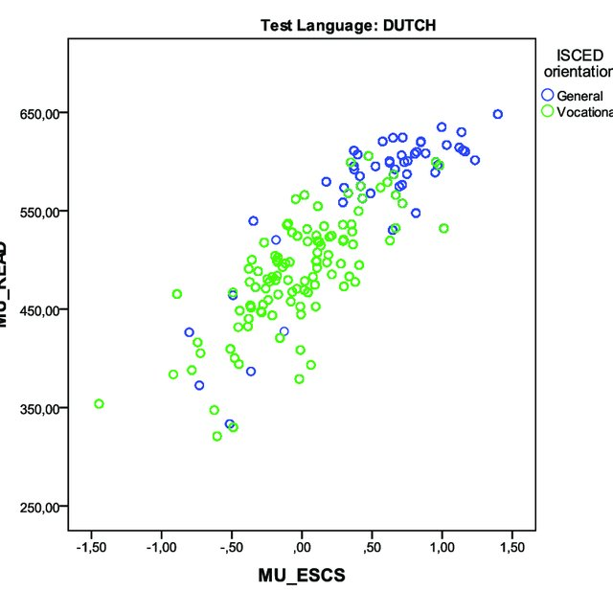

Group Homework Credit

Group B Task

Non-parametric Density Estimation

1. Dataset O={x1,x2,x3,x4}
2. Data Points

x1=(0,1), x2=(4,4), x3=(5,5), x4=(5,4)

3. Query Points

q1=(1,1) and q2=(4,5)

1. Tasks

Assume Manhattan distance[1] is used as the distance function.

a. Compute fGauss (q1) assuming bandwidth σ=1

b. Compute fGauss (q2) assuming bandwidth σ=1

c. Compute fGauss (q2) assuming bandwidth σ=2

1. d((x1,y1),(x2,y2))= |x1-x2| + |y1-y2|