Group I GHC Tasks

(to be presented on Nov. 18, 2022)

**Support Vector Machines**

a) The soft margin support vector machine solves the following optimization problem:

svn-equation

What does the first term minimize (be precise!)? What is the purpose of C? How many examples are misclassified in the figure below! Add arrows to all examples in the figure below, whose ξi values are positive---the length of the arrow should correspond with the value to the respective ξi !What is the relationship between the value of ξi and example i being misclassified?

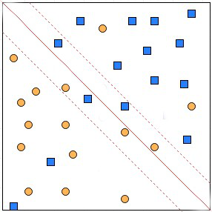

b) SVMs have been successfully used in conjunction with Kernels. How does this approach exactly work? Why do you believe it has been often successful for many datasets, achieving very high accuracies?