# **Task1 (Exploratory Data Analysis)  Enjoyability**

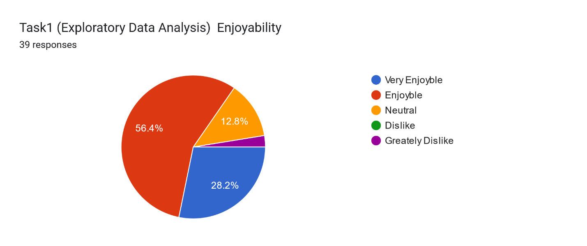

# Task1 (Exploratory Data Analysis) Difficulty

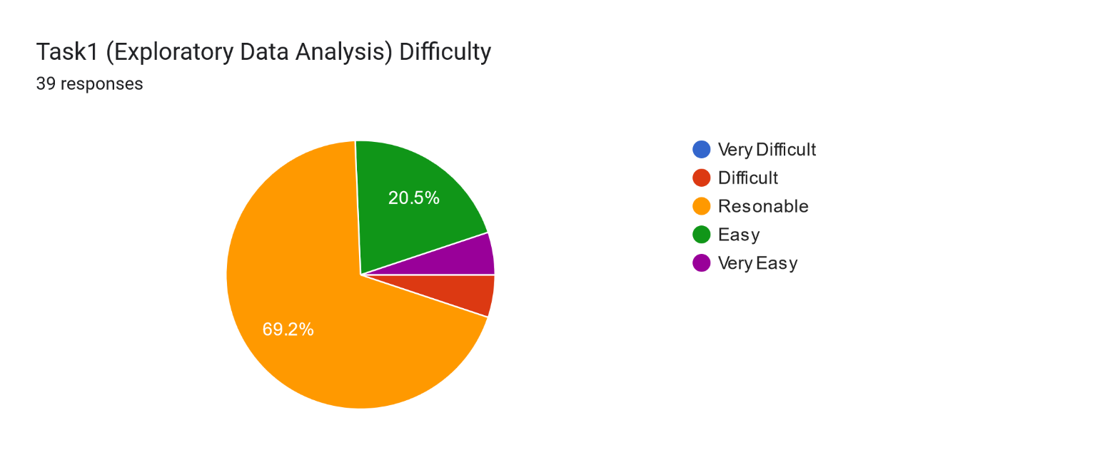

# Task2 ( Outlier Detection ) Enjoyability

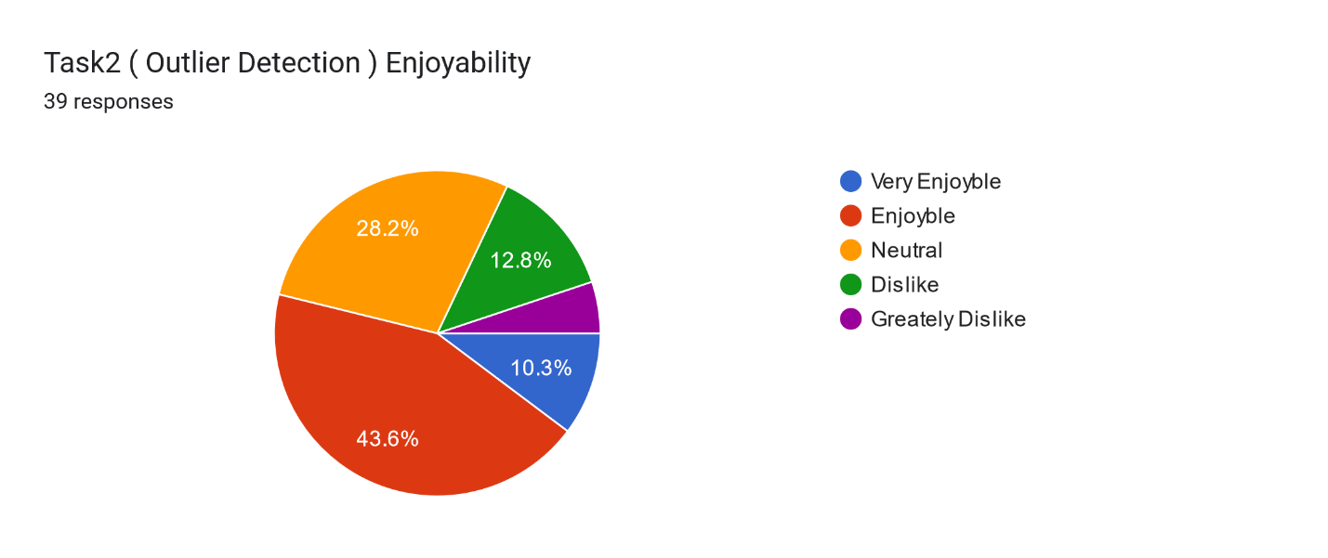

# Task2 (  Outlier Detection ) DifficultyC:\Users\mdmah\AppData\Local\Microsoft\Windows\INetCache\Content.MSO\EC5E50B0.tmp

# Task3  (Clustering Task) Enjoyability

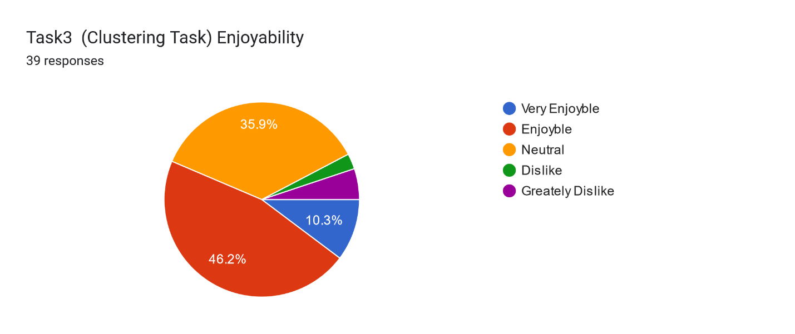

# Task3  (Clustering Task) Difficulty

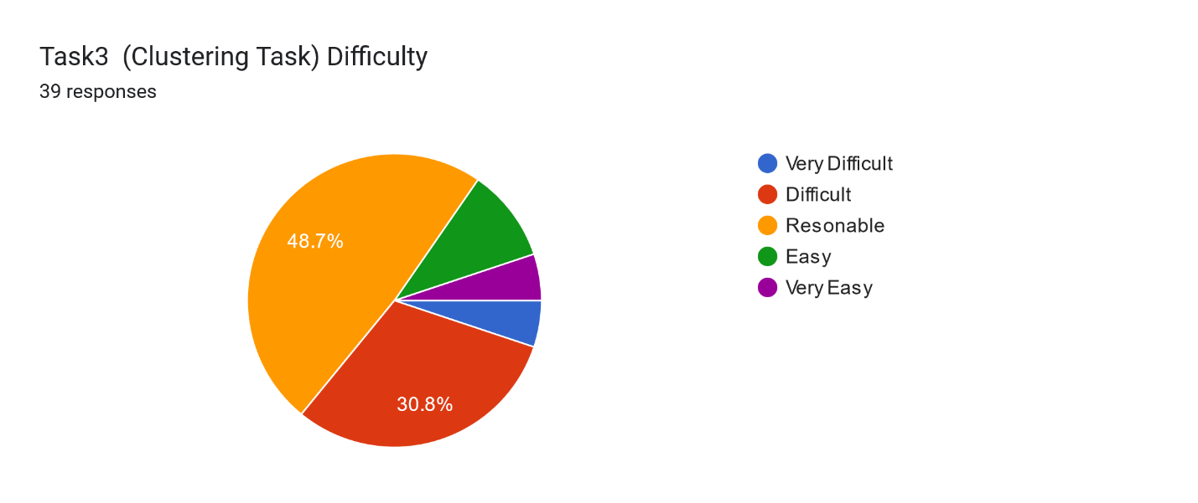

# Task4 ( Deep Learning ) Enjoyability

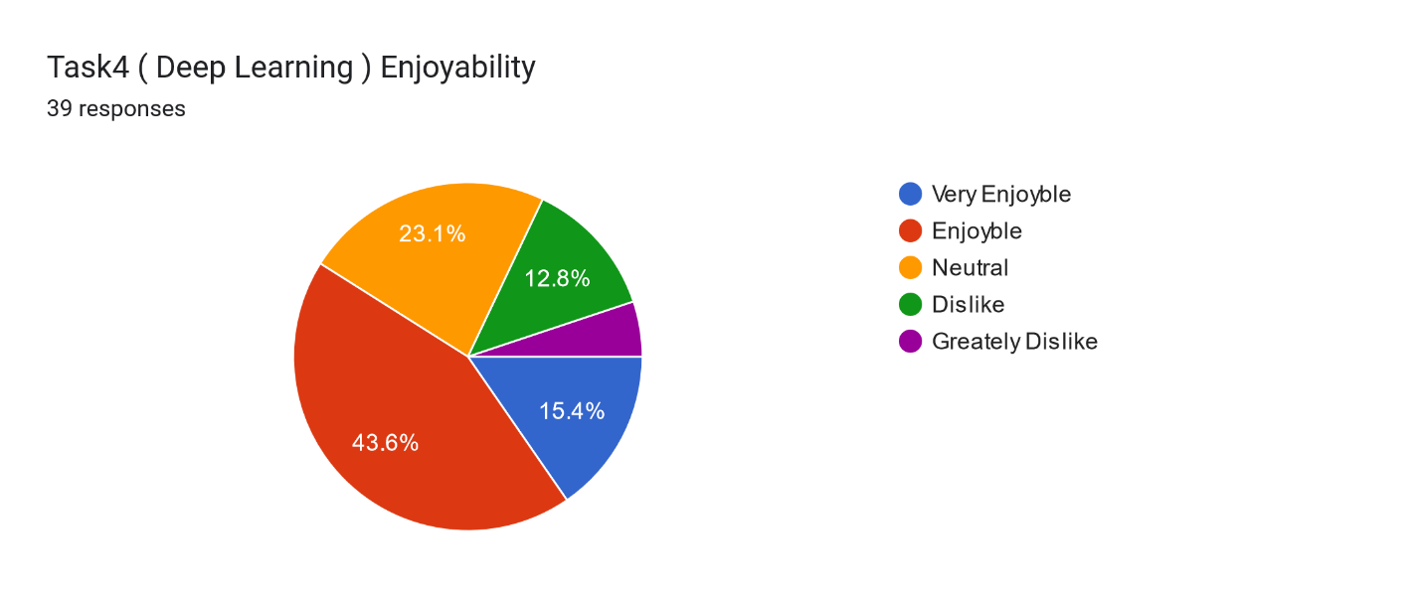

# Task4 ( Deep Learning ) Difficulty

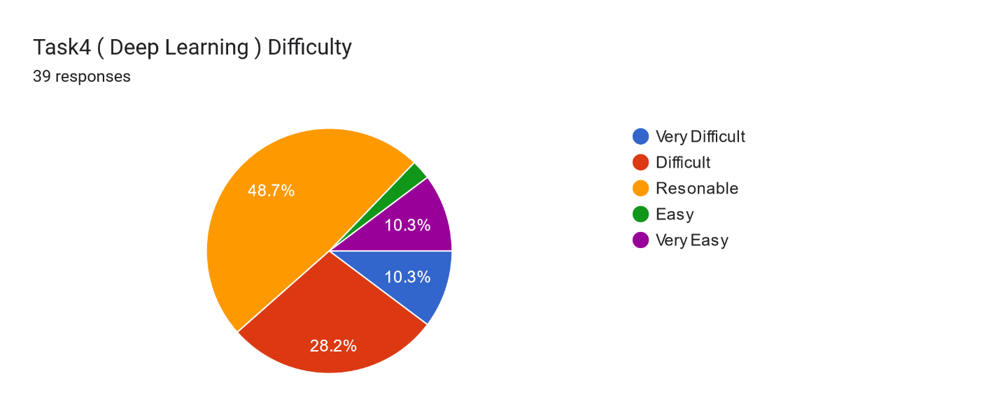

# Task5 (Paper Review Group Task) Enjoyability

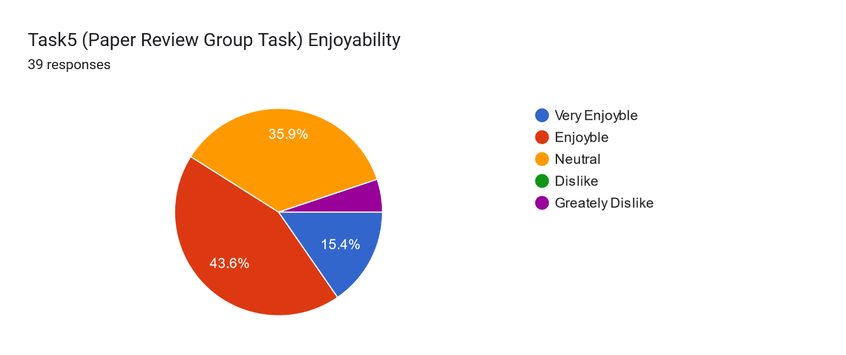

# Task5 (Paper Review Group Task) Difficulty

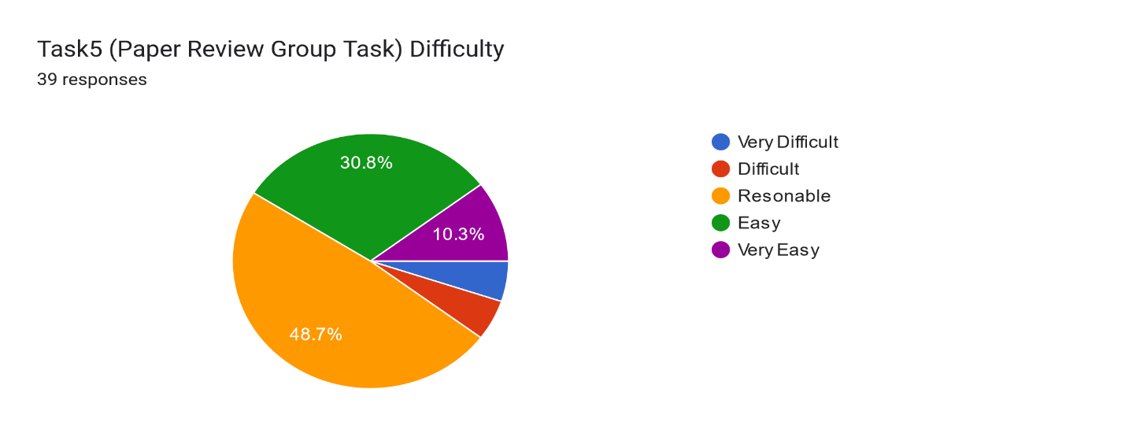

# Time Spent for Tasks

# Difficulty of Using Kritik

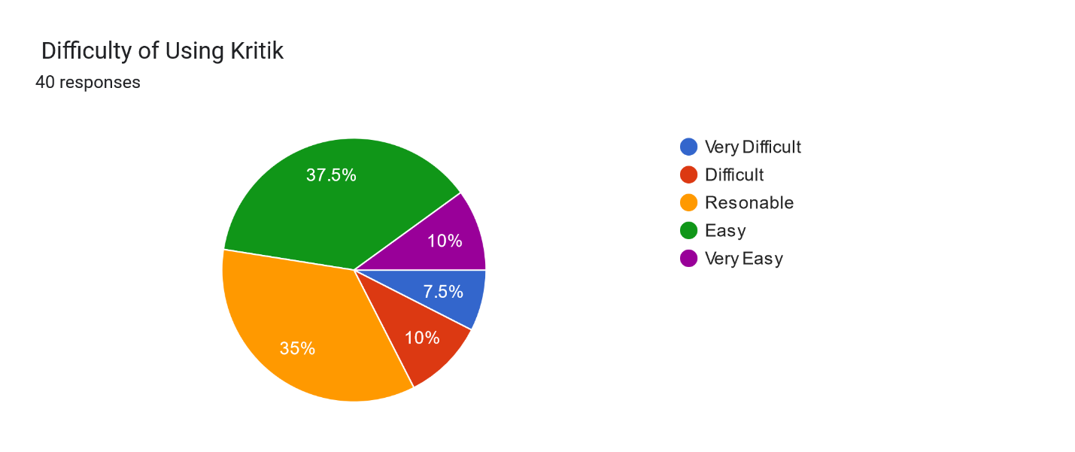

# Merit of Using Kritik for 6335

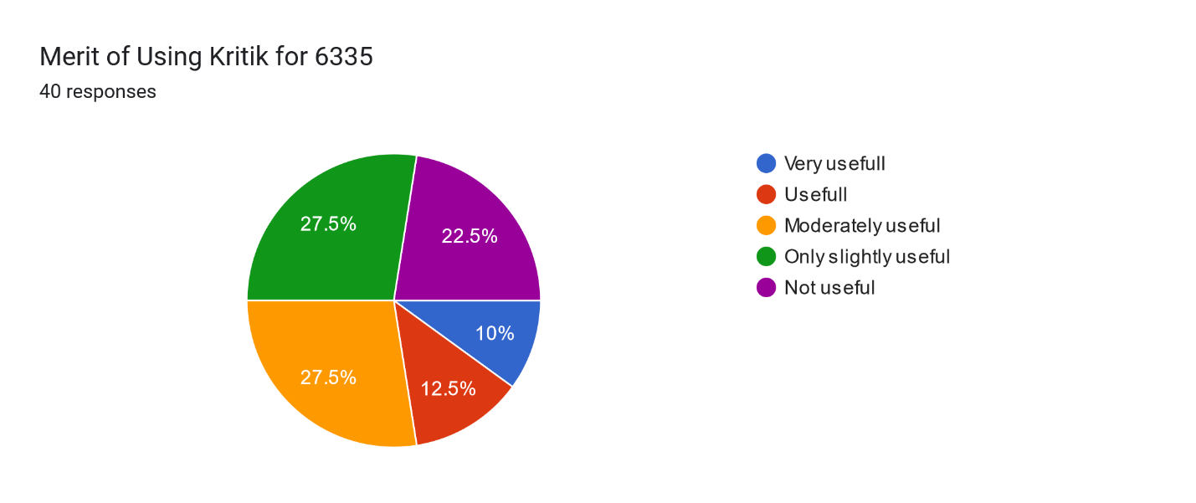

# Summary Summary Describe your Kritk Experience (what was good, what was not so good) in 5-8 sentences (Responses given in the Appendix A)

## Positive Aspects (Liked Features)

### 1. Learning and Improvement:

- Peer reviews offered diverse perspectives, critical thinking, and self-improvement opportunities. **(16 mentions)**

- Anonymous grading ensured fairness and reduced bias.

### 2. Ease of Use:

- Kritik's structured workflow for submissions and feedback was intuitive and organized. **(8 mentions)**

### 3. Unique Features:

- Comparing submissions with peers helped identify improvement areas.

- Grace periods for submissions were appreciated. **(5 mentions)**

## Negative Aspects (Issues and Complaints)

### 1. Evaluation and Grading Challenges:

- Evaluation scores were confusing, overly rigid, and felt unfair.

- Penalization for evaluation mistakes was harsh, especially without clear guidance. **(21 mentions)**

### 2. Effort and Time Concerns:

- Multiple steps in the workflow were tedious and time-consuming, particularly for detailed technical tasks. **(11 mentions)**

### 3. Feedback Quality:

- Peer feedback was inconsistent, often vague, or unhelpful.

- Lack of clear grading metrics or ground truth answers made evaluations frustrating. **(10 mentions)**

### 4. Platform Costs:

- The $30 cost for limited assignments was viewed as excessive. **(3 mentions)**

### 5. Interface and Navigation:

- The platform could feel overwhelming and hard to navigate at times. **(4 mentions)**

## Suggestions for Improvement

### 1. Simplify and Clarify Evaluation:

- Provide ground truth answers or sample solutions, clearer rubrics, and more flexibility in scoring criteria. **(14 mentions)**

- Remove evaluation scores from the grade or reduce their weight.

### 2. Streamline Workflow:

- Reduce steps in the submission and evaluation process.

- Limit the number of peer reviews to one or two per student. **(7 mentions)**

### 3. Enhance Training and Feedback Quality:

- Offer onboarding tutorials, mock assignments, and better peer training to improve constructive feedback. **(9 mentions)**

### 4. Address Technical Issues:

- Ensure consistent deadlines and integrate Kritik with existing systems like Canvas. **(6 mentions)**

## Overall Sentiment

- **Positive/Constructive Experience:23 mentions

- **Negative/Frustrating Aspects:15 mentions

# Summary Make a 1-sentence recommendation, if we should use Kritik in the next teaching of the course (Responses given in the Appendix B)

## Positive Feedback (Support for Using Kritik)

### 1. Promotes Peer Learning:

- Kritik helps in understanding diverse perspectives, peer learning, and critical thinking. **(8 mentions)**

- Anonymous grading ensures fairness.

- Facilitates interaction and improves analytical skills.

### 2. Potential Benefits with Improvements:

- Useful for peer feedback, but grading parameters and platform features need refinement. **(5 mentions)**

- Could be more effective with better training, evaluation adjustments, and platform reliability.

### 3. General Support:

- Fun and interactive tool for task evaluation.

- Positive experience with its structured approach. **(6 mentions)**

## Negative Feedback (Against Using Kritik)

### 1. Complexity and Unfairness:

- The system for grading and evaluation is confusing and feels unfair. **(7 mentions)**

- Multiple deadlines and steps (submission, evaluation, and remarks) are tedious and time-consuming.

### 2. Lack of Effectiveness:

- Limited depth in feedback reduces its overall utility.

- Scores lack meaning, and peer reviews don't align with instructor standards. **(5 mentions)**

### 3. Cost Concerns:

- The platform is expensive for students, especially for limited usage. **(3 mentions)**

## Suggestions for Improvement

### 1. Simplify and Refine Grading:

- Remove or reduce evaluation score weight.

- Use proper grading parameters and clarify metrics.

- Consider eliminating peer scoring and focus on instructor evaluation.

### 2. Enhance Training and Onboarding:

- Provide tutorials and mock tasks to familiarize students with Kritik.

- Clearer guidelines for constructive feedback and evaluation.

### 3. Streamline Workflow:

- Centralize all tasks on one platform (e.g., Kritik or Teams).

- Reduce the number of tasks requiring peer reviews or simplify the steps.

### 4. Cost Adjustments:

- Explore sponsorships or alternative pricing structures to reduce financial burden.

## Overall Sentiment

- Supportive of Kritik (with or without modifications):15 mentions

- Critical of Kritik and suggest alternatives:10 mentions

# Summary: Any suggestions how to enhance the use of Kritik for the course? (Responses given in the Appendix C)

## Issues and Complaints

### 1. Evaluation and Scoring Challenges:

- Evaluation scores are difficult to understand, lack transparency, and feel unfair.

- Comparing peer scores to instructor scores creates inconsistency and frustration.

- Evaluation grade weight should be reduced or removed entirely.

### 2. Overly Complex Workflow:

- Multiple steps (evaluation, remarks) are time-consuming and tedious.

- Deadlines are unclear or inconsistent, causing confusion.

### 3. Feedback Quality Concerns:

- Feedback often lacks depth and actionable insights.

- There is no mechanism for discussing feedback or seeing others’ evaluations for learning.

### 4. Platform Limitations:

- The interface can be overwhelming for new users.

- The $30 fee for limited tasks is viewed as excessive.

## Suggestions for Improvement

### 1. Simplify and Clarify Evaluation:

- Remove or reduce evaluation grades' weight in the final score.

- Provide detailed rubrics, sample solutions, or ground truth to guide evaluations.

- Allow flexibility in scoring criteria to accommodate diverse perspectives.

### 2. Streamline Workflow:

- Limit the number of peer reviews to focus on quality over quantity.

- Use a single submission platform for consistency.

- Make deadlines straightforward and reflective of actual due dates.

### 3. Enhance Onboarding and Training:

- Offer demos, mock assignments, and tutorials to familiarize students with Kritik.

- Provide clearer guidelines for constructive feedback.

### 4. Improve Feedback Mechanisms:

- Allow reviewers to see anonymous evaluations from others for learning.

- Add features for collaborative discussions and feedback clarification.

### 5. Adjust Costs and Accessibility:

- Reduce the fee or increase the number of assignments included to maximize value.

## Positive Feedback

### 1. Promotes Peer Learning:

- Helps students learn from diverse perspectives and encourages critical thinking.

- Anonymous grading ensures fairness and reduces bias.

### 2. Structured and Organized:

- Provides a clear process for submissions and evaluations, making task management easier.

## Overall Sentiment

- Constructive Feedback with Suggested Improvements:Most responses acknowledge Kritik's potential but highlight significant areas for refinement.

- Frustration with Evaluation System:Many express dissatisfaction with evaluation scoring and feedback mechanisms.

# Appendix A

I liked the idea of Kritik, except I find it difficult to understand the score of Evaluation

It was a little tedious to have to go back in and evaluate the other submissions and than rate the responses. It added an extra layer of work. It was also so that we had to keep going back to do the different parts of it. I think everyone is so use to finishing an assignment and moving forward that it took a while to get use to. One very weird thing was how the submission deadline was set up for it. It says one deadline but the real deadline is the day after.

Kritk provided a structured platform for managing tasks and receiving valuable feedback, which helped refine my work and improve collaboration. The resources and tools available were useful for hands-on learning. However, the interface could be overwhelming at times, especially with multiple assignments, and feedback occasionally lacked depth. Enhancing clarity and offering better onboarding tutorials would improve the experience.

It was good to see how peers performed and learn from it. It was organized at one place where we can easily know what to do and how to grade. Overall its useful.

It was a good experience, the motto behing using kritik is to peer review and understand other's perspective, which is a great initiative but I felt like that could have been achieved in some other way perhaps. The entire grading and then again the cross grading just makes the whole process complicated and repitative according to me.

I believe there still are loopholes in the grading system, especially the evaluation and feedback part. If one person gives a low score on either, it is having a large effect on the cumulative grade.

Evaluation is not good, scoring criteria is not good

It's a great software. I think it makes assignments a bit complicated. It's useful for students who are interested in knowing many approaches to a problem. It helps in strengthening the understanding of students. Its price is reasonably high for the functionality it offers.

its really frustrating, the way the evaluation score is calculated. Without knowing the exact correct answer how are we supposed to grade others. there should be a key for each assignment from the instructor or TA for better understanding of the tasks. Even till now, i didn't know the mistake i made in the tasks and there is no way to enhance my knowledge and correct my mistakes.

It was not as good using kritik to grade assignments, we still do not know completely about the evaluation section on how it grades the grader on evaluation.

Giving feedback of a peer evaluating my task did not seem useful and efficient

Overall, my experience with Kritik was positive, as the application encouraged critical thinking among peers and constructive feedback. It was relatively easy to use, and the peer review provided multiple perspectives which enriched my learning. Furthermore, it helped me to develop analytical skills while reviewing the work of others. However, sometimes the level of feedback received from peers was superficial and vague, not too helpful for corrective measures. Also, the grade system sometimes felt inconsistent due to subjectivity in the peer reviews. Sometimes, timing and coordination of submissions were challenging, with peers submitting late, hence affecting the feedback cycle. Despite these challenges, Kritik provided a special way of collaborative learning useful overall. easy to use

Using Kritk for peer reviewing assignments was a mixed experience. On the positive side, it streamlined the process of giving and receiving feedback, making collaboration more efficient. The interface was intuitive, with clear guidelines for reviewers, ensuring feedback was relevant and constructive. Receiving feedback from multiple peers helped identify blind spots in my work that I might not have caught otherwise. However, one downside was the variability in the quality of feedback—some peers provided detailed, actionable suggestions, while others gave overly generic or unhelpful comments. The lack of a feature to directly discuss feedback with reviewers felt limiting at times, as it could have clarified misunderstandings. Additionally, the platform occasionally experienced technical glitches, such as slow loading times, which interrupted the workflow. Overall, while Kritk served its purpose effectively, there is room for improvement, particularly in enhancing feedback consistency and platform reliability.

I liked the peer reviewing process, however, the evaluation score is not a good addition as it is difficult to predict how the instructor would grade that student versus how I should. I lost a lot of points there and I think it is not meaningful to add this score to grade.

It was easy to use and provided opportunity to grade peers work. I found it flexible as well. I did not like how only the leader have the ability to submit in group work. I believe any team member should be able to.

I believe having evaluation weightage in overall kritik grade is not a good idea.

Kritik is good platform for managing assignments but peer review system is little off, as it is very much dependent upon how close our scoring is to actual scoring, which sometimes is not best because different people can have different point of views.

I liked the peer feedback part. Didn't like the Evaluation score keep on fluctuating based on others creation scores though. Consumes a lot of time.

It's easy to submit the task on Kritk. However, I think it is not good to use for peer review. Even though the rubric is given, it is so abstract that students still face problems giving the grade.

Kritik is definitely a good app with a good cause. I enjoyed using it but I do not think it is that useful. I also felt it takes a lot of time over a week to evaluate and give feedbacks. For few tasks it was easy but when we had to go through each of the persons code keenly and review, it was so time consuming. Also, even after investing so much time into peer review, it was discouraging to get a very low automatic score for evaluation from the app. Apart from these, I think using this approach is different and good.

I dont know about everyone but it took me pretty more time to evaluate three peers from my class who may think differently for a same tasks.

It was good and helpful

Horrible

I liked it if we only could communicate to discuss the assignments and help each other by getting new ideas of different thoughts, but it wasn't like that, and we only evaluated each task based on our knowledge without being given the correct manual (report) of the tasks. In this way every person could make many mistakes in evaluating other students because they assume the only correct answer is their own report. I don't like the evaluation scores at all, and I feel it's more unfair for someone like me who gets lowers score only because of evaluations and evaluations could decrease my creation score up to 8-9 points which is a lot for one task.

The way Kritik is set up allows for people to just put in a score without looking through the assignment. Also they can just give an evaluation and feedback filled with meaningless content. Another issue is if someone does a portion of a task incorrectly they won't be able to properly evaluate how well you did on that portion of the task. Also this can lead to feedback that is misinformed it someone doesn't know the correct way to solve a problem how can they tell you how to improve upon it.

The platform’s structured workflow for submission, evaluation, and feedback ensured clear timelines. However, evaluating peers based on self-correct answers was challenging and sometimes led to a lower grade, as the criteria felt rigid The grading transparency could be improved, as it wasn’t always clear how final grades were determined after calibration. Peer feedback quality varied significantly, which sometimes impacted the learning experience negatively. While the opportunity to critique others’ work was insightful, receiving un constructive or overly brief feedback felt unhelpful.

Using kritik was very helpful as it not only helped me understand where i was going wrong with the help of peer evaluation but also helped me in having a positove note on my work.

I highly disliked the evaluation and remarks section of kritik. As a PhD student with two courses in my first semester, 20 hours of on site lab work under Dr Kakadiaris, 20 hours of TA work of my own(making slides of lectures, labs, instructing labs, attending classes, making grading and proctoring quizzes and exams, attending to students needs in addition to office hours), I have to work from 60 to 70 hours per week in my first semester of PhD in a new country. I have to strictly work on a laid out schedule to be successfully able to complete tasks. With constantly changing due dates, in Kritik, the due dates of latter tasks such as evaluation and remarks are also changed but are not announced. As a result missing one remark of a group assignment penalized 10% of my total grade. The idea of being graded on my own grading skills on the content I had not been assessed yet, is unfair in my opinion. I have made the utmost effort to work hard to complete all tasks in this semester with my 100%, but it is disheartening to see my grades fall for a confusing and unfair platform. Instead, the evaluation and remarks could be a curious endeavor outside of the cumulative grade, that could promote students to check others work after the due date and discuss ideas. This seems like a very good tool if it was used for this purpose.

6

It was good. I can reach others suggestions and recommendations about my work. But I don't like this one, anybody didn't know the true answers of the tasks and I am not sure that other's points can affect my total point. And understanding the overall point is difficult and complicated for me. Overall using the kritik was a good experience for me.

The platform is easy to use and has interesting ways to grade work. People can easily move around and understand most parts of the system. However, the feedback can be very strict, which sometimes lowers the total score. The grading part can be a bit confusing and hard to understand. While the platform has good points, there are still some areas that could be improved to make the experience better for users.

Didn't like we had to pay for it. It's a good platform for peer review work, making it easier for grading and students to learn from other submissions with everything being anonymous.

Viewing others' performance helped me understand how I compared to my peers. Comparing my work with other submissions highlighted areas for improvement. Evaluating three assignments deepened my understanding of diverse approaches. Having ground truth or sample answers beforehand would make evaluations easier and more accurate. Paying $30 for just a few assignments seemed excessive. Lack of clear metrics like highest, medium, or lowest scores for the final score

It was a good experience using Kritik as it helps to understand our peers and peer reviewing. The best part of Kritik was able to provide the submissions with a grace period and also be able to evaluate our peers besides comparing my submission with my peers. I was able to see diverse approaches of my peers which helped me to expand my thinking capability. Also, anonymous grading ensured fair and unbiased evaluations.

It was pretty good experience, becuase it gave response from anonymous people so that we can improve.

I don’t think the evaluations on kritik were genuine and if the professor is going to re evaluate the scores anyway, I think it’s just an extra step for students to evaluate 3 student scores again

It's unnecessary to buy this for 29

It was neutral .. i liked the peer evaluation because you learn from each other assignment but it takes time all steps

My Kritk experience was both enriching and insightful. I appreciated the platform's ability to facilitate interactive learning through peer reviews and detailed feedback, which enhanced my understanding of various concepts. The structured approach to assignments and critiques provided a clear framework to analyze and improve my work. Additionally, engaging with others' submissions broadened my perspective and introduced me to diverse problem-solving approaches. However, I found that the quality of feedback varied significantly depending on the reviewer, which sometimes limited its usefulness. The platform could also benefit from more intuitive navigation and a user-friendly interface to streamline the process. Overall, it was a constructive experience that balanced learning, feedback, and improvement effectively.

# Appendix B

I have no preference for this question.

Yes, use kritik but restructure it as well as change the duedate system.

I would not recommend using Kritik in the next course, as its limited depth of feedback reduce its overall effectiveness.

Yes, I recommend using kritik, as it helps in understanding the task is different perspectives also.

I do not recommend it.

Though I understand peer reviewing is important, I do not think Kritik is efficient, atleast the way we used it this semester was not.

No, The scores are not meaning full

I think it's not required since majority of the students might not be interested in knowing other student's perspective.

no please

use proper parameters for grading in the evaluation section.

Kritik is useful

I recommend using Kritik in the next teaching of the course as it effectively promotes peer learning and critical thinking, provided the implementation is refined.

I recommend using Kritik in the next teaching of the course, as it effectively facilitates peer feedback, but ensuring additional training for reviewers and addressing platform reliability issues could enhance the overall experience.

Yes

I think it would be fun.

It is a great tool where we can explore work by fellow classmates, so i would recommend having kritik in next course but with modification that instructor evaluates all the tasks, instead of peers.

Its not a bad idea, looks good if rules for scoring are well defined.

If possible use any other platform.

Not recommended.

Not so useful. Can skip it.

Maybe not.

Yes I guess but the price is bit expensive

—

Removing the evaluation scores, maybe using as bonus

For the purposes of peer review it does a good job at keeping people anonymous but, it might just be better to have students submit the assignment without the peer review portion.

Kritik should be used in the next course as it promotes peer learning, but only with improvements in grading consistency and feedback quality.

Yes, i would definetely recommend to use Kritik

No. This is a highly confusing and unfair system for grading in my opinion. Having to keep up with multiple deadlines of completing the task, evaluation and remarks, makes the platform highly confusing and greatly unfair. Being graded on my grading skill on an assignment I have yet not received remarks on by the instructor leaves me vulnerable to being penalized thrice for the same error.

I feel some issues while evaluation

Kritik can be used for all tasks not using Teams for some of the tasks.

Conduct a poll among the students and let them decide.

It can used but something should be done about the cost to students.

I recommend using Kritik in the next course teaching, but consider reducing the evaluation weight to 10-15% and increasing the assignment creation weight to 85%.

I recommend using Kritik in next teaching of course as it helps in evaluating and understanding our peers

Yes, make yse of kritik in the next teaching of course as it gives multiple opinions from both TA and fellow students.

It can kept for 1 task to get experience of evaluating but also if the uni can sponsor/ provide for Kritika accounts, it would be great

I wouldn't recommend

I think all tasks must be in the same place .. kritik or teams

Yes, Ofcourse.

# Appendix C

None

No

Making the evaluation part understandable.

remove having to evaluate the results of other peoples evaluations. Change the due date to be the real date that its due.

To enhance the use of Kritik for the course, consider providing clearer guidelines for giving constructive feedback, incorporating more detailed rubrics for evaluation, and offering tutorials or workshops to familiarize students with the platform.

No suggestions, all good.

If there is going to be kritik used, then I do not have any changes to propose.

Give a proper demo of the platform, give a few mock assignments to get the hang of the platform, thoroughly explain the grading mechanism of Kritik

need to correct the scoring criteria when comparing with students and professor grade for each peers task.

Making a student evaluate only one other student makes them focus on it better.

better go with the traditional way of grading and provide the key for assignments

use proper parameters for grading in the evaluation section.

Exclude the final feedback to evaluation part

No suggestions per say

More transparancy in evaluation grading.

Don't include evaluation score as mentioned earlier.

Maybe give the detailed grading rubik to students. It would be easier to evaluate peers task.

remove evaluation grade weightage and peer evaluation.

the scoring comparison to actual score comparison should have some flexibility, as students can have different point of views.

Not much.

Give some sample solutions for the students to make the peer review.

Maybe can reduce number of reports per person. Maybe just one report to evaluate works. And for group tasks, it would have been nice if reports come to all members at a time instead of individual reviews.

Better to use canvas as we can do peer review part on canvas too but doesn't compare with evaluator's evaluation. No one knows who's answer is correct while evaluating, if they get a good result using any one of the methods, they may believe that its correct but only the final evaluation finalizes everything about the tasks and it weighs more.

No suggestions

It's best if it allows students more communicate upon their thoughts on the given tasks rather than scoring

Not sure

Provide clearer guidelines for peer evaluations to ensure consistency and constructive feedback. Enhance the calibration process to ensure fair grading based on evaluation quality rather than strict adherence to self-correct answers.

N/A

Remove evaluation and remarks from comprehensive grade and use it as a curious endeavor to learn about peer's work for insights after task

You can share the answers of the tasks after all processes are finished.

The evaluation section where we get the evaluation scores based on how other score the same report might need some improvements.

I think it was managed and used quite well. I think evaluators should be able to see the evaluations of other evaluators of each of the 3 submissions/creations they evaluated, still being anonymous.

Paying $30 for just three assignments seems excessive, so it may be worth considering increasing the number of assignments submitted through Kritik to maximize its value.

It would be great if the evaluations were done with proper ground truth for certain assignments for which there can be exist multiple answers. More guidance on effective peer evaluation would enhance the experience.

All tasks in the kritik is better

To enhance Kritik for the course, provide a detailed rubric to ensure consistent feedback, offer practice rounds for critique skills, and include discussion forums for collaboration. Share exemplars for clarity, maintain anonymous reviews, and allow feedback on critiques for accountability. Flexible deadlines and integrated tutorials can further improve the experience.