Dr. Eick
COSC 6335 “Data Mining” Fall 2012
Project5: Association Analysis—Finding Collocation Patterns Involving Building Types in a City
Group Project
Due: Wednesday, December 5, 11p (electronic Submission)
Last Updated: November 8, 4p
Remark: Group size will be two; we will set up the groups!

This project centers on mining collocation patterns of building types in a city; Figure 1 visualizes such a dataset—you will get a building dataset, called Zinj from now on, in form of a KML-file that contains the buildings and building type information of three neighborhoods of the city Zinj.

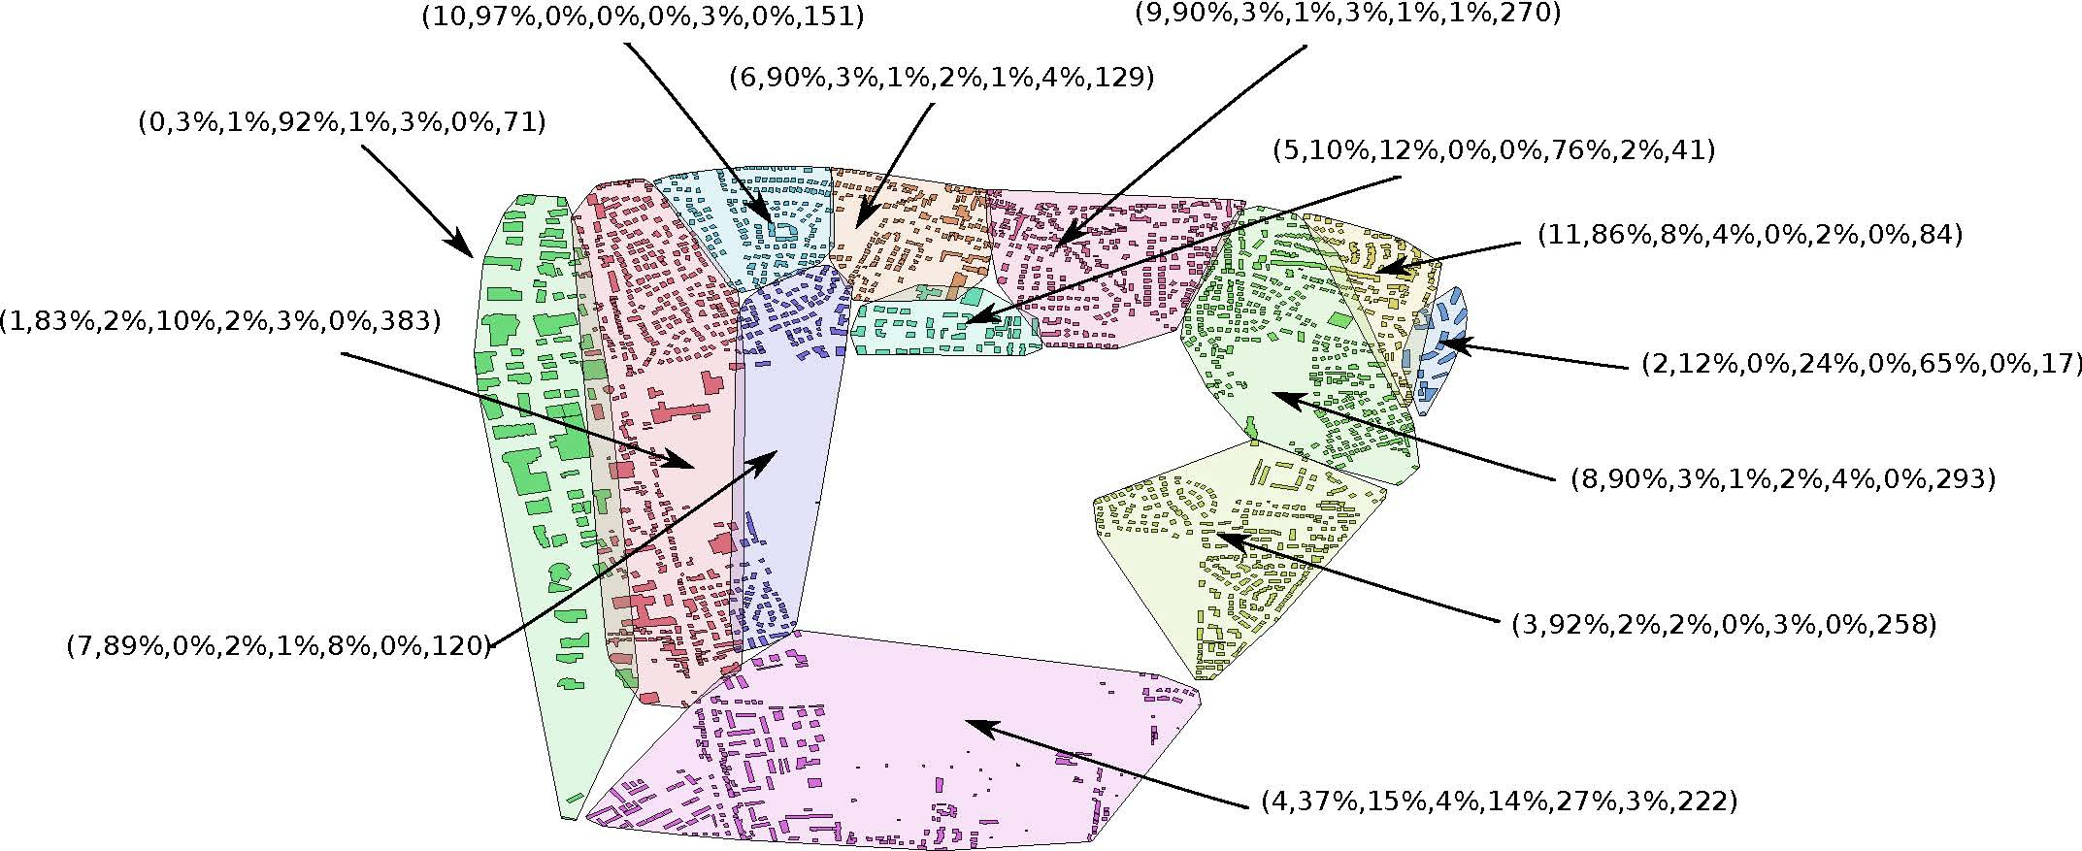
Fig. 1: Example Building Dataset.

In particular, Project5 centers on analyzing collocation patterns with respect to the following six building types in the dataset: single house, garage, commercial building, light buildings, collective house, and schools. Questions you will need to answer in this project include:
- Are buildings randomly distributed or is there some clustering?
- Are buildings of the same building type collocated, anti-collocated or not?
- Are building belonging to different building types collocated, anti-collocated or not—for example, you will try to answer the question if garages are collocated with commercial buildings.

The main objective of this project is to give conclusive answers to these three questions—many suitable approaches exist to accomplish this goal; consequently, I expect a lot of variation with respect to methods different groups apply to answer the three questions.
In this project, we consider garages, commercial buildings and collective houses as primary building types and light buildings, single houses and schools as secondary building types. You will analyze question 2 only for primary building types, and question 3 only for collocation pattern involving primary building types with other building types. You will analyze the distance characteristics of these associations using K-functions and other curves or statistics that are constructed by computing k-nearest neighbor distances; you will also analyze the distance characteristics for datasets in which buildings are randomly placed, but preserving the proportions of the building types in the dataset. The tasks of the project include:

- Perform some exploratory data analysis on dataset Zinj.
- Summarize the building distance distribution (not distinguishing between building types) in dataset Zinj.
- Create a dataset Z in which buildings are placed at random—but preserving the building type distribution in Zinj—; next, compute the distance characteristics of dataset Z and compare those with the results for Zinj to answer Question 1.
- Answer Question 2!
- Answer Question 3!
- Summarize your most interesting findings of answering the three questions!

Another additional challenge is the large size of the dataset Zinj and the large complexity of creating building type distance distribution curves. Be creative in proposing sampling or approximate computing approaches, if creating the necessary summaries turns out to be too time consuming! Normalization of analysis results to make them comparable is a second additional challenge of the project.

Summarize the methods you used and the project results in (3-5 single-spaced pages) report. Also describe the software you produced in the project in an appendix, and submit the source code as an additional attachment.

Lab3 scheduled for Thursday, November 15 will provide some support for Project5, discussing:
- Background information for the KML-dataset Zinj and how to visualize KML files in Google Earth
- Distance functions for polygons
- Concave hull algorithms
- Methods to create a dataset with randomly placed buildings within the concave hull of the buildings of the dataset Zinj.
- …

The file will be password protected and posted at Zechun’s website; you will also have to sign a confidentiality agreement not to share dataset Zinj with others; for that reason we call the city Zinj in this project—named after the fictional lost city introduced by Michael Crichton in his novel Congo—although the dataset actually contains buildings of a real city!
The dataset Zinj also contains buildings belonging to other building types which you will ignore in your analysis.
See for example: http://dhf.ddc.moph.go.th/abstract/s22.pdf or http://wiki.landscapetoolbox.org/doku.php/spatial_analysis_methods:ripley_s_k_and_pair_correlation_function
Moran’s I-function is such a statistics: http://svitsrv25.epfl.ch/R-doc/library/ape/html/MoranI.html all those are in R: http://rgm2.lab.nig.ac.jp/RGM2/func.php?rd_id=GeoXp:moranplotmap
There is actually a real lost city named Z see: http://www.top10listing.net/travel/top-10-lost-cities

