Review for April 28, 2026 2:30p Exam
For Exam2 COSC 6335

1. EM
a) What cluster models does EM use

Each cluster is described by:
a. a mean value
b. a covariance matrix
c. a cluster prior/weight (weights of the k clusters have to add up to one)

Gaussian Mixture Models — PyPR v0.1rc3 documentation (sourceforge.net)

b) How does EM determine if a point i belongs to a cluster j

$$p\left(C_{j} | x_{i}\right)=\frac{p\left(x_{i} | C_{j}\right)p(C_{j})}{\sum_{l=1}^{k}{p\left(x_{i} | C_{l}\right)p(C_{l})}}$$

2. DENCLUE and SNN

For SNN see GHC presentation of group F.

How does DENCLUE form clusters?

DENCLUE associates a non-parametric density function with a dataset. For each object in the dataset it uses hill climbing to find a local maximum of this density function; the obtained maximum is called a density attractor. Finally, clusters are formed by grouping objects that are associated with the same density attractor. Finally, clusters with low density attractors are discarded and optionally, clusters that match specific conditions are merged (not discussed here).

3) Miscellaneous Questions [19]
a. What are the characteristics of overfitting when learning decision trees? What can be done to deal with overfitting? [3]

The tree is too large, the training error is 0 or very low; the testing error is not optimal
1. reduce the size of the tree [1.5]
2. increase the size of the training set by adding new training examples [1.5]

b) A confusion Matrix of a classification model for distinguishing dogs, cats and rabbits is given below:
What is the accuracy of the classification model; what is its precision for class rabbit? What is its recall for class rabbit? It is okay to represent your answers as fractions; e.g. 17/36! [3]
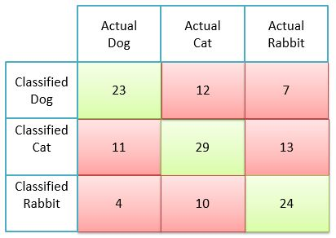

Accuracy=23+29+24/(total number of examples)
Precision rabbit: 24/(24+10+4)=24/38
Precision rabbit: 24/(24+13+7)

c) Compute the information gain for the following decision tree split (give the formula and compute the actual value as well)!

(4,2,2) (2,2,0)
(2,0,0)

(0,0,2)

Compute information gain as:
Entropy_before_the_split − Entropy_after_the_split

We obtain:
H(1/2,1/4,1/4)-0.5*(H(1/2,1/2,0))

½*log_2(2) + 2*1/4log_4(4)-0.5*2*1/2log_2(2)=1.5-0.5=0.5
4) Autoencoders

a) What role do Kullback–Leibler (KL) divergences play in Variational Autoencoders (VAEs)?
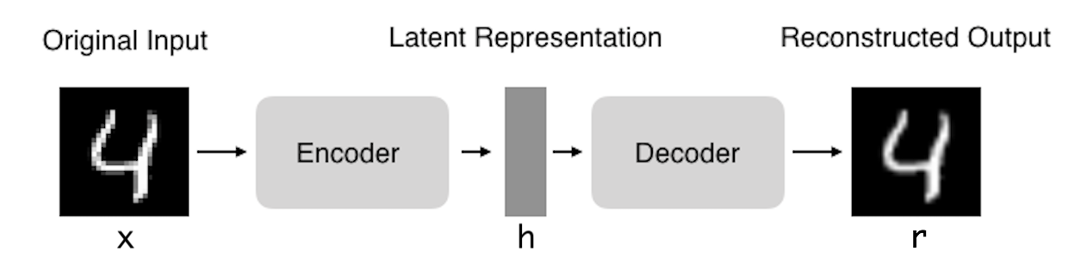
i. KL-divergences measure the distance between two distributions e.g. how close are N(0.3,1.3) and N(5,13) to N(0,1); obviously,
d_{KL}(N(0.3,1.3),N(0,1))<< d_{KL}(N(5,13),N(0,1))

ii. KL-divergences are used in VAE loss functions to create a penalty that is proportional to how much the latent vector deviates from an assumed prior (e.g. from N(0,1) or from a covariance matrix which has 1 in the diagonal and 0 everywhere else); this accomplish some regularization of the latent space and also can be used to enforce independence of the different latent variables)

b) How can autoencoders be used for outlier detection?

Steps:
i. Learn an Autoencoder Y for your Dataset D
ii. Feed all example e∈D into Y obtaining ē and add the reconstruction loss d(e, ē)—e.g. the Euclidian distance from e to ē—as an outlier score to example e.
Remark: the larger d(e,ē)is the more likely x is an outlier

5) Association Rule Mining
a) Assume we have the following Transaction Database

T1: {A,B,C,D}
T2: {A,C,D,E}
T3: {C,D,E,F}
T4: {B,C,D,E}
T5: {A,D,E}

What is the support and confidence the following association rule:
IF (C and D) THEN E? [3]

Support = 3/5 [1.5]
Confidence=3/4 [1.5]

b) Assume the APRIORI algorithm identified the following five 4-item sets that satisfy a user given support threshold: abcd, acde, acdf, acdg adfg; what initial candidate 5-itemsets are created by the APRIORI algorithm; which of those survive subset pruning? [4]

acdef, acdeg, acdfg [3] One error: at most one point!

None survives pruning [1]

6) Neural Networks [8]
See GHC presentation of Group I; also read carefully the pages of the Prince book; the exam might ask questions about those pages that we not or only briefly discussed in the lecture.
7. CLIQUE
Assume we apply the CLIQUE algorithm to a numerical dataset with attributes A, B, C, D and E. What is the main difference between CLIQUE and traditional Clustering algorithms such as K-means with respect to the clusters CLIQUE finds? How does CLIQUE take advantage of the APRIORI principle? How does CLIQUE form clusters? [6]

Find clusters in the subspace rather in the complete space A-B-C-D-E-F [2]
K+1 dimensional grid-cell candidates are computed from K-dimensional grid-cell which are dense (the number of points they contain is above the density threshold. [2]
Clusters in subspaces are formed by a growing algorithm which starts with a seed grid-cell and adds neighboring grid-cells [2]

Other answers might deserve full or partial credit!

No correlation between variables.

