Review 1 COSC 6335 on Th. October 4, 2012

1) K-Means and K-Medoids/PAM[16]
- What are the characteristics of clusters K-Medoids/K-means are trying to find? What can be said about the optimality of the clusters they find? Both algorithms a sensitive to initialization; explain why this is the case! [5]
- Compare K-means and K-Medoids/PAM. What are the main differences between the two algorithms? [5]
c) Assume the following dataset is given: (2,2), (4,4), (5,5), (6,6), (8,8),(9,9), (0,4), (4,0) . K-Means is used with k=4 to cluster the dataset. Moreover, Manhattan distance is used as the distance function (formula below) to compute distances between centroids and objects in the dataset. Moreover, K-Means’s initial clusters C1, C2, C3, and C4 are as follows:
C1: {(2,2), (4,4), (6,6)}
C2: {(0,4), (4,0)}
C3: {(5,5), (9,9)}
C4: {(8,8}}
Now K-means is run for a single iteration; what are the new clusters and what are their centroids? [5]
d((x1,x2),(x1’,x2’))= |x1-x1’| + |x2-x2|
2) DBSCAN
- What is a border point in DBSCAN?
- How does DBSCAN form clusters?
- Assume I run DBSCAN with MinPoints=6 and epsilon=0.1 for a dataset and I obtain 4 clusters and 5% of the objects in the dataset are classified as outliers. Now I run DBSCAN with MinPoints=8 and epsilon=0.1. How do expect the clustering results to change?
3) Similarity Assessment
Design a distance function to assess the similarity of customers of a supermarket; each customer in a supermarket is characterized by the following attributes:
- Ssn
- Items_Bought (The set of items the bought last month)
- Age (integer, assume that the mean age is 40, the standard deviation is 10, the maximum age is 96 and the minimum age is 6)
- Amount_spend (Average amount spent per purchase in dollars and cents; it has a mean of 40.00 a standard deviation of 30, the minimum is 0.02 and the maximum is 398)
Assume that Items_Bought and Amount_Spend are of major importance and Age is of a minor importance when assessing the similarity of the customers.
4) Short Questions
- What is the main difference between ordinal and a nominal attributes?
- Name two descriptive data mining methods!
- What are the reasons for the current popularity of knowledge discovery in commercial and scientific applications?
- What is (are) the characteristic(s) of a good histogram (for an attribute)?

5) Exploratory Data Analysis [10]
a) What is the role and purpose of exploratory data analysis in a data mining project?
b) Interpret the following 2 histograms and their relationships which describe the male and female age distribution in the US, based on Census Data.
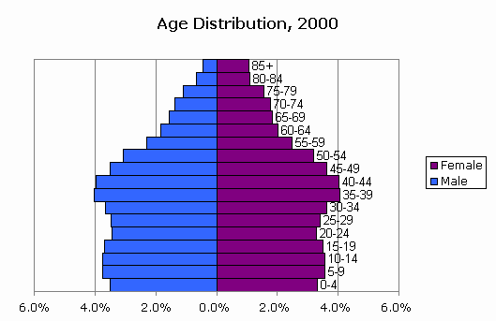

E.g. (111234232, {Coke, 2%-milk, apple}, 42, 3.39) is an example of a customer description.

