Dr. Eick
COSC 6335
Review2 on Tu., October 23, 2012.
1. Decision Trees/Classification
- Compute the GINI-gain for the following decision tree split[4] (just giving the formula is fine!):
(5,3,2) (4,0,2)
(1,3,0)
b) Assume you learn a decision tree for a dataset that solely contains numerical attributes. What can be said about the shape of the decision boundaries that the learnt decision tree model employs? [2]
c) Are decision trees capable to learns disjunctive concepts; for example.
IF A>3 OR B>7 THEN class1 ELSE class2?
Give a reason for your answer! [3]
d) What is the purpose of decision tree pruning in decision tree learning? [3]
e) What are the characteristics of underfitting? [2]
f) Are decision trees suitable for classification problems involving continuous attributes when classes have multi-modal (http://en.wikipedia.org/wiki/Multimodal) distributions? Give reasons for your answer!

2. APRIORI
a) What is the APRIORI property?
b) Assume the APRIORI algorithm identified the following 7 4-item sets that satisfy a user given support threshold: abcd, acde, acdf, acdg, adfg, bcde, and bcdf; what initial candidate 5-itemsets are created by the APRIORI algorithm; which of those survive subset pruning?
c) What is the final result that the APRIORI algorithm computes?
d) Assume an association rule if smoke then cancer has a confidence of 86% and a high lift of 5.4. What does this tell you about the relationship of smoking and cancer?

3. A little more on clustering
a) What of the following cluster shapes K-means is capable to discover? i) triangles ii) clusters inside clusters iii) the letter ‘T ‘iv) any polygon of 5 points v) the letter ’I’
b) What the weaknesses of the DBSCAN clustering algorithm ?

3) Exploratory Data Analysis [10]
a) Assume attribute A has a correlation of -0.95 with attribute B; what does this say about the relationship of the two attributes? [2]
b) Assume you have a dataset with 3 attributes and the entries of the covariance matrix have positive numbers in the diagonal, but all other entries are 0. What does this say about the relationship of the 3 attributes? [2]
c) Interpret the following scatter plot that describes dependencies between the eruption duration and eruption time of Old Faithful in Yellowstone National Park! [6]
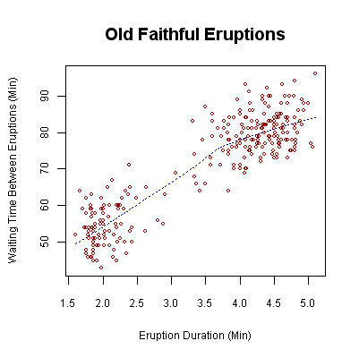

(GINI before the split) minus (GINI after the split)

