COSC 3337
Review on October 30, 2024
for the Nov. 4 Midterm2 Exam
1) SVM
a) The soft margin support vector machine solves the following optimization problem:
What is the purpose of the first term in the above formula? [1] What does ξ_{i} measure?[2]
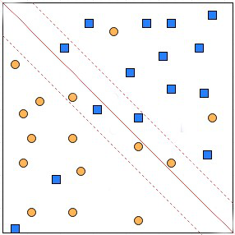
It measures the width of the inverse margin.[1] (if margin only mentioned, 0.5 points).

The error of the i’th example which is 0 if the example is on the correct side of the example’s class hyperplane and the distance to the example’s class hyperplane.

b) Assume we use SVMs in the conjunction with a dataset that uses numerical attributes A1, A2, A3 and the learnt SVM uses the hyper plane:

A1*5 + A2*3 – A3*2 + 1

How is this hyperplane used to classify an example; e.g. (A1=1,A2=0,A3=6)? [2]

You plug in the attribute values into the equation and determine the class based on the sign of the number you get.[2]
Alternatively, they can say the computation leads to 5-12+1=-6 and the negative class is selected.

2. K-Means and K-Medoids/PAM and Clustering in General

- Assume we apply K-medoids for k=2 to a dataset consisting of 4 objects numbered 1,..,4 with the following distance matrix:

0 6 5 2 object1
0 4 3
0 1
0 (e.g. the distance between object 2 and 4 is 3)

The current set of representatives is {3,4} (objects 3 and 4); indicate all computations k-medoids (PAM) performs in its next iteration! Does k-medoids get a new set of representatives or does it terminate in the next iteration? [6]

RS={3,4} clusters: {3} (1,2,4} SEE=2**2+3**2

New Represnetative sets are created
{1,4} …. SSE=3**2+1**2
{2,4} {2} {1,3,4} SSE=2**2+1**2
{1,3} …SSE=4**2+1**2
{2,3} … SSE=5**2+1**2
The SSE decreased and therefore PAN will run for another generation for the “new” representative set {2,4}
One error: at most 3.5 points; 2 errors at most 1 point.

b) DBSCAN
A dataset consisting of object A, B, C, D, E, F, G, I and J with the following distance matrix is given:
distance | A | B | C | D | E | F | G | H | I | J
A | 0 | 3 | 9 | 8 | 2 | 10 | 8 | 3 | 9 | 6
B |  | 0 | 9 | 7 | 8 | 9 | 8 | 6 | 8 | 4
C |  |  | 0 | 6 | 6 | 6 | 7 | 6 | 7 | 7
D |  |  |  | 0 | 14 | 15 | 7 | 7 | 7 | 8
E |  |  |  |  | 0 | 4 | 2 | 6 | 7 | 9
F |  |  |  |  |  | 0 | 4 | 7 | 8 | 8
G |  |  |  |  |  |  | 0 | 6 | 9 | 7
H |  |  |  |  |  |  |  | 0 | 8 | 6
I |  |  |  |  |  |  |  |  | 0 | 8
J |  |  |  |  |  |  |  |  |  | 0

- Assume DBSCAN is run for this dataset with MINPOINTS=3 and epsilon=ε=5
How many clusters will DBSCAN return and how do they look like? Which objects are outliers and border points in the clustering result you obtained? Give reason for your answers! [7]
A:4 corepoint
B:3 corepoint
C:1 noise point
D:1 noise point
E:4 corepoint
F: 3 corepont
G:3 corepoint
H: 2 borderpoint inside the circle of A
I: 1 noisepoint
J: 2 borderpoint inside the circle of B

1 Clusters: {A, B, H, J, E, F. G}

Problem 2 continued
c) Compare k-means with Hierarchical clustering; what are the main differences in the way they are forming clusters and in general? [4]

K-Means creates a single clustering and HC creates a hierarchy of object sets; that is, multiple clusterings [2]

HC creates a dendrogram by merging the closest clusters[1]; K-means creates clusters by assigning the objects in a dataset to the closest centroid [1]

d) What do the models that EM ‘learns’ looks like if it is called for k=4? How does the underlying density function look like,

It learns 4 Gaussian models each of which characterized by
- Their prior
- Ther mean-value
- Their Covariance Matrix

These components are combined as follows to obtain a density function which computes the density of a query point x_{n} as follows:
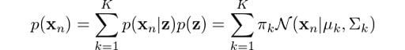

With

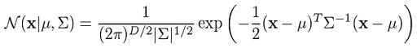

3. Density Estimation

a. How do parametric density estimation techniques find the parameters of models they try to fit to a dataset? For example, if we fit a Gaussian Model to a 1D dataset how does this approach choose the mean value μ and the standard deviation σ? [4]

The idea is to select parameters; e.g. value μ and the standard deviation σ in the case of a Gaussian 1D- distribution---which maximizes the probability of the examples in D: Maximize the sample that is: ∏_{d∈D} P(d|μ,σ)
where P is the density function of the distribution whose parameter need to be selected.
Other solutions might deserve credit!

b) Assume a dataset O={x₁,x₂,x₃} with data points x₁=(1,2), x₂=(5,7), x₃=(7,7), is given; moreover, assume Manhattan distance is used as the distance function and z=(6,6) is a query point. Compute f_{Gauss (}z₎ assuming bandwidth σ=1! [4]
Remark: it is okay to use an expanded formula as your answer; e.g “e⁻¹² + e^{--2.5}…” as your answer; it is not necessary to report the exact value!
f_{Gauss (}(6,6)₎ = e^{−81/2} + e^{−4/2} + e^{−4/2}= e^{-81/2}+ 2* e⁻²

Solutions which use the normalized 2D KDE function also deserve full credit.

With

f_{Gauss}(z)=Σ_{i} e**((−d(z,x_{i})**2)/(2σ²))
4. Hierarchical Clustering

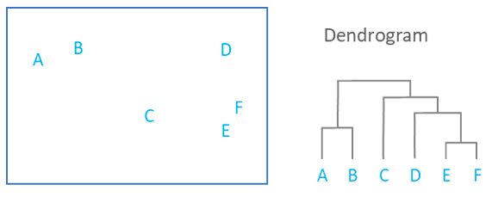
Other ways to specify dendrograms through Merge history in Midterm2:
- {E} and {F}
- {A} and {B}
- {E,F} and {D}
- {D,E,F} and {C}
- {A,B} and {C,D,E,F}

5. Outlier Detection

How does model-based outlier detection work? Limit your answer to at most 4 sentences! [4]

Basic points they should mention: a. fit a model M to the dataset [2] b. using the model D compute the density of each point o in the dataset and use this density as the outlier score [2].

The object itself counts towards the number of objects in its ε-radius when determining core points!
d((x1,y1),(x2,y2))= |x1-x2| + |y1-y2|

