Christoph F. Eick
Review1 COSC 3337 Fall 2019
September 30, 2019
- Explain what the following C.R.A.P. Design Principles emphasize:
- Alignment
- Proximity
2. Supervised Learning & Decision Trees
- What role do test sets play in supervised learning?
….to determine the accuracy of the learnt model
- Compute the GINI-gain for the following decision tree split (just giving the formula is fine!)
(12,4,6) (3,3,0)
( 9,1,0)
(0,0,6)
- What test does the Decision Tree Induction Algorithm prefer to create?
Splits that in the examples in subsequent nodes mostly belong/all belong to the same class

- What does the size of the box of a boxplot measure; what statistical measure is it related to?

- A R-boxplot (also called Turkey boxplots) of an attribute A has whiskers at 2 and 10; what does this tell you about attribute A? What attribute values are typically considered to be outliers in boxplots?
- Comparing Histograms
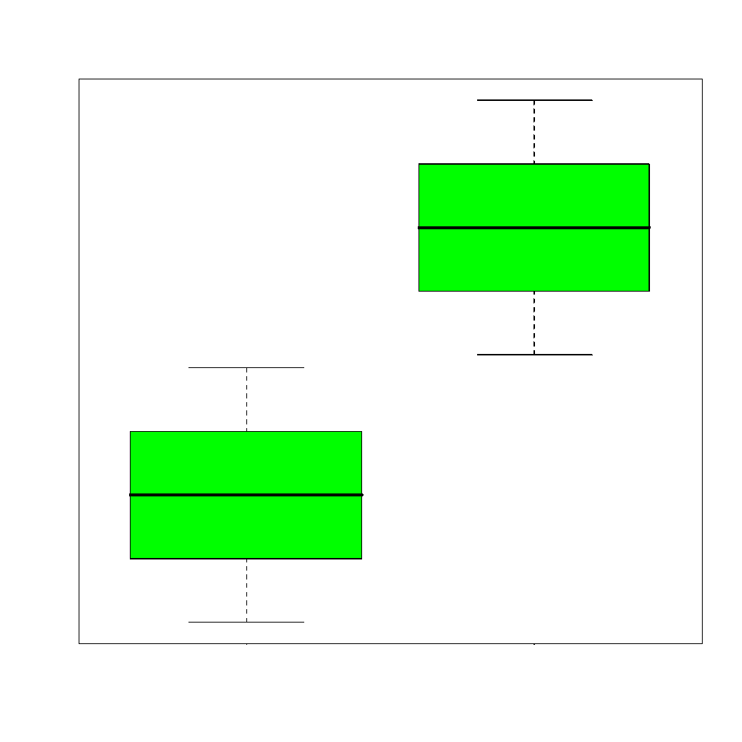
- What is the main difference between ordinal and a nominal attributes?
- What role does exploratory data analysis play in a data mining project?
- Assuming use 2D non parametric density estimation for a dateset D={(0,0), (2,2), (0,1)) and h=1. Give the formula that computes the density in the query points (1,1)!
ϕ_{O}(v)$=\frac{1}{{n*2*h}^{2}}\sum_{oO}{exp⁡(-\frac{{{(o.x-v.x)}^{2}+ (o.y-v.y)}^{2}}{2h^{2}})}$

- Interpret the supervised scatter plot depicted below; moreover, assess the difficulty of separating males from females using Factor 1 / Factor 2 based on the scatter plot! [5]

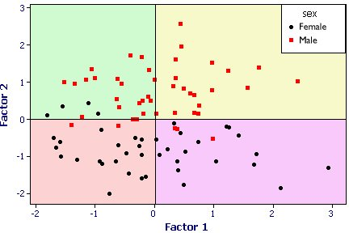
Both the female and male class have a uni-modal distribution; no gaps in data density are visible. Factor2 does mostly a good job in separating females and males; there is only overlap close to 0; Factor1 does a poor job separating the 2 classes. The classification task should not be too difficult as the examples are well separated although there are a few exceptions.
- What is (are) the characteristic(s) of a good histogram (for an attribute)?
- Interpret the following 2 histograms and their relationships which describe the male and female age distribution in the US, based on Census Data. Already Discussed in the Lecture!
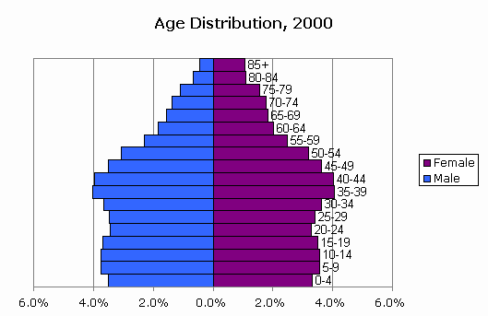
Both histograms: curves are continuous with no gabs or outliers, and somewhat smooth[1], bimodal with 2 (1??; 0??) not well separated maxima at 5-19 and 35-44 [1.5], values significantly drop beyond age 55[1]skewed distribution
Comparison: Curves are somewhat similar until age 55 [1] (although there are more males initially [0.5]); decline in the male curve is significantly steeper---women live longer[1]. Other observations might receive credit; points will be subtracted if you write things which do not make any sense or are false.

- Assume you find out that two attributes have a correlation of 0.02; what does this tell you about the relationship of the two attributes? Answer the same question assuming the correlation is -0.98!

A subset of the problems 1-8 and 15 will be discussed on September 24, and a subset of problems 9-14 will be discussed on the lecture on September 26.
(GINI before the split) minus (GINI after the split)

