Christoph F. Eick
Review1 COSC 3337 Fall 2019
September 30, 2019
- Explain what the following C.R.A.P. Design Principles emphasize:
- Alignment
With alignment, no element in a design is positioned arbitrarily. Each element visually connects to other elements, leading to cohesiveness in a design.
- Proximity
The principle of proximity states that elements that are associated with each other should be placed closely (grouped together), and vice versa.
2. Supervised Learning & Decision Trees
- What role do test sets play in supervised learning?
….to determine the accuracy of the learnt model
- Compute the GINI-gain for the following decision tree split (just giving the formula is fine!)
(12,4,6) (3,3,0)
( 9,1,0)
(0,0,6)
G(6/11,2/11,3/11) – (6/22*G(0.5,0.5,0) + 10/22* G(0.9,0,1,0) + 0)=
(1- (6/11)**2-(3/11)**2-(2/11**2)- (6/22*0.5)- 10/22*(1-0.9**2-0.1**2)=
(121-36-9-4)/121 - …=
72/121=0.595-=
- What does the size of the box of a boxplot measure; what statistical measure is it related to?
The difference between the 25th and 75th quantile, also called IQR, of the attribute; the size of the box is used as an estimator of the standard deviation of the attribute.
- A R-boxplot (also called Turkey boxplots) of an attribute A has whiskers at 2 and 10; what does this tell you about attribute A? What attribute values are typically considered to be outliers in boxplots?
The largest attribute value that is not an outlier is 10, and the smallest attribute value that is not an outlier is 2; all attribute values that are 1.5IQR or more above the 25% quantile or 1.5IQR below the the 75% quantile of the attribute are considered outliers.
- Comparing Histograms
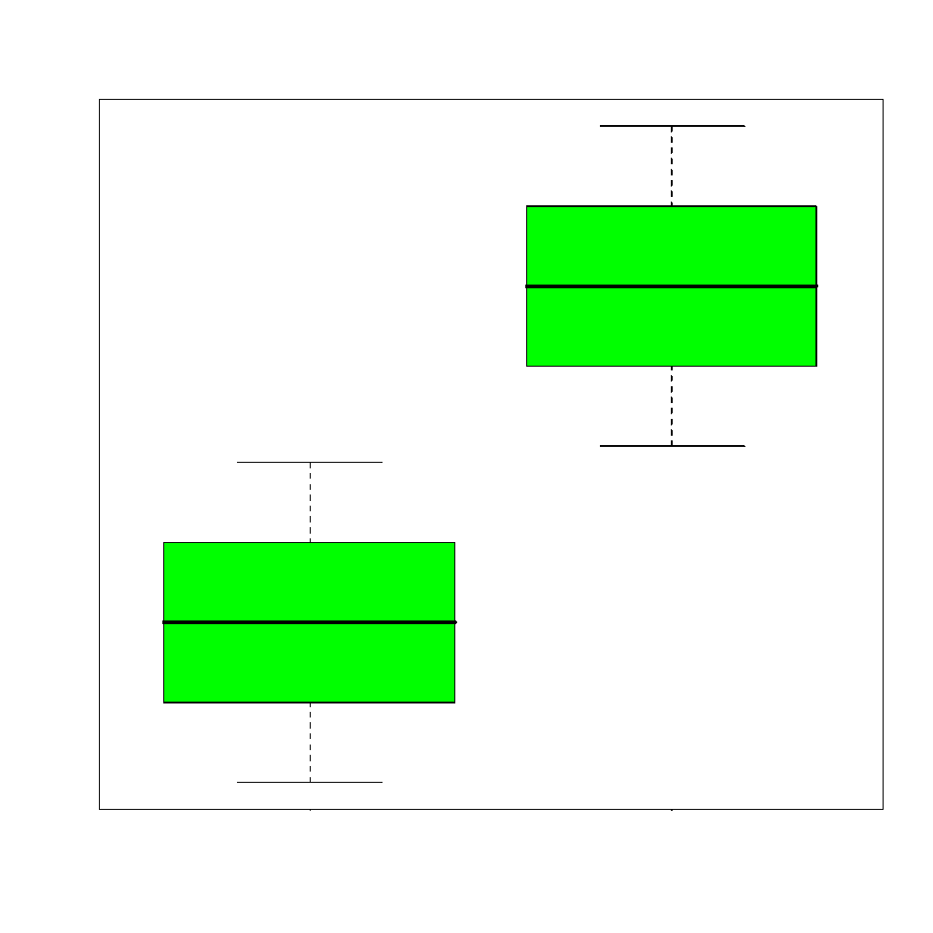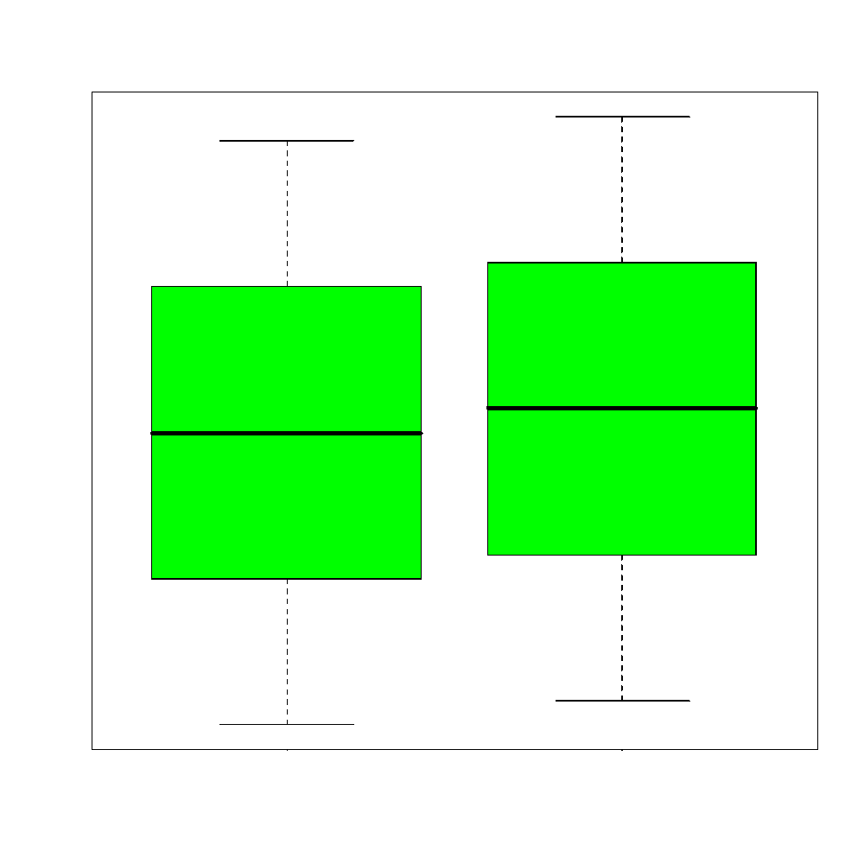

Dramatically different: one is almost always higher (with exception of outliers); not much difference; one is slightly highter, but their boxes mostly overlap!

- What is the main difference between ordinal and a nominal attributes?
The values of ordinal attributes are ordered; this fact has to be considered when assessing similarity between two attribute values!
- What role does exploratory data analysis play in a data mining project?
create background knowledge about the dataset and the task at hand [1], assess difficulty [1], provide knowledge to help select appropriate tools for the task[1], assess quality of data [1], validate data [1], help to form hypothesis [1], find issues, patterns and errors in data [1]
- Assuming use 2D non parametric density estimation for a dateset D={(0,0), (2,2), (0,1)} and h=1. Give the formula that computes the density in the query points (1,1)---give the influences of each point!
ϕ_{O}(v)$=\frac{1}{{n*2*h}^{2}}\sum_{oO}{exp⁡(-\frac{{{(o.x-v.x)}^{2}+ (o.y-v.y)}^{2}}{2h^{2}})}$ (General Formula)

ϕ_{D}(1,1))= (1/ (3*2π))∗(e⁻¹+e⁻¹ + e^{-0.5})=… (YOU WERE ONLY ASKED TO GIVE THE Formula)
ϕ_{D}(2,2))= (1/ (3*2π))∗(e⁻⁴+1 + e^{-2.5})=… (YOU WERE ONLY ASKED TO GIVE THE Formula)

- Interpret the supervised scatter plot depicted below; moreover, assess the difficulty of separating males from females using Factor 1 / Factor 2 based on the scatter plot! [5]

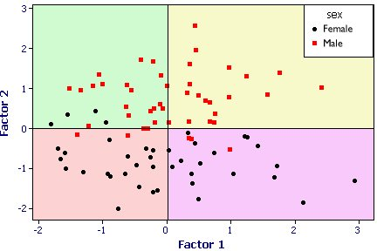
Both the female and male class have a uni-modal distribution; no gaps in data density are visible. Factor2 does mostly a good job in separating females and males; there is only overlap close to 0; Factor1 does a poor job separating the 2 classes. The classification task should not be too difficult as the examples are well separated although there are a few exceptions.
- What is (are) the characteristic(s) of a good histogram (for an attribute)?
It captures the most important characteristics of the underlying density function
- Interpret the following 2 histograms and their relationships which describe the male and female age distribution in the US, based on Census Data. Already Discussed in the Lecture!
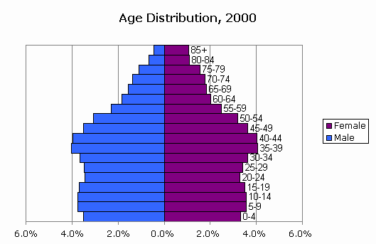
Both histograms: curves are continuous with no gabs or outliers, and somewhat smooth[1], bimodal with 2 (1??; 0??) not well separated maxima at 5-19 and 35-44 [1.5], values significantly drop beyond age 55[1]skewed distribution
Comparison: Curves are somewhat similar until age 55 [1] (although there are more males initially [0.5]); decline in the male curve is significantly steeper---women live longer[1]. Other observations might receive credit; points will be subtracted if you write things which do not make any sense or are false.

- Assume you find out that two attributes have a correlation of 0.02; what does this tell you about the relationship of the two attributes? Answer the same question assuming the correlation is -0.98!
0.02:= no linear relationships exists between the two attributes—but other relationships might exist; 0.98:=a strong linear relationship exists—if the value of one attribute goes up the value of the other goes down

(GINI before the split) minus (GINI after the split)

