Dr. Eick
COSC 4335“Data Mining” Assignment4 Spring 2016
Design and Implementation of an Outlier Detection Technique for Spatial Data
Final Draft
Individual Project

Due date: Friday, May 6, 11a (students who submit by May 5, 11p get a 5% bonus)
Last updated: April 26, 2016 at 10a

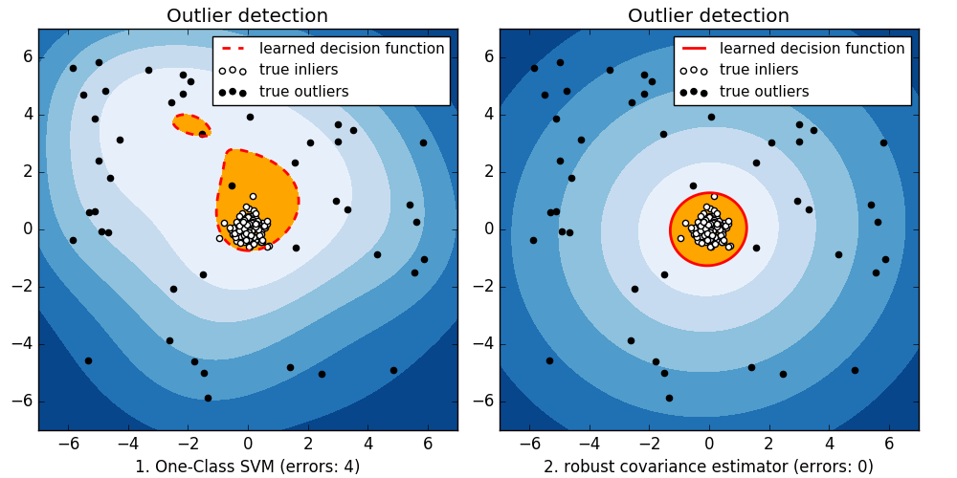

The goal of the project is to design and implement a 2D spatial outlier detection technique of your own preference and to apply it to a dataset called complex9_gn8 (http://www2.cs.uh.edu/~ceick/UDM/complex9_gn8.txt ) which is the variation of the Complex9 dataset, we used before. Your outlier detection technique should take the dataset and create a copy of the dataset that contains an additional column/attribute called ols (“outlier score”) which contains numbers that indicates how much your outlier detection method believes that the particular object is an outlier—the smaller the value of the ols attribute the less likely the object is believed to be an outlier. For the project, you can use any R-library or other software to accomplish the project tasks; just acknowledge what external software you used in your project report.

The complex9_gn8 dataset has attributes x, y, class; for example, after applying your outlier detection technique to the last 5 examples of the dataset, the result created by your outlier detection technique could look as follows:

728.899,535.627,8,0.24
504.528,-46.2297,8,0.41
373.256,409.026,8,0.12
850.838,242.711,8,0.33
641.676,347.544,8,0.11

This depicted result indicates that the second example is the most likely outlier, the fourth example is the second most likely outlier,…, and that the last example is the least likely outlier.

Assignment4 Tasks:
Task0: Visualize the complex9_gn8 dataset; visualize the third attribute using different colors, similar to supervised scatterplots we used in Assignments 1.
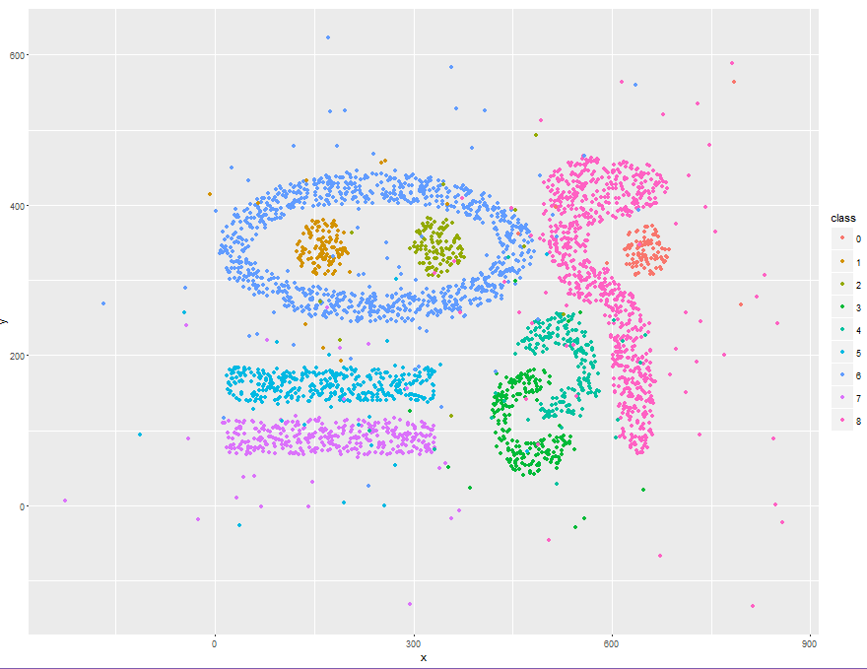

Task1: Develop a 2D spatial outlier detection technique of your own preference that identifies abnormal data in datasets which contain pairs of numbers.
Description:
The outlier detection technique I am going to apply in this paper is density-based local outlier factor (LOF). LOF is an algorithm for finding outliers by measuring local deviation of data point with respect to its neighbors. By comparing local density of a point (which is given by k nearest neighbors) with the densities of its neighbors, we can identify points that have a substantially lower density than their neighbors, and classify them as outliers.

Local density is calculated by distance at which a point can be "reached" from its neighbors. The definition of "reachability distance" used in LOF is an additional measure to produce more stable results within clusters.

Task2: Implement the chosen outlier detection technique for the complex9_gn8 dataset.
Description:
As explained earlier your implementation of your outlier detection technique should add a column/attribute ols to the dataset and fill this column with numbers, as explained above.

For this task, I will use package Rlof (a parallel implementation of LOF that speeds up LOF computation for large datasets). Rlof also supports multiple k values, which will be used to improve outlier detection task. More specifically, function lof of this package will be used.

Function lof finds the local outlier factor of the matrix "data" using k
neighbors. The LOF takes into consideration the density of the neighborhood around the observation to determine its outlierness. Outliers are points with largest LOF value. This is a faster implementation of LOF by using a different data structure and distance calculation function.
It also supports multiple k values to be calculated in parallel, as well as various distance measures besides the default Euclidean distance.

Task 3: Evaluation
a. Apply our outlier detection to the complex9_GN8.data dataset obtaining a new file X; your outlier detection method is only applied to attributes x and y of the dataset, and ignores the attribute named class.

#set up directory and load the dataset
setwd("~/DATAMINING/ass4")
data <- read.csv("complex9_gn8.txt")
as4<- data.frame(x=data[,1],y=data[,2],class=as.factor(data[,3]))

#load library Rlof and apply function lof
library(Rlof)
as4lof<-data.frame(x=(as4$x),y=(as4$y))
xylof<-lof(as4lof,k=c(10)) #For now, we use k=10 . LOF values (or OLS) are now stored in xylof
as4lof$lof <- xylof #add attribute ols (LOF values) to the dataset
as4lof$class<- as4$class

b. Sort X in descending order based on the values of attribute ols (the example with the highest ols value should be the first entry in X)!
as4lof<- as4lof[order(-as4lof$lof),] #sorting descending based on OLS

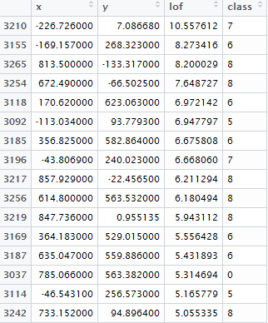(A snapshot of dataset after sorting)

c. Visualize the first 2% of the observations in X, just displaying their x and y value and the class using a different color for each class, in a display and the remaining 98% of the observations in a second display. In general, the first display visualizes the outliers and the second display visualizes the normal observations in the dataset.
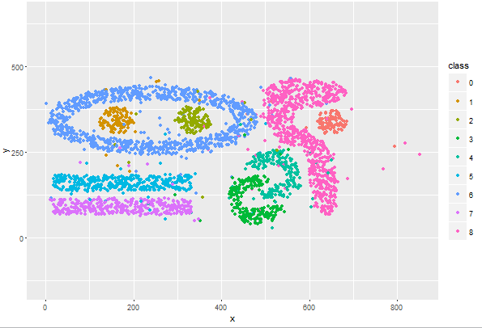
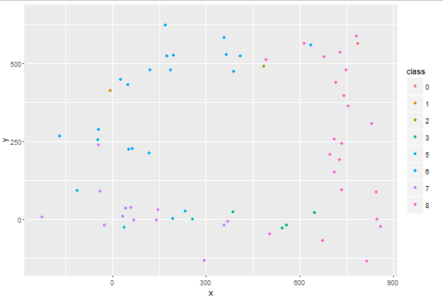
Outliers: Normal observations

Bonus: Outliers (red “x”) and Normal observations on the same graph
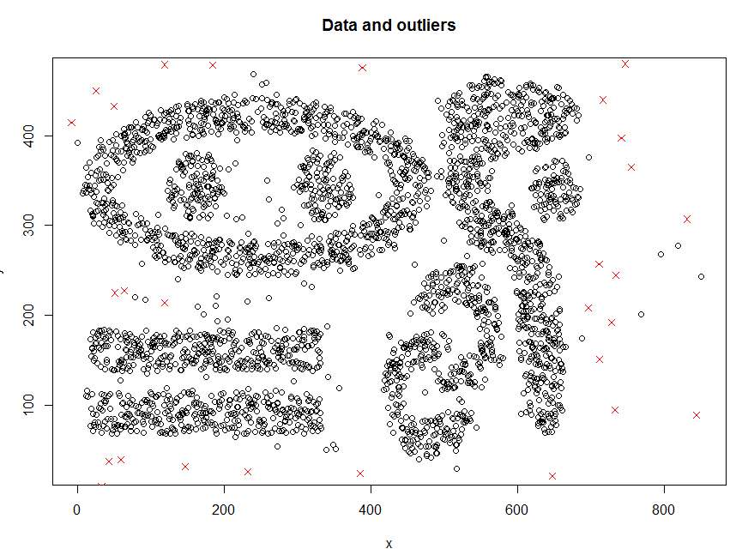
d Visualize the first 5% of the observations in X, just displaying the x and y value and the class using a different color for each class and the remaining 95% of the observations in a second display.
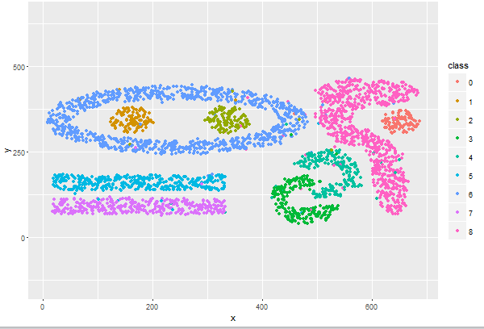
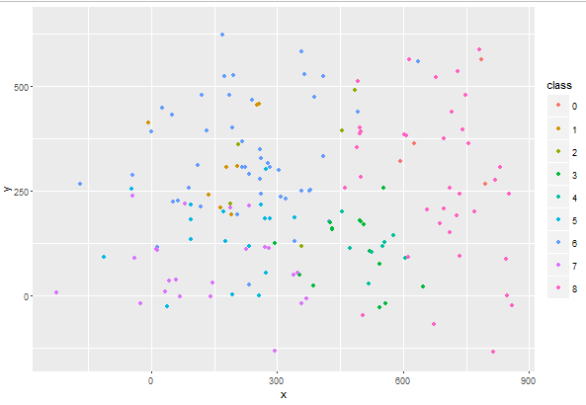
Outliers: Normal Observations

Outliers (red “x”) and Normal observations on the same graph
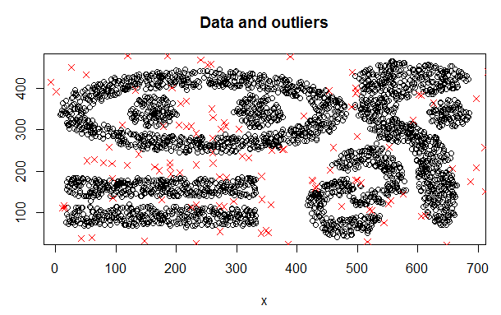
e. Visualize the first 10% of the observations in X, just displaying the x and y value and class using a different color for each class, in a display and the remaining 90% of the observations in a second display.
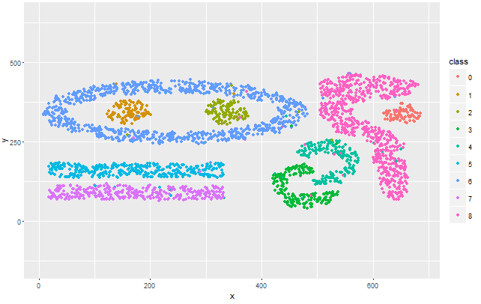
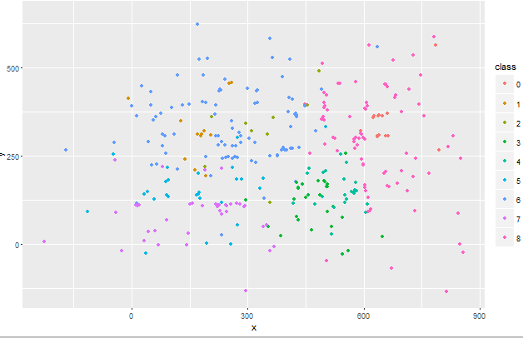
Outliers Normal Observations

Outliers (red “x”) and Normal observations on the same graph
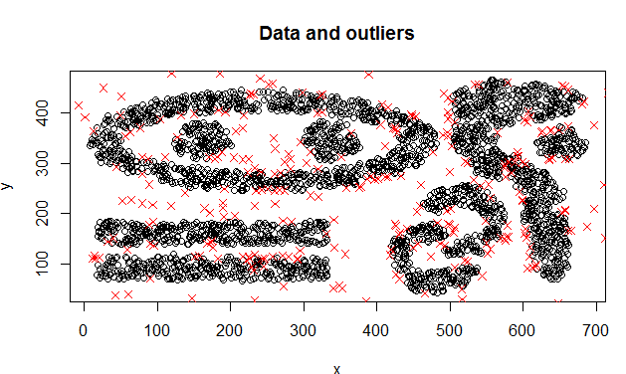
f. Interpret the 6 displays you generated in steps c-e; particularly, assess how well does your outlier detection method work—intuitively observations that are quite far a way of the 9 natural clusters of the original Complex 9 dataset should be outliers. Also try to characterize which points are picked as outliers first (the top 2%), second (2% to 5% percentile), and third (5-10% percentile).

For the first 2% of observation, the outlier detection is able to recognize lots of outliers that are quite far away from 9 classes. However, it cannot detect some outliers on the right side of class 0 and 8. Also, it did not detect outliers between classes (such as outliers between class 5 and 6 and outliers inside class 5)

For 5% of observation, there are major improvements. All of outliers outside of 9 classes are recognized and detected. Plus, all outliers between classes (as mentioned previously) are detected. There are few outliers it cannot detect, such as 2 outliers on the left of class 8, a group of 4 outliers on the right side of class 4 … Overall, we can safely say that the outlier detection technique of density-based LOF with kNN works tremendously well with this dataset.

For 10% of observation, besides all the outliers LOF can detect from previous part, it can detect few outliers that the 5% of observation can’t (as mentioned above also). However, it seems to detect some of the normal observations as outliers. These points are near the boundary of each class, such as the upper part of class 7 or points near the inner boundary of class 6. LOF in 10% of observation did a great job on trimming classes to distinguish them from the others better. There are some exceptions; some points in the middle part of class 8 are misclassified as outliers.

Points are picked as outliers first (the top 2%) are points that are quite far away from 9 classes. Later (2% to 5% percentile), outliers near the classes and outliers between classes are classified. From 5% to 10% percentile, points across the boundary of each class are detected as outliers.

g. Create a histogram for the ols values of the top 10% entries in file X. Interpret the results. Moreover, look for gaps in the ols values in the file X; if observe any gaps, try you best to interpret why they occur!
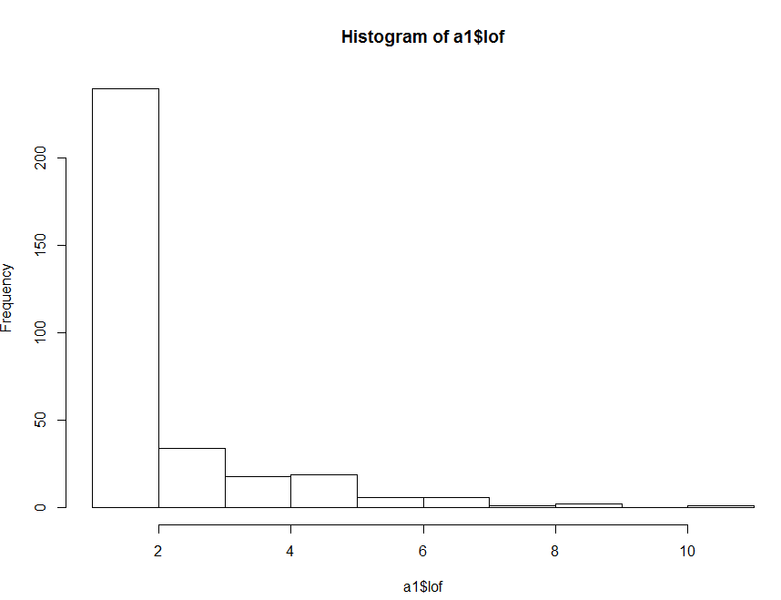

For 10% observation (327 records), there is a high frequency of LOF score <2. Since our dataset is sorted, this indicates that beside outliers, we capture quite a lot of normal observations within 10% observation (normal record will have LOF score closer to 1). This also means that all outliers are detected within 10% observation. Plus, a sharp decrease of frequency after 2 means that there is a quick increase of LOF score. We can say that outliers are distinctive and easy to spot using our technique.
There is a gap in the histogram (where ols = 9). This is probably coming from the dataset.
Since LOF calculates and compares local density to its k nearest neighbor density, if a point is more far away and isolated from others, it will have higher outlier score. Therefore, the appearance of gaps is due to the distribution of outliers in the dataset. For example:
These points have higher outlier scores than usual, thus creating gaps in histogram.

Task 4 (optional): Enhance your outlier detection technique based on the feedback of Task3 and redo Task 3

To enhance my outlier detection (LOF with kNN approach), we can find the best value of k of nearest neighbor.
K value in function lof is the kth-distance to be used to calculate LOFs. k can be a vector which contains multiple k values based on which LOFs need to be calculated.
Therefore, we can choose a minimum k and a maximum k, compute for each object its LOF values within this range.
Based on the paper “LOF: Identifying Density-Based Local Outliers” by Markus Breunig, minimum k should be at least 10 to remove unwanted statistical fluctuation.
We propose the heuristic of ranking all objects with respect to the maximum LOF value
within the specified range. The range of k is from 10 to 30. The ranking of an object p, or the outlier score, is based on:
max{LOF_{MinPts}(p) | min of k <= k <= max of k}.

In R:
mtrxlof<-lof(as4lof2,k=c(10:30)) #create a matrix that stores LOF score of each object for each k between 10 and 30

#find the maximum LOF for each records
theLof <- NULL
for(i in 1:nrow(as4lof2))
{
theLof <-c(theLof,max(mtrxlof[i,]))
}

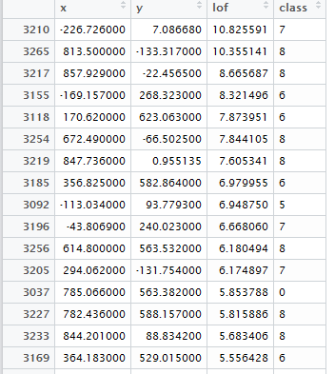(snapshot of dataset after sorting)

Redo task 3
- 2% of observation
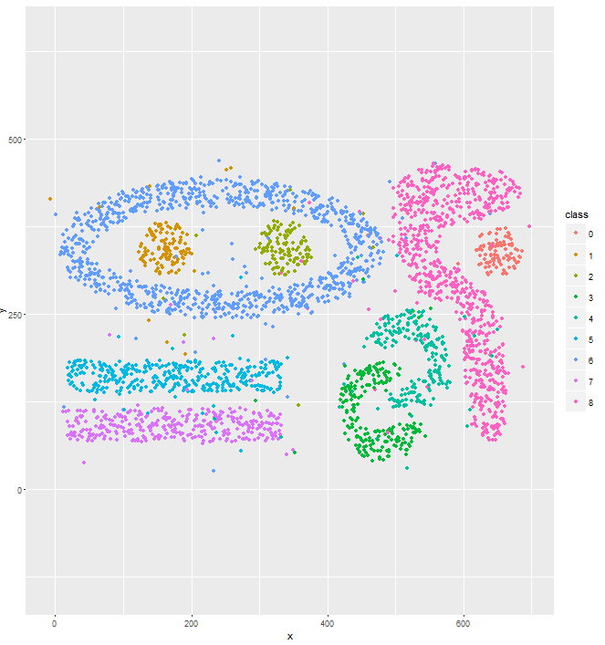
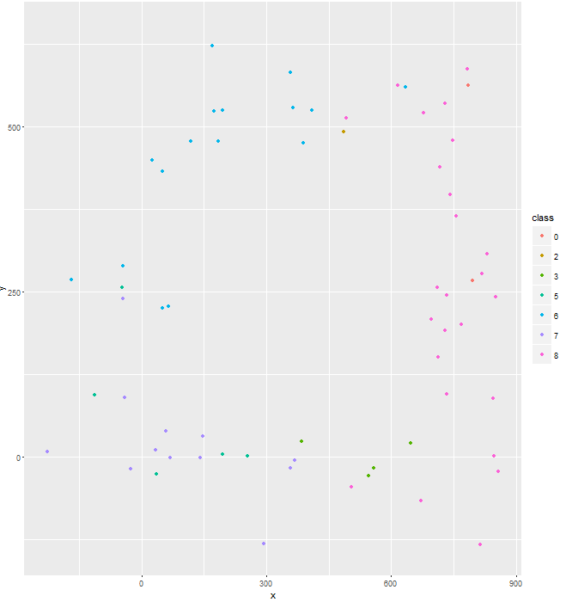
Outliers Normal Observations

Comment: The new enhanced technique works better because it can detect all far outliers on the right of class 8 within in its top 2% of observation.

- 5% of observation
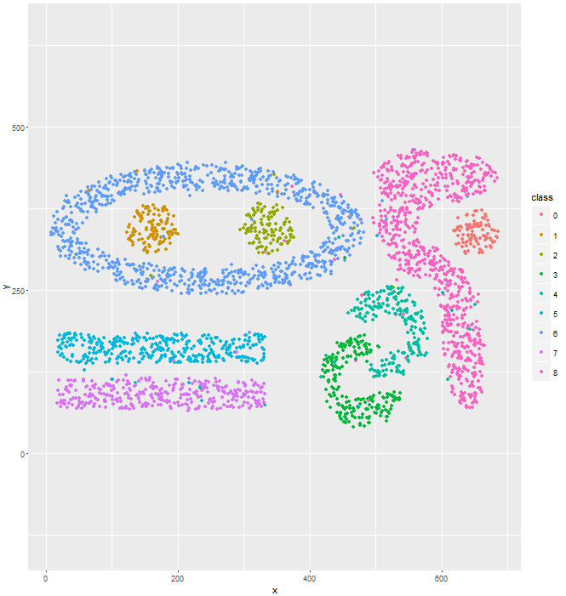
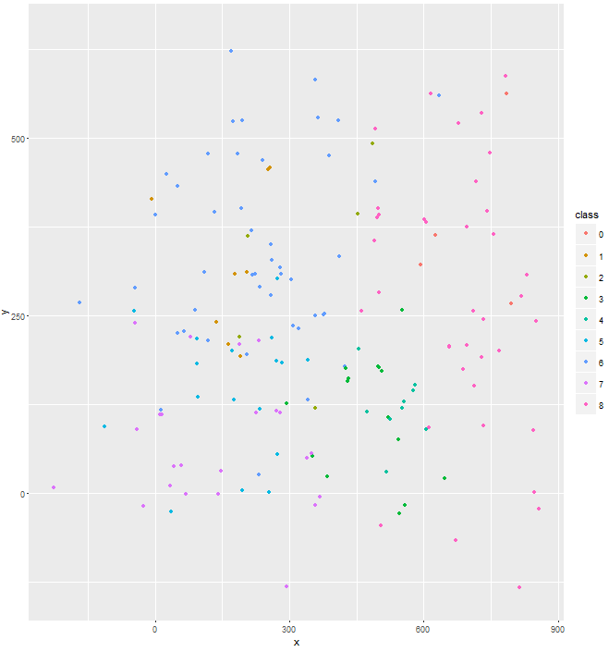
Outliers Normal observations
Comment: There is no major change comparing to the old technique

- 10% of observation
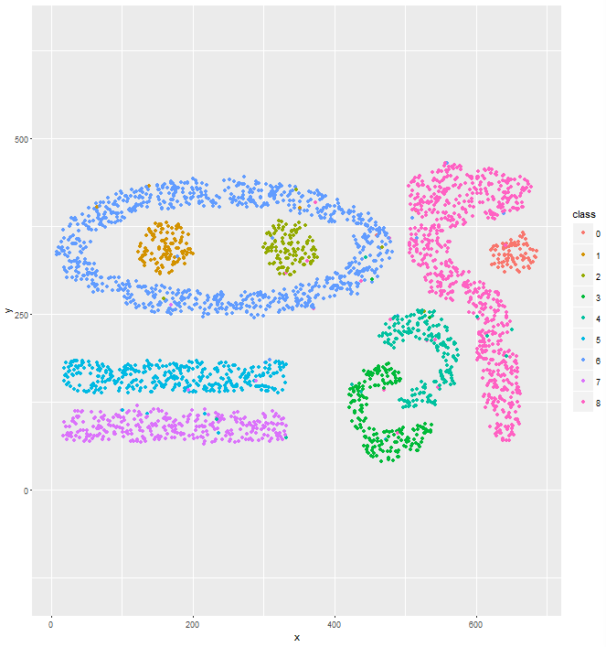
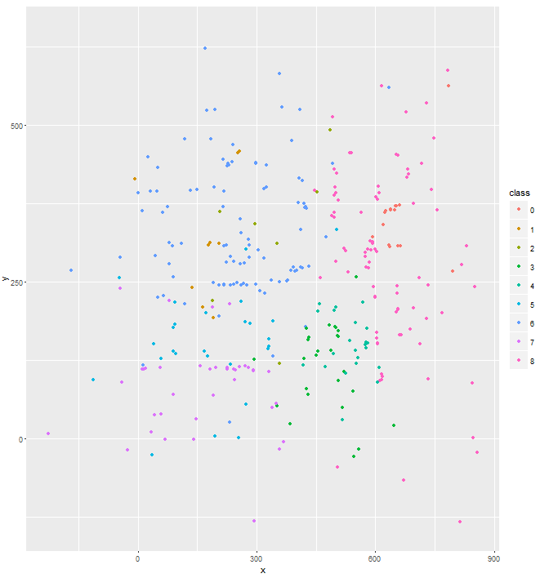
Outliers Normal Observations

- Comment: there still no major change for top 10% observation

Conclusion: The enhanced technique works great on finding extreme outliers (points with far distance from classes) early, as we can see from its result on top 2% observation. For 5% and 10% observation, its performance is similar to the previous technique.
Overall, we recommend using the enhanced technique, since it draws results by applying LOF to a range of k value instead of just one k, and it shows its effectiveness of finding outliers early in the dataset (within top 2% observation)

Task 5: Write a 2-5 paragraphs, explaining your outlier detection technique works and how it was implemented. If you enhanced your approach based on feedback to get better results also describe how you enhanced your technique. If your outlier detection technique needs the selection of parameter values before it can be run, describe how you selected those parameter values for conducting Task3. Moreover, mention in a paragraph what (if any) external software packages your used in the project!

- Explaining outlier detection technique works and how it was implemented: can be found in descriptions of Task 1 and 2
- Enhance outlier technique: in Task 4
- My outlier technique needs 2 parameters: the dataset itself, and k value (this parameter can be passed as a vector, which I utilized in Task 4).
- Package use: Rlof (more information in description of Task 2)

Reference:
Breunig, Markus. “LOF: Identifying Density-Based Local Outliers”. 2000.

Task 6: Submit the code of the implementation of your outlier detection technique!

setwd("~/DATAMINING/ass4")
data <- read.csv("complex9_gn8.txt")
as4<- data.frame(x=data[,1],y=data[,2],class=as.factor(data[,3]))

#graph the dataset
require("lattice")
require("ggplot2")
xyplot(y ~ x | class, as4, groups=as4$class, pch=20)
ggplot(as4, aes(x=x, y=y, colour=class))+ geom_point()
#ggplot(as4, aes(x = x, y = y)) + geom_point() + facet_grid(~class)
ggplot (as4, aes (x = x, y = y, colour = class)) + stat_density2d ()
p <- ggplot(as4, aes(x = x,y = y))
p+geom_point()+geom_density2d()

#draw normal observation, given % of data
drawMajor<- function(data,p)
{
n<- round(nrow(data)*p)
a2<- data[(n+1):nrow(data),]
ggplot(a2, aes(x=x, y=y, colour=class))+ geom_point() + coord_cartesian(xlim=c(-230, 900)) + coord_cartesian(ylim=c(-140, 650))

}

#draw outliers, given % of observation
drawOutliers<- function(data,p)
{
n<- round(nrow(data)*p)
a1<- data[1:n,]
ggplot(a1, aes(x=x, y=y, colour=class))+ geom_point()+ coord_cartesian(xlim=c(-230, 900)) + coord_cartesian(ylim=c(-140, 650))
}

#plot both outliers and normal observations
plotAll<- function(data,p)
{
n<- round(nrow(data)*p)
a1<- data[1:n,]
a2<- data[(n+1):nrow(data),]
plot(a2[,1:2], main = "Data and outliers")
points(a1[,1:2], col = "red", pch = 4)
}

drawHist<- function(data,p)
{
n<- round(nrow(data)*p)
a1<- data[1:n,]
hist(a1$lof)
}

#library(dbscan)
library(Rlof)

#as4scaled<- data.frame(x=scale(as4$x),y=scale(as4$y))
as4lof<-data.frame(x=(as4$x),y=(as4$y))
xylof<-lof(as4lof,k=c(10))

as4lof$lof <- xylof
as4lof$class<- as4$class
plot(sort(xylof),type = "l")
#sorting lof
as4lof<- as4lof[order(-as4lof$lof),]

#visualize first 10%
drawMajor(as4lof,0.1)
drawOutliers(as4lof,0.1)
plotAll(as4lof,0.1)

#visualize first 5%
drawMajor(as4lof,0.05)
drawOutliers(as4lof,0.05)
plotAll(as4lof,0.05)

#visualize the first 2%
drawMajor(as4lof,0.02)
drawOutliers(as4lof,0.02)
plotAll(as4lof,0.02)

drawHist(as4lof,0.1)

#enhanced technique
as4lof2<-data.frame(x=(as4$x),y=(as4$y))
mtrxlof<-lof(as4lof2,k=c(10:30))
theLof <- NULL
for(i in 1:nrow(as4lof2))
{
theLof <-c(theLof,max(mtrxlof[i,]))
}

as4lof2$lof <- theLof
as4lof2$class<- as4$class
plot(sort(theLof),type = "l")
#sorting lof
as4lof2<- as4lof2[order(-as4lof2$lof),]

#visualize first 10%
drawMajor(as4lof2,0.1)
drawOutliers(as4lof2,0.1)
plotAll(as4lof2,0.1)

#visualize first 5%
drawMajor(as4lof2,0.05)
drawOutliers(as4lof2,0.05)
plotAll(as4lof2,0.05)

#visualize the first 2%
drawMajor(as4lof2,0.02)
drawOutliers(as4lof2,0.02)
plotAll(as4lof2,0.02)

drawHist(as4lof2,0.1)

The outlier detection method is only applied to the first 2 numerical attributes and the third attribute is just used for visualization purposes; for that reason, it is called a spatial outlier detection methods; e.g. it can detect outliers for object locations described by (longitude, latitude)-pairs.

