Christoph F. Eick and Sen

COSC 4368 Spring 2026

Task1: Using Reinforcement Learning

To Discover Paths in a Transportation World

Individual Task

Version 1

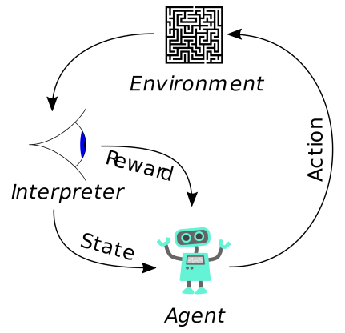

Deadline: Feb. 21, 2026
Last updated: Jan. 26, 9a

In this assignment we will use reinforcement to learn and adapt “promising paths” in a Grid World. Learning objectives of this assignment include:
- Understanding basic reinforcement learning concepts such as utilities, policies, learning rates, discount rates and their interactions.
- Obtain experience in designing agent-based systems that explore and learn in initially unknown environment and which are capable to adapt to changes.
- Learning how to conduct experiments that evaluate the performance of reinforcement learning systems and learning to interpret such results.
- Development of path visualization and analysis techniques to interpret and evaluate the behavior of agent-based path-learning systems.

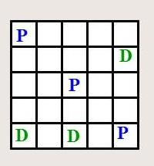
Figure 1: Visualization of the PD-World.

Figure 2: An Urban Grid World.

In particular you will use Q-learning/SARSA for the PD-Word (http://www2.cs.uh.edu/~ceick/ai/2026-World.pptx), conducting the experiments using different parameters and policies, and summarize and interpret the experimental results. Moreover, you will develop path analysis techniques that are capable to shed light on what paths the learning system actually has learnt from obtained Q-Tables—we call such paths attractive paths in the remainder of this document. An example of an attractive path has been given in Figure 3.

In experiments you conduct, the learning rate is α=0.3 and the discount rate is assumed to be γ=0.5 and we assume that q values are initialized with 0 at the beginning of the experiment. The following 3 policies will be used in the experiments:

- PRANDOM: If pickup and dropoff is applicable, choose this operator; otherwise, choose an applicable operator randomly.
- PEPLOIT: If pickup and dropoff is applicable, choose this operator; otherwise, apply the applicable operator with the highest q-value (break ties by rolling a dice for operators with the same q-value) with probability 0.8 and choose a different applicable operator randomly with probability 0.2.
- PGREEDY: If pickup and dropoff is applicable, choose this operator; otherwise, apply the applicable operator with the highest q-value (break ties by rolling a dice for operators with the same q-value).

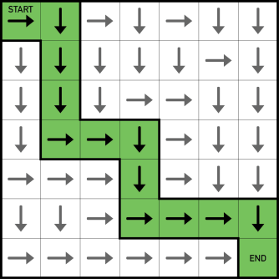
Figure 3: Visualization of an Attractive Path for a Search Problem

The three experiments you conduct are as follows:
- In Experiment 1 you use α=0.3, and run the Q-learning algorithm for 4000 steps with policy PRANDOM; then run PGREEDY for 4000 steps. Display and interpret the Q-table you obtained in the middle and the end of the experiment.
- In Experiment 2 you use α=0.3, and run the Q-learning algorithm for 8000 steps with policy PEXPLOIT—however, use policy PRANDOM for the first 200 steps of the experiment, and then switch to PEXPLOIT for the remainder of the experiment. Analyze the performance variables and summarize what was learnt by analyzing the q-table at different stages of the experiment.
- In Experiment 3 you use α=0.3, and run the SARSA q-learning variation for 8000 steps with policy PEXPLOIT—however, use policy PRANDOM for the first 200 steps of the experiment, and then switch to PEXPLOIT for the remainder of the experiment. When analyzing Experiment 3 center on comparing the performance of Q-learning and SARSA. Also report the final q-table of this experiment.

For all experiments, if the agent reaches a terminal state, restart the experiment by resetting the PD world to the initial state, but do not reset the Q-table. Run each experiment twice, and report and interpret the results; e.g. utilities computed, rewards obtained in various stages of each experiment.

Summarize the experimental results and assess which experiment obtained the best results. Next, for Experiment 2, analyze the various q-tables you created and try identify attractive paths for the obtained q-tables, if there are any. Moreover, briefly assess if your system gets better after it solved a few PD-world problems—reached the terminal state at least once. Finally, briefly analyze to which extent the results of the two different runs agree and disagree in the 3 experiments.

Moreover,
- Make sure that you use different random generator seeds in different runs of the same experiment to obtain different results—having identical results for the 2 runs of the same experiment is unacceptable. It is okay just to report and interpret the Q-tables for the better of the two runs for each experiment, but you should report the performance variables for all ten runs.

- You should use the traditional Q-learning and SARSA algorithm in the project and not any other Q-learning variations or reinforcement learning algorithms!
- As far as counting operator applications in performance measures is concerned, you should never count operators that are not applicable in a particular state.
- Students that provide good methods for visualizing q-tables and good visualizations for the analysis of attractive paths obtain extra credit.
- Evidence of the running of your system has to be provided using screen shots that will be delivered in a separate document; it is sufficient, if you do that for just one experiment, preferably Experiment 2.

Write a 6-7 page report that summarizes the findings of the project. Be aware of the fact that at least 25% of the points available for this project are allocated to the interpretation of the experimental results. Finally, submit the source code of the software you wrote in addition to your project report and a ReadMe file on how to run the system; you might also be asked to demo your system. More detailed assignment submission guidelines will be posted around Feb. 14.

Project Links

https://github.com/kristofvanmoffaert/Gridworld
http://cs.stanford.edu/people/karpathy/reinforcejs/gridworld_td.html
https://mediatum.ub.tum.de/doc/1238753/1238753.pdf

SARSA is a variation of Q-learning that uses the q-value of the actually chosen action and not the q-value of the best action!
You have the option to use the SARSA algorithm instead, if you prefer that! Make clear in your report which algorithm you used in Experiment1.
Do not reset the q-table after 4000 steps!
Additionally, report the following Q-tables for Experiments 2 (or Experiment 3 if you prefer that, in this case you will only need to report the final Q-Table of Experiment 2) in your report a) when the first drop-off location is filled (the fifth block has been delivered to it) and b) when a terminal state is reached and c) the final Q-table of each experiment. The Q-table in the screenshot should be presented as a matrix, with s rows (states) and t columns (operators). Thus, the Q-table for recommended state space has 25 x 2 rows and 6 columns; however, the q-values for the drop-off and pickup operators do not need to be reported. If your Q-Table is large just visualize a subset of the Q-table.
Provide graphs that show, how the algorithm’s performance variables changed over the duration of the experiment in the three experiments.
A path going from (i,j) to (i’,j’) is attractive if, the q-values of the motion operators are high in comparison to other directions. Be aware of the fact that different paths are attractive for agents who hold a block and for agents how do not hold a block.

