Christoph F. Eick

COSC 4368: Fundamentals of Artificial Intelligence Spring 2021

Problem Set3 (Individual Tasks)

Second Draft

Deadlines: Problem 7 April 29, Problem 6 May 5

Last updated: April 22

6. Ethical Problems of AI (18 points) Mahin
Write a short essay of 450-550 words, focusing on the Ethics and Governance of Artificial Intelligence Systems. Possible topics of your essay include how to accomplish a balance between regulation and innovation, how to ensure that AI systems follow our principles when making decisions, how should we regulate AI systems and what responsibilities should they have among others. If you want to write an essay on another theme, not mentioned above, but related to Ethics and Governance of AI, send Dr. Eick and Mahin an e-mail to get your topic approved.

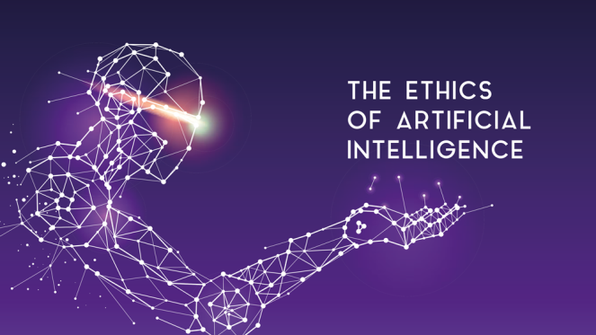
Fig. 4: AI & Ethics

Be aware of the fact that plagiarism will not be tolerated in this course; however, this does not mean that you are not allowed to use material on the internet and taken from the scientific literature when writing your essay; you just need to cite the material you used and you will need to use quotations, if you use (parts of) sentences “unchanged” from other publications in your essay!

Some hopefully useful links for identifying a topic for your essay:
- http://web.stanford.edu/class/cs122/
- https://www.vanderbilt.edu/strategicplan/undergraduate-residential-education/universitycourses-2018/ethics_of_artificial_intelligence.php
- https://www.media.mit.edu/courses/the-ethics-and-governance-of-artificial-intelligence/

7. Using a Belief Network Tool (16 points) Theodoros

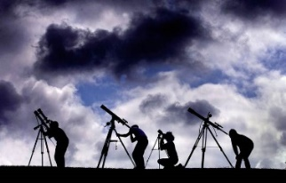
Fig. 3: Multiple Astronomers Looking at the Sky

Assume we have 3 astronomers in different parts of the world who make measurements M1, M2, and M3 of the number of stars N in some region of the sky. Normally, there is a probability of 0.2 (20%) that the astronomer undercounts by one star; you can assume that the three astronomers never overcount, unless drunk; moreover, if there is no star visible (N=0) the astronomer does not undercount). Moreover, there is a 5% probability that the astronomer is drunk (P(D_{i}=1)=0.05 for i=1,2,3) represented using Boolean random variables D1, D2, and D3), in which case the astronomer overcounts by 0 or 1 or 2 stars but never undercounts, even if N=0 (e.g. if N is 2 a drunk astronomer will count 2 or 3 or 4 stars). Moreover, you can assume if information is missing that each case has the same probability. Design a belief network, and compute the probability of the other variables assuming the following pieces of evidence are given (feel free to use Netica (http://www.norsys.com/download.html ) or any another belief network tool to compute your answers!):

- M1=3 M2=3 M3=1
- M1=3 M2=3 M3=0
- N=2, M2=1, M3=0
- D1=1 D2=0 M3=3
- M1=6 M2=4 D1=1
Submit the complete Belief Network you created—including all its probability tables—, and the findings you obtained for the five cases listed above!

E.g. they do not discriminate and follow other principles, such as saving lives is more important than avowing property damage.
You can assume that N is limited to 4—but the astronomer do not know that: M1, M2 and M3 are therefore limited to values 0 through 6.
Including the answer ‘inconsistent’ in the case that the evidence is inconsistent, e.g, the evidence N=1 M1=4 is inconsistent—as it is ‘impossible’ because astronomer1 never overcounts by more than 2 stars!

