COSC 6368 (Spring 2009)
Assignment 3: Machine Learning

Deadlines: problems 8, 10, 11: April 23, 11p; problem 9: April 26, 11p (electronic submission); problem 9 is a group project, and the other problems are not!
Last updated: April 19, 2009, 10p

8) Decision Tree Induction w=1
a) We would like to predict the gender of a person based on two binary attributes: leg-cover (pants or skirts) and beard (beard or bare-faced). We assume we have a data set of 20000 individuals, 12000 of which are male and 8000 of which are female. 80% of the 12000 males are barefaced. Skirts are present on 50% of the females. All females are bare-faced and no male wears a skirt.
  - Compute the information gain of using the attribute leg-cover for predicting gender!
  - What is the information gain of using the attribute beard to predict gender?
  - Based on yours answers to i) and ii) which attribute should be used as the root of a decision tree?

9) Using C5.0 --- Knowledge Discovery for the NBA w=7 Group Project
The goal of this project is to explore how decision tree tools (e.g. download the tool form http://www.rulequest.com/download.html ) can help in predicting the free throw goal percentage (FT%) of a basketball player using the following NBA-Player Data Set and the popular decision tree tool C5.0. The goal of the project is to predict a player’s free throw percentages based on other attributes of the player. Free throw percentage is defined as an attribute that takes values HIGH and LOW.

Tasks to be solved and questions to be answered: Take the NBA Data Set ( http://www2.cs.uh.edu/~ceick/4368/nba.names and http://www2.cs.uh.edu/~ceick/4368/nba.data). Assess the accuracy of decision trees for the classification task! Analyze which degree of pruning is best for the classification problem by running the tool for different parameter setting; report and interpret the results in your report. Conduct a sensitivity analysis by running the tool for slightly different parameter settings/inputs (e.g. slightly different training sets) by comparing the obtained decision trees—do they agree, somewhat agree, disagree; is the decision tree tool stabile with respect to the decision trees it creates? Moreover, report the best decision tree or trees you found together with the parameter settings that were used to generate these trees. Analyze the decision trees that have a high accuracy in predicting good free throw shooters --- what does it tell us about the classification problem we were trying to solve; e.g. did the decision tree approach work well/work badly for the problem at hand; did we find anything interesting that distinguishes successful shooters from unsuccessful shooters in the NBA)? Finally, write a 4-page (single spaced) report that summarizes your results centering on: (1) accuracy (2) pruning (3) sensitivity analysis
(4) best decision tree(s) found (5) Assessment, if the tool solves the problem at hand.

- Neural Networks w=5
Assume we have the perceptron that is depicted in Fig. 1 that has two regular inputs, X1 and X2, and an extra fixed input X3, which always has the value 1. The perceptron's output is given as the function:
Out= If (w1*X1 + w2*X2 + w3*X3) > 0 then 1 else 0
Note that using the extra input, X3, we can achieve the same effect as changing the perceptron's threshold by changing w3. Thus, we can use the same simple perceptron learning rule presented in our textbook to control this threshold as well.
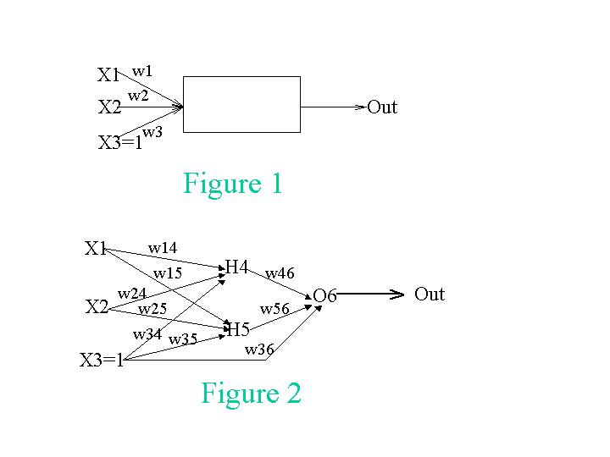
A. We want to teach the perceptron to recognize the function X1 XOR X2 with the following training set:
X1 | X2 | X3 | Out
1 | 1 | 1 | 0
0 | 1 | 1 | 1
1 | 0 | 1 | 1
0 | 0 | 1 | 0
Show the change in the weights of the perceptron for every presentation of a training instance. Assume the initial weights are: w1=0.1, w2=0.1, w3=0.9 Important: Do the iterations according to the order of the samples in the training set. When you finish the four samples go over them again. You should stop the iterations once you get convergence, or when the values you get indicate that there will be no convergence. In either case explain your decision to stop the iterations. Assume in your computations that the learning rate α is 0.4.
Sample# | X1 | X2 | X3 | Output | True_Out | Error | w1 | w2 | w3
0 |  |  |  |  |  |  | 0.1 | 0.1 | 0.9
1 | 1 | 1 | 1 |  | 0
2 | 0 | 1 | 1 |  | 1
3 | 1 | 0 | 1 |  | 1
4 | 0 | 0 | 1 |  | 0
5 | 1 | 1 | 1 |  | 0
6 | ... | ... | ... | ... | ... | ... | ... | ...
7
8
...

B. This time, instead of being limited to a single perceptron, we will introduce hidden units and use a different activation function. Our new network is depicted in Fig. 2. Assume that the initial weights are w14 = 0.1, w15 = 0.1, w24 = 0.1, w25 = 0.1, w34 = 0.1, w35 = 0.1, w36 = 0.2, w46 = 0.2, and w56 = 0.2. The training set is the same as in (A). Use γ=0.3 as your learning rate. Show what the new weights would be after using the backpropagation algorithm for two updates using just the first two training instances. Use g(x) = 1/(1+e**(-x)) as the activation function; that is g'(x)=(e**(-x))/(1+e**(-x))**2).
S# | X1 | X2 | X3 | Out | True_Out | Error | w14 | w15 | w24 | w25 | w34 | w35 | w36 | w46 | w56
0 |  |  |  |  |  |  | 0.1 | 0.1 | 0.1 | 0.1 | 0.1 | 0.1 | 0.2 | 0.2 | 0.2
1 | 1 | 1 | 1 |  | 0
2 | 0 | 1 | 1 |  | 1

11) Reinforcement Learning for the STU World w=8
a) Compute the utility of the different states in the STU World (http://www2.cs.uh.edu/~ceick/ai/STU-World.ppt) starting with initial utility value of 0 for each state by running Bellman update for 200 iterations for γ=1 and γ=0.2. Interpret the results! If you run into unusual numerical problems, use the “more complicated” approach that is described in Fig. 17.4 of the textbook.
b) Using temporal difference learning, compute the utilities of states of a policy P that chooses actions at random:
- If there is more than one action applicable for a state, each action has the same chance to be chosen.
- If a probabilistic action is chosen, the next state is chosen based on transition probabilities associated with the successor states.

Run the TD-Learning algorithms for 50 loops using the policy P with α=0.25 and γ=0.5; report the utility values; then run the TD-Learning algorithm for 50 more loops but reversing the rewards associated with states (positive rewards become negative, and negative rewards become positive; e.g. a reward of +9 becomes -9). Interpret the results! Is this form of learning suitable to cope with changes of the reward function? Also briefly compare the results of the first part of the experiment for question b with the results you obtained for question a.
c) Based on the findings you obtained in steps a and b devise a good policy for an agent to navigate through the STU world!!
Write a 2-3 page report that summarizes the findings of the project. Be aware of the fact that at least 30% of the available points are allocated to the interpretation of the experimental results.

Focus your analysis just on 2 of the C5.0 parameters: pruning CF-factor and minimum number of cases.
As in the previous task use 0 as the initial utility of a state; however, do not reinitialize the utilities after 40 loops have been completed.

